**Project 1: Deploying a website on AWE EC2 Instance**

**1.Virtual Private Cloud**

**Steps :**

**1.In AWS console, search VPC.**

**2.In VPC dashboard , you will get my VPC’s and click on myvpc’s.**

**3.Click on create VPC. Select resource to create as vpc only.**

**4.Give name as krishald-vpc and IPv4 CIDR as 10.0.0.0/16.**

**5.Then click on create VPC.**

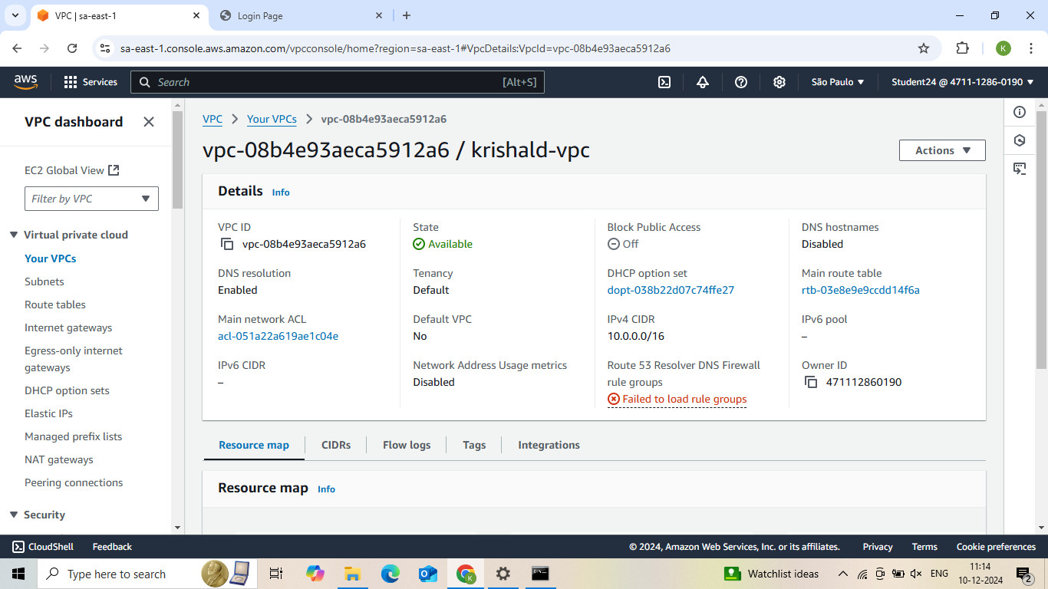

**2. Internet Gateway**

**Steps :**

**1.In VPC dashboard, click on Internet Gateway.**

**2.To create Internet gateway, click on create Internet Gateway.**

**3.Then give name as krishald-igw and click on create Internet Gateway.**

**4.Your internet Gateway is created.**

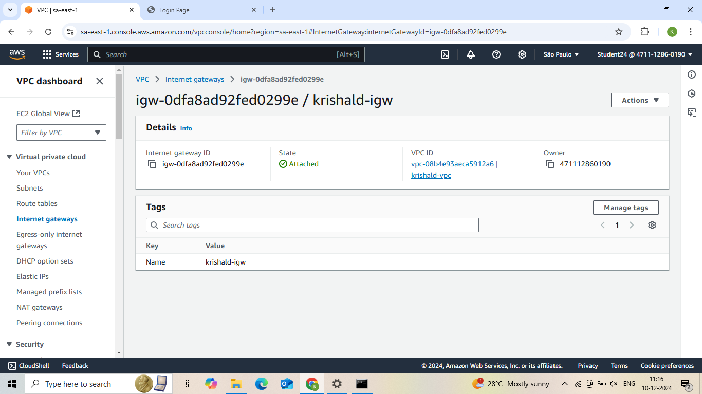

**3. Public Subnet1**

**Steps :**

**1.To create subnet, go to VPC dashboard under virtual private cloud, click on subnet.**

**2.Select the vpc you have already created and in subnet setting, give subnet name as public-subnet-01 .**

* 1. **3.Then choose availability zone as region you have selected before creating the vpc and IPv4 subnet CIDR block as 10.0.1.0/25.**

**4.Then create one more subnet as following subnet but give name as public-subnet-02 and then choose availability zone and IPv4 subnet CIDR block as 10.0.2.0/24.**

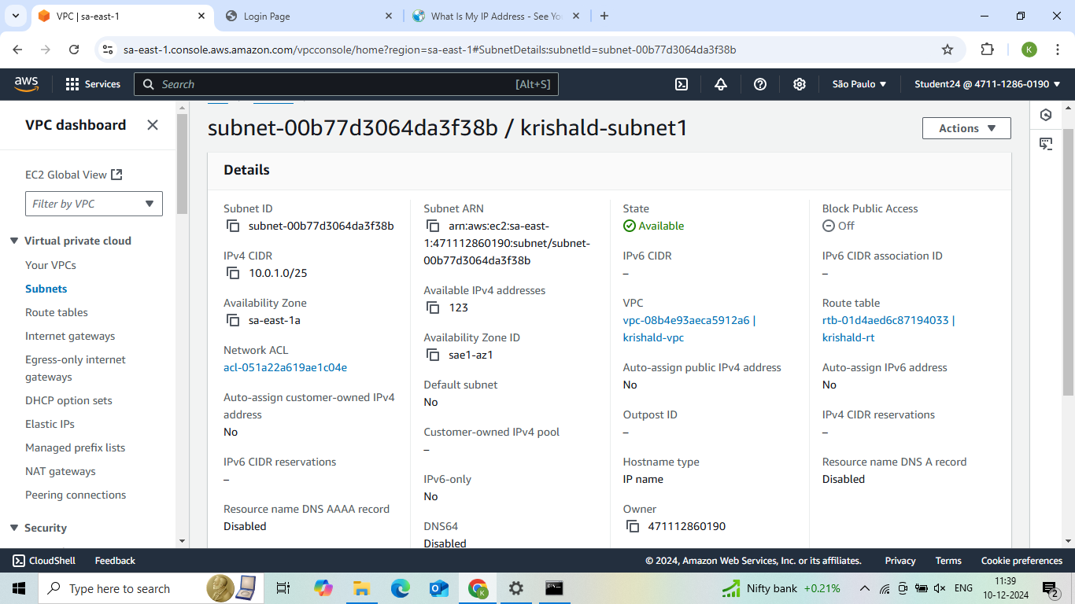

**4. Public Subnet2**

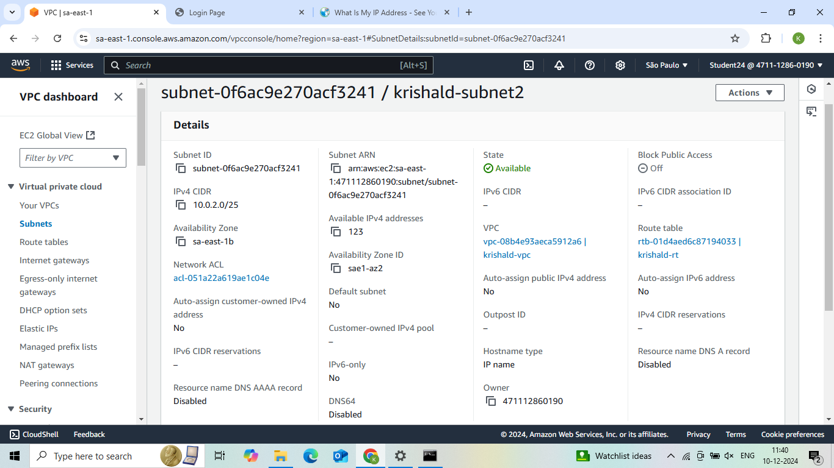

**5. Router Table**

**1. To create Route table, click on create route table.**

**2. In route table setting, give route table name as krishald-rt and select vpc that is created.**

**3. Then click on create route table.**

**4. After route table is created, go to routes and click on edit route and then click on add route.**

**5. Then in destination, select 0.0.0.0/0 as destination and target as Internet Gateways .**

**6. After selecting internet gateway, it allows to select the igw- and select the internet gateway that is created by you.**

**7. At last click on save changes.**

**8. Then go to subnet association and click on edit subnet association.**

**9. Select the subnet you have created and click on save changes**

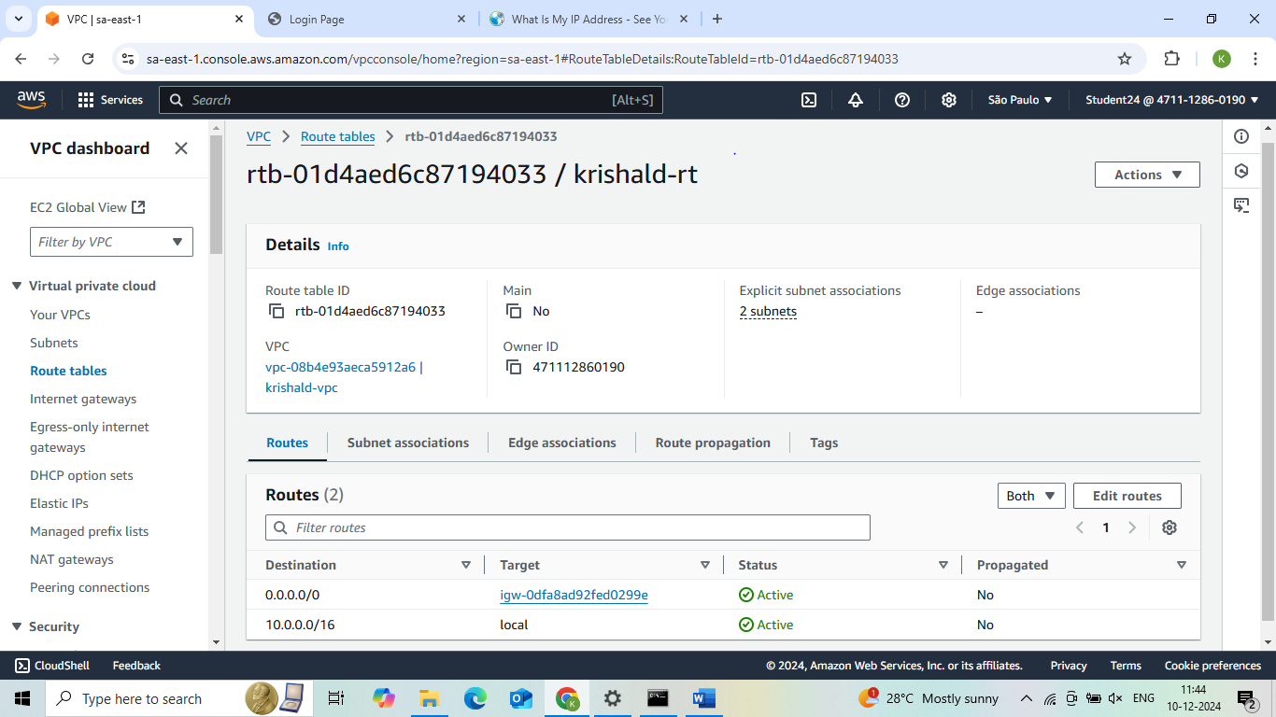

**6. EC2 Instance**

**Steps:**

**1.Go to EC2 in AWS console and click on instances.**

**2.Click on launch instance and give the name for the instances as krishald-server.**

**3.After giving name to instances, select application and OS Images as Amazon Linux and instances type as t2.micro .**

**4. In keypair, click on create keypair and give keypair name as krishald-keypair and click on create keypair. The keypair is created.**

**5.Then in network setting, click edit. Select vpc and subnet and also assign public IP as enable.**

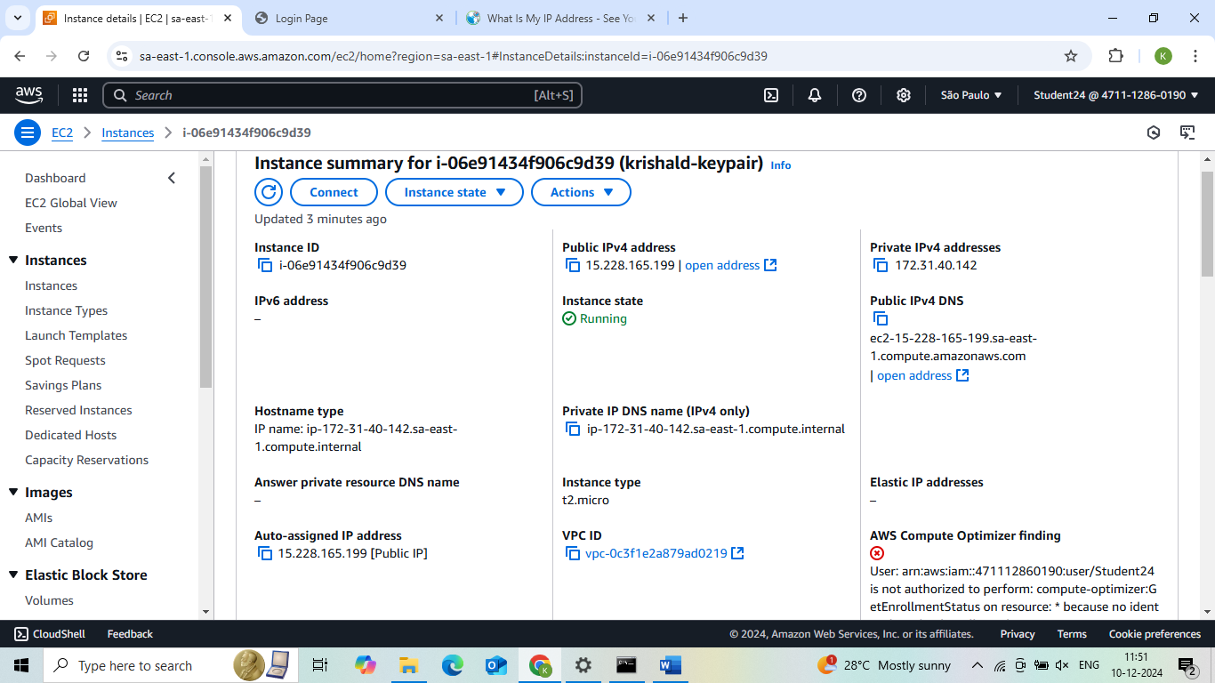

**7. Creatig Connection**

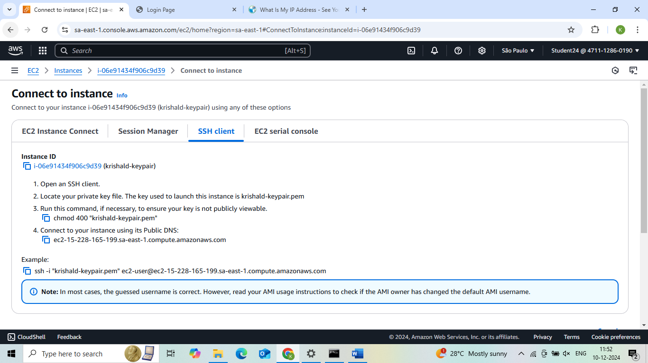

**8.Command prompt**

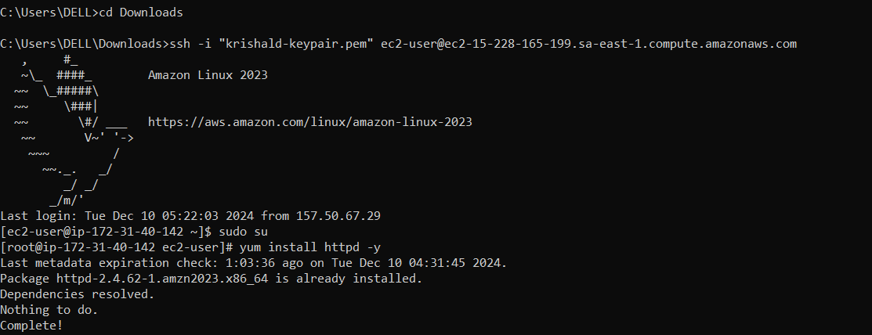

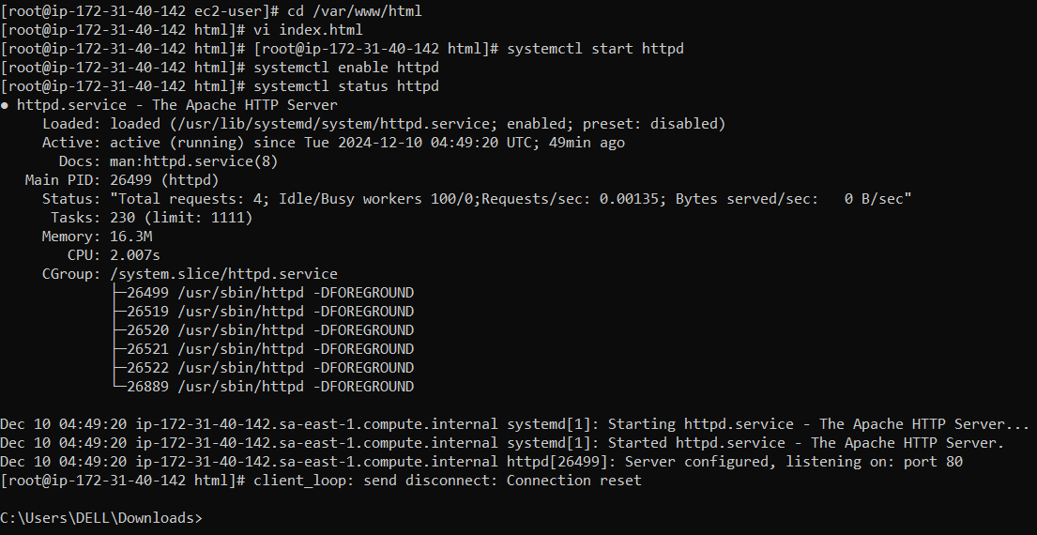

**9.Final Result**

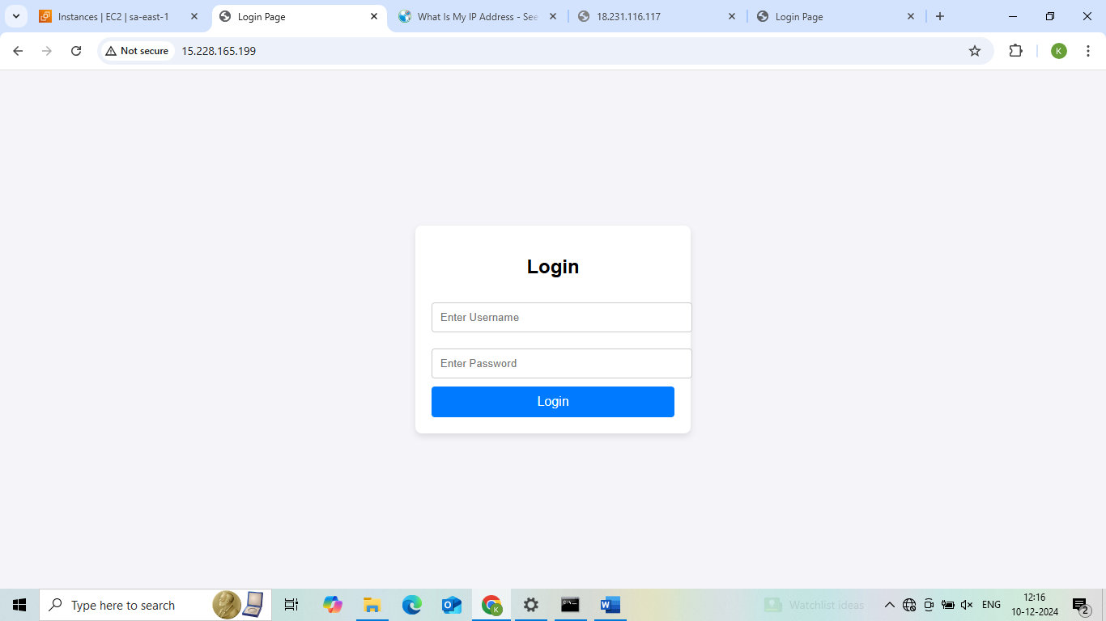

**Project 2: How to create new instance using AMI**

**1.Creating Image**

**Steps:**

**1. To create image using AMI, go to EC2 and click on instances.**

**2. Select the instance that is created before and click on action.**

**3. In action, select image and template. In image and template, select create images.**

**4. Give name as anu-server-backup and description to the instances.**

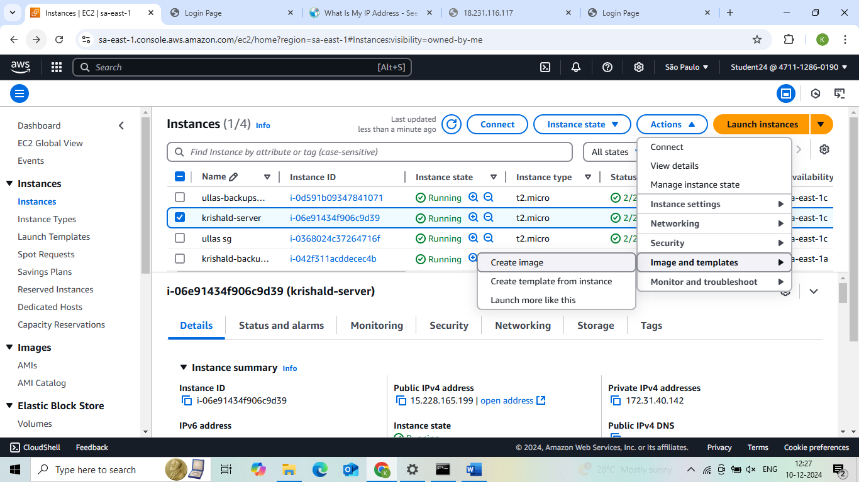

**2.AMI Summary**

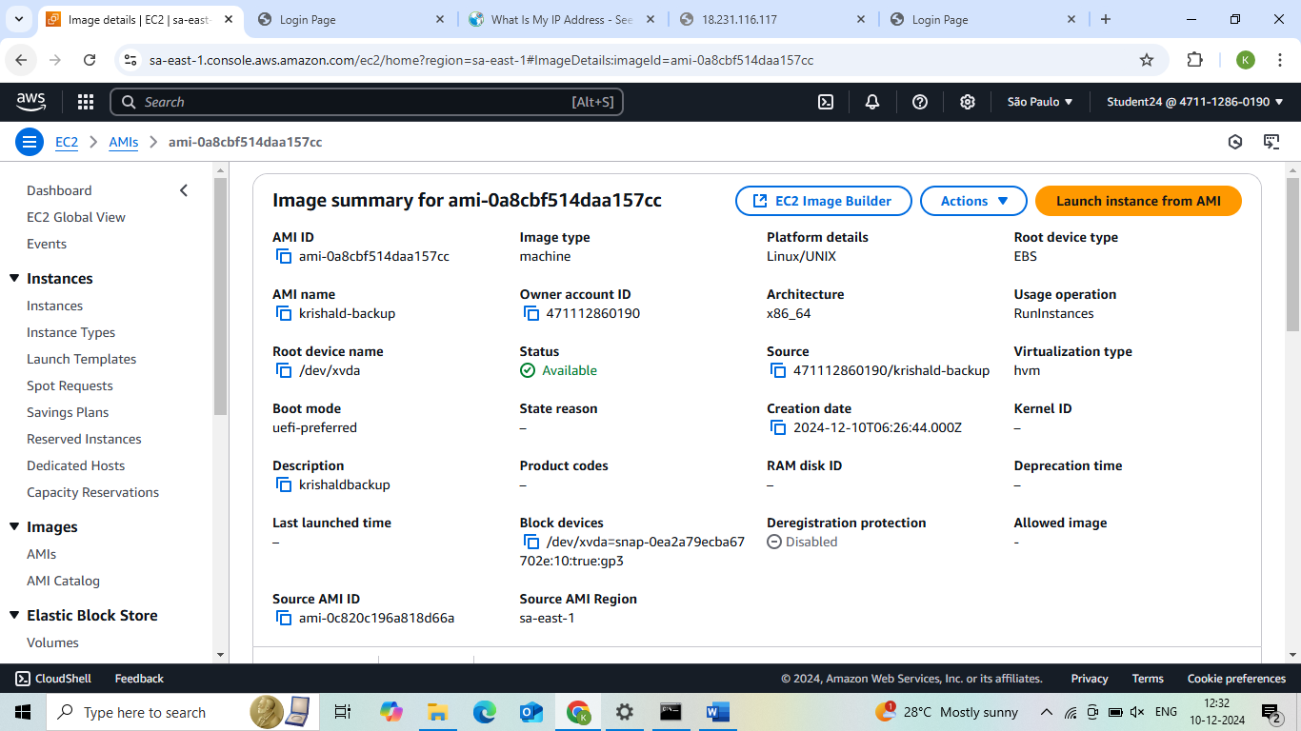

**3. After launching the backup server**

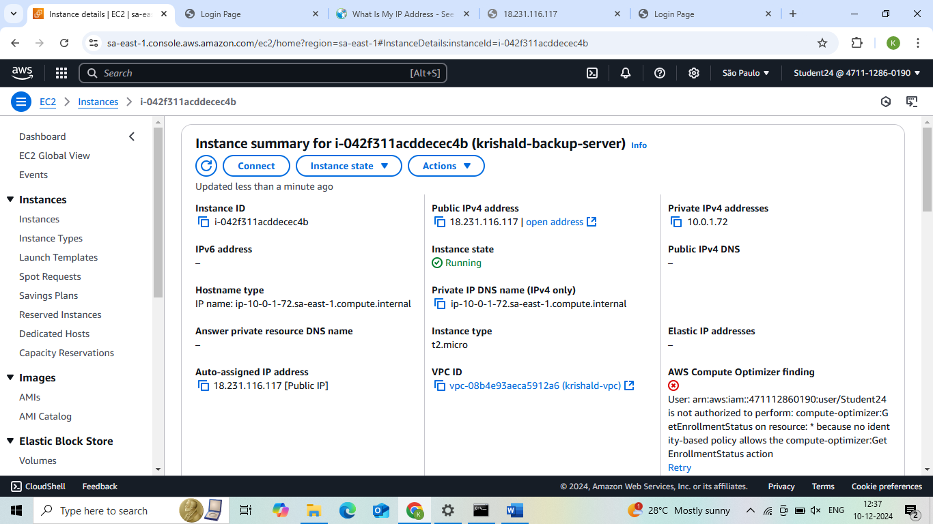

**4. Final Result**

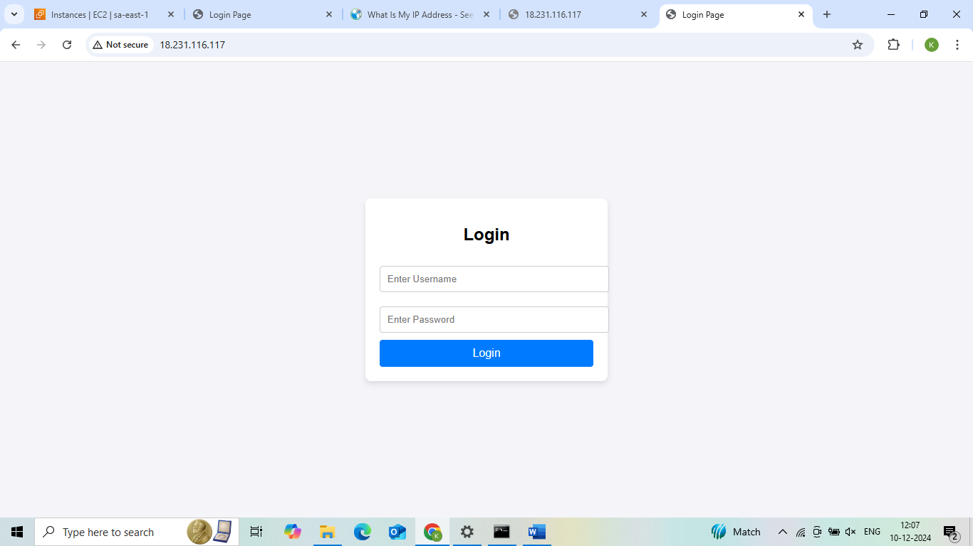

**Project 3:How to connect private server to internet using NAT gateway(Jump server/Bastion host)**

1. **Virtual private cloud**

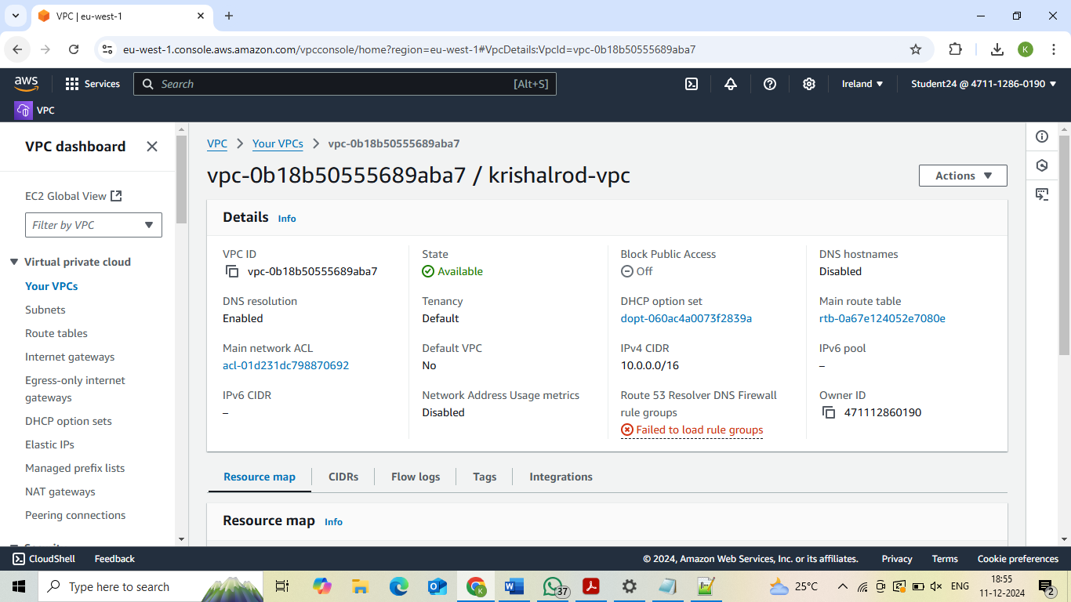

**2. Internet Gateway**

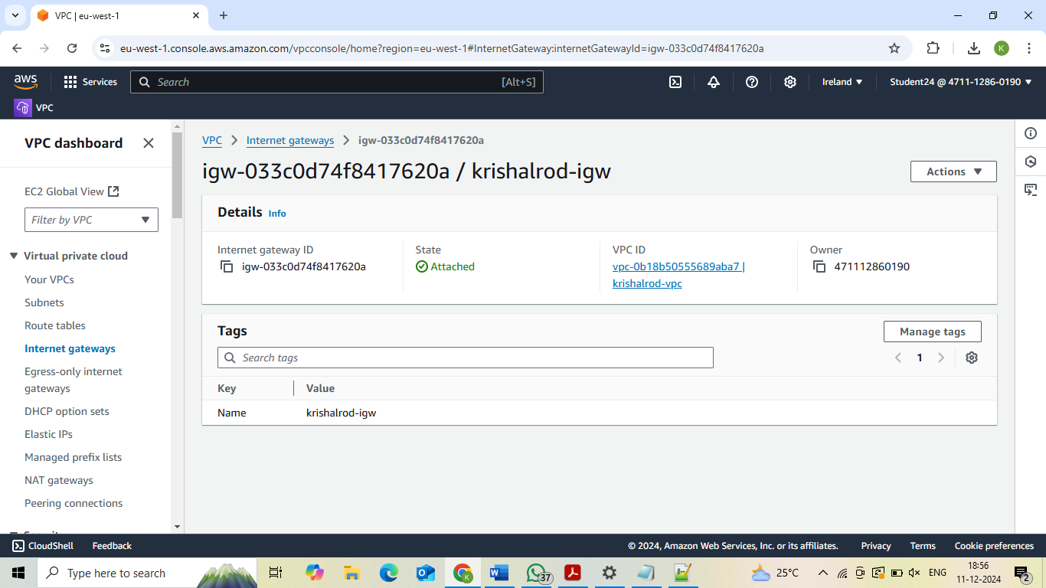

**3. Public Subnet 1**

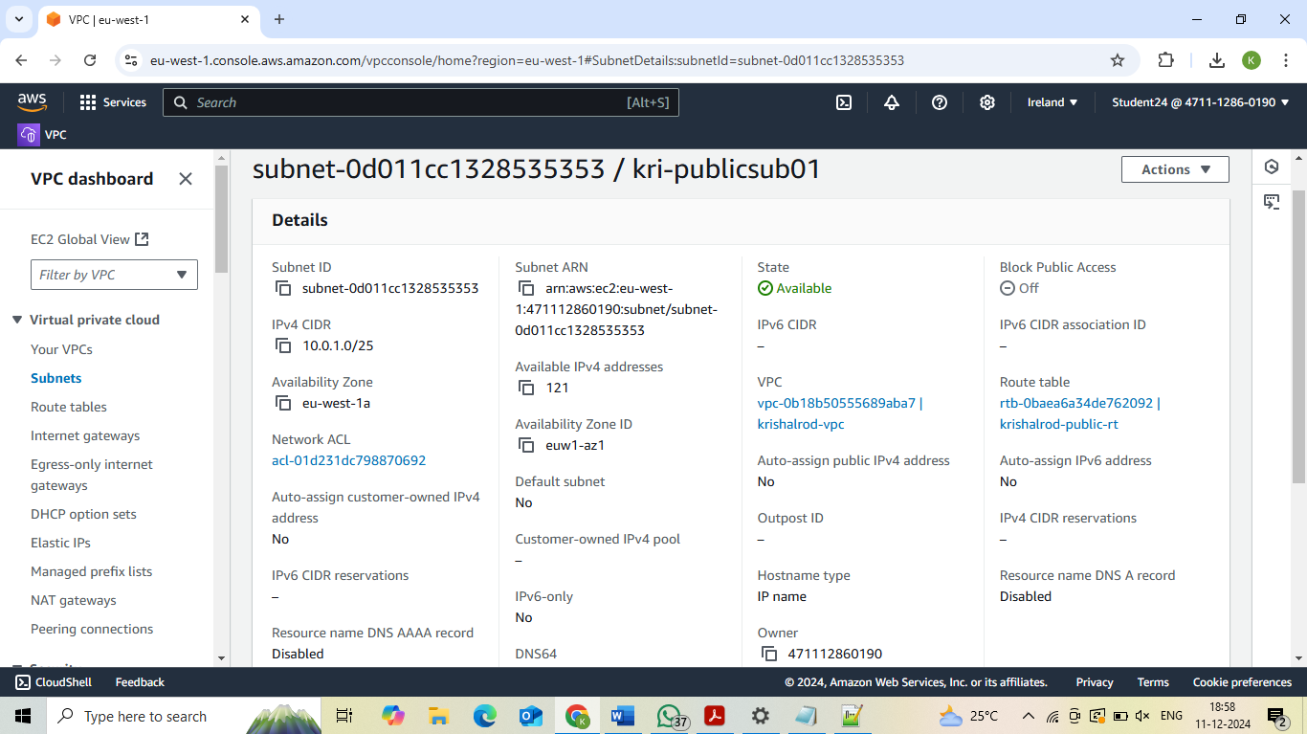

**4. Public Subnet 2**

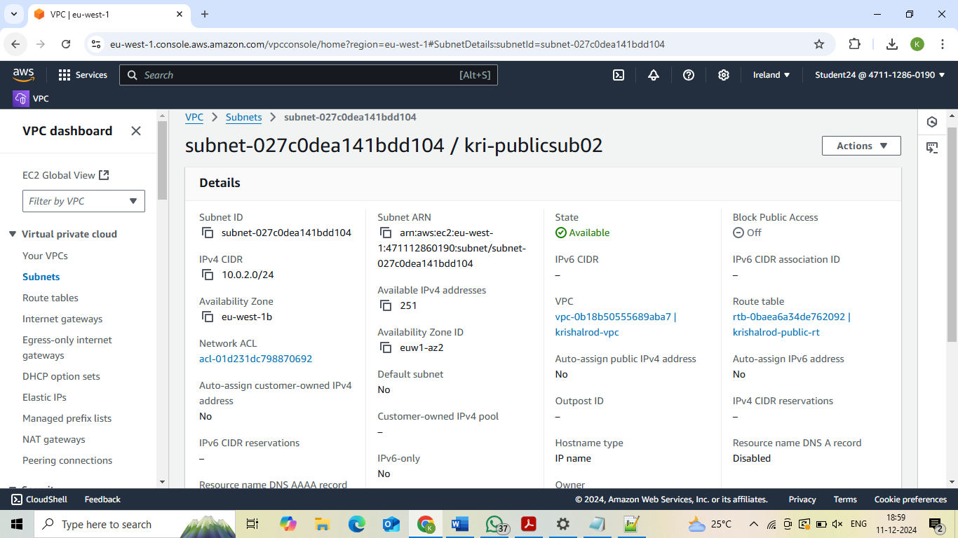

**5. Public route table:**

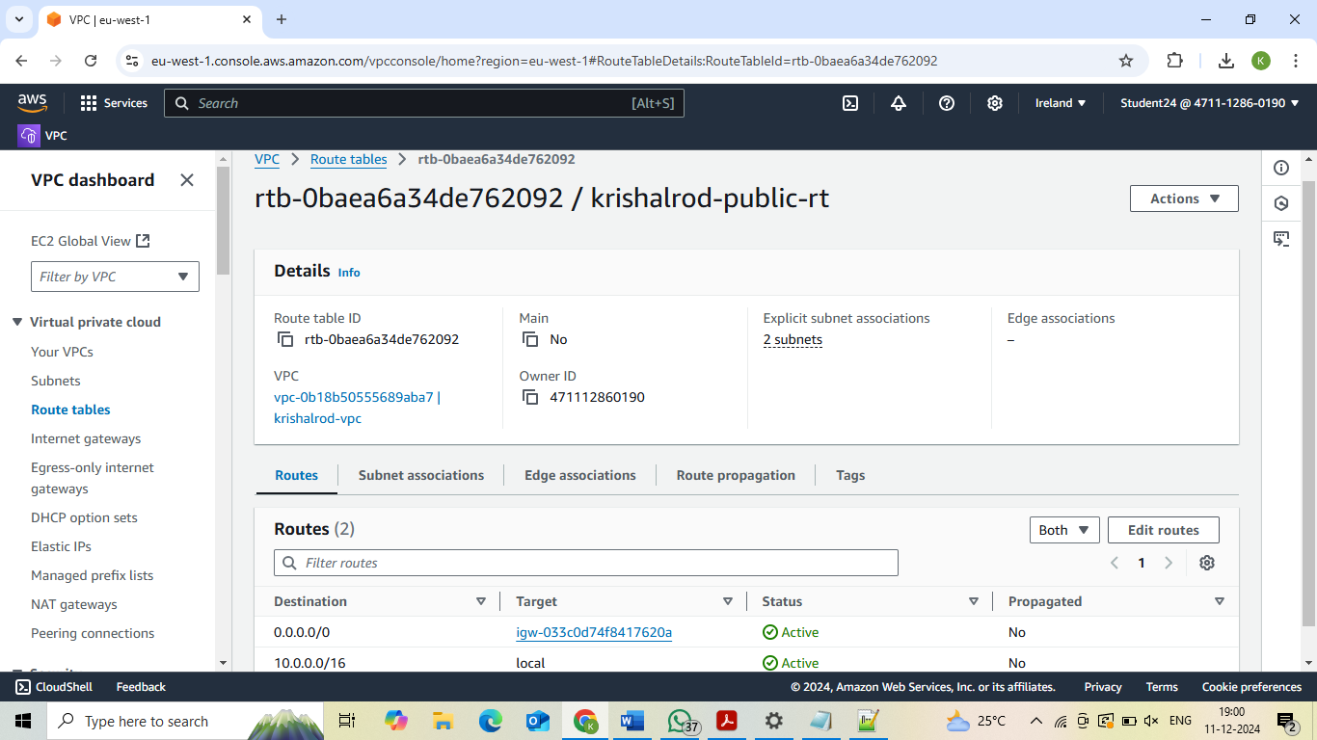

**6. Private subnet 1**

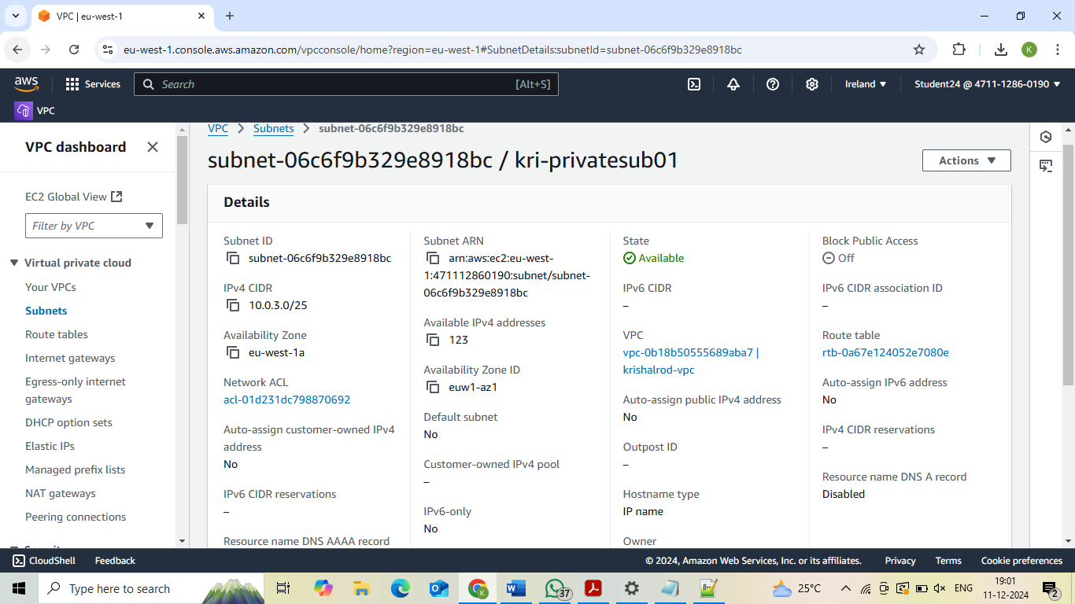

**7. Private subnet 2**

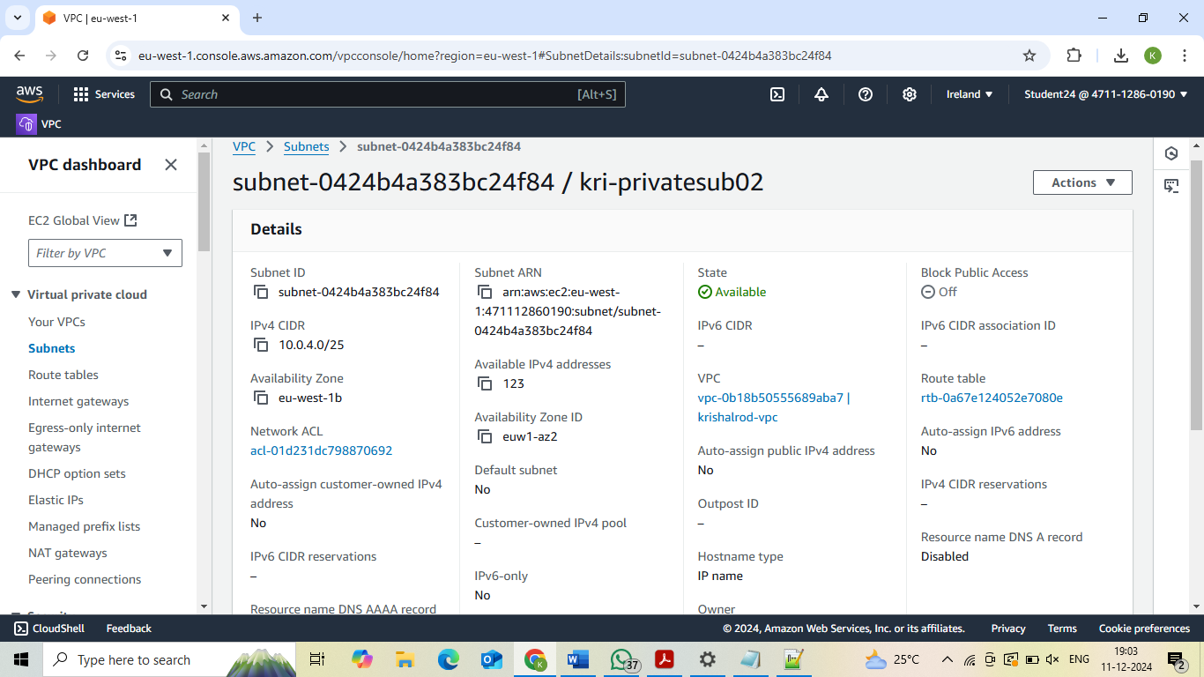

**8. Private route table**

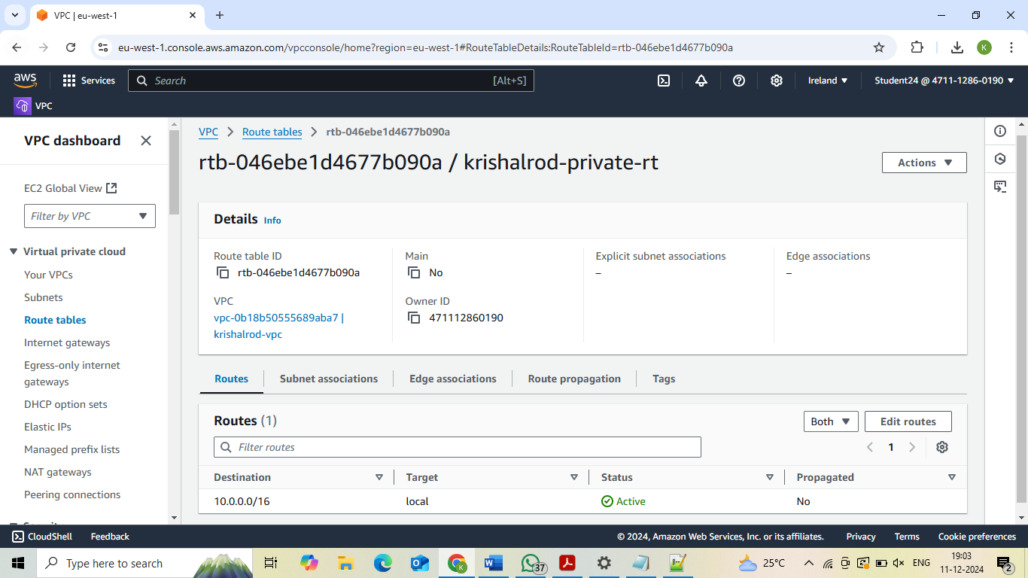

**9. NAT Gateway**

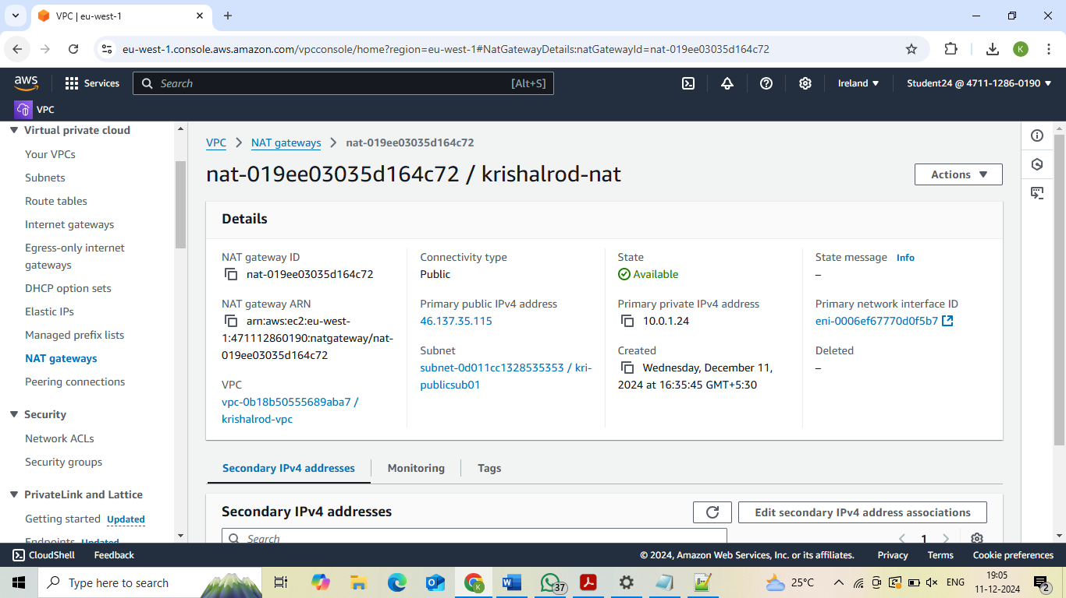

**10. Instances**

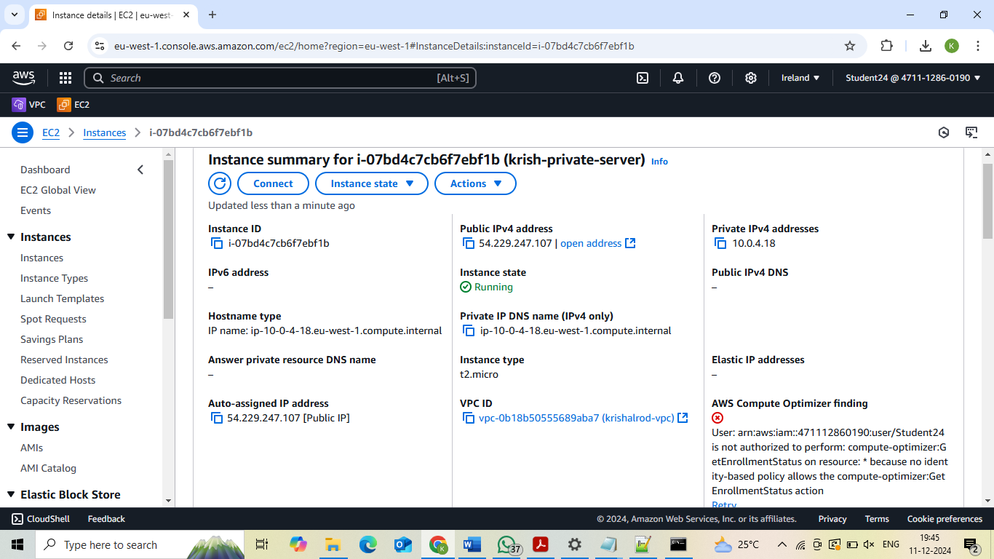

**Final Result**

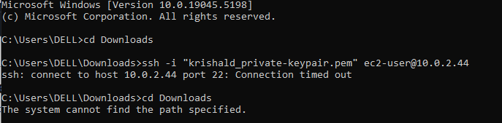

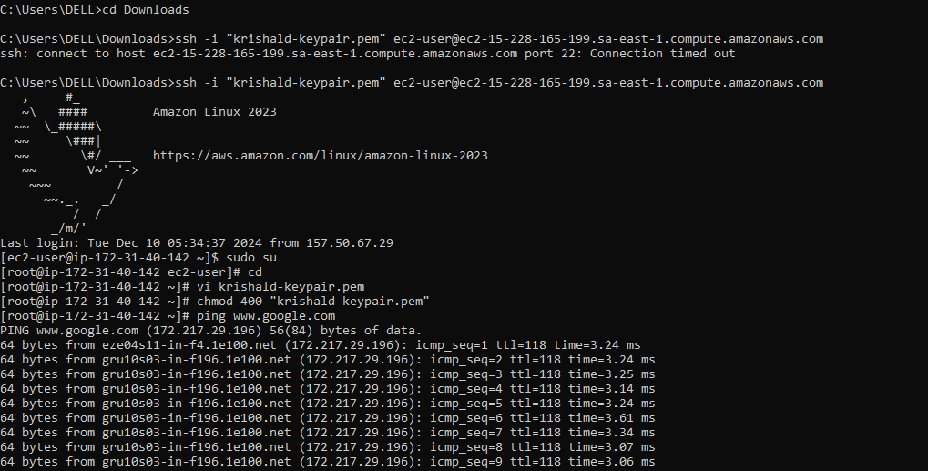

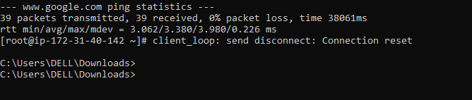

**Project 4: Hosting static website using S3 bucket**

**S3 bucket**

**Steps:**

**1. Go to search bar and type s3. Click on s3.**

**2. In S3 dashboard, go to general purpose buckets and click on create**

**bucket button.**

**3. In general configuration, select bucket type as general purpose and give**

**name as anusha04.**

**4. Click on create bucket button. Your bucket is created.**

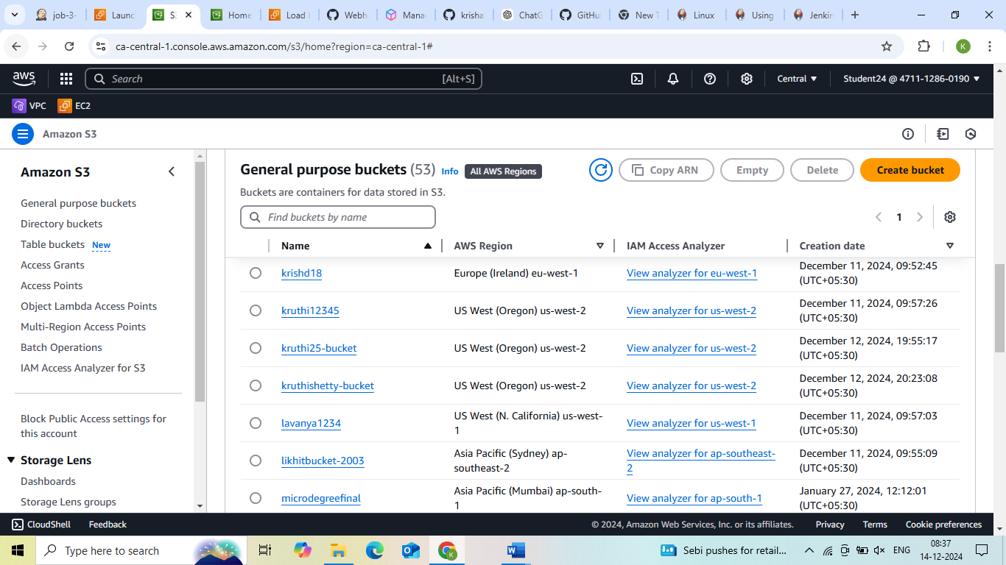

**Uploading a file:**

**Steps:**

**1. Click on created bucket.**

**2. Bucket window gets opened and click on upload button.**

**3. In upload window, select files and folders and Click on add files and**

**select the file you want to add.**

**4. Then click on upload. Your file is uploaded.**

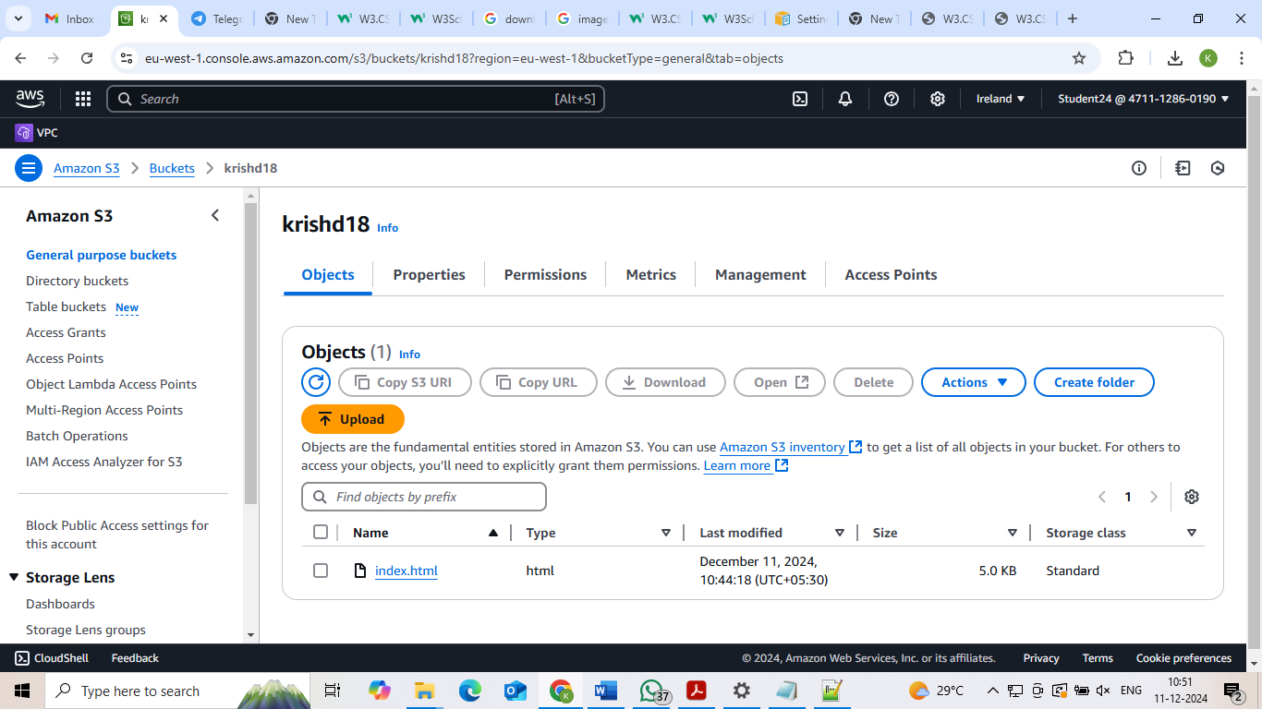

**Static website hosting:**

**Steps:**

1. **Select the properties, go to static website hosting and click on edit.**
2. **Give index document name as file name that is dailyping.html and click on save changes button.**

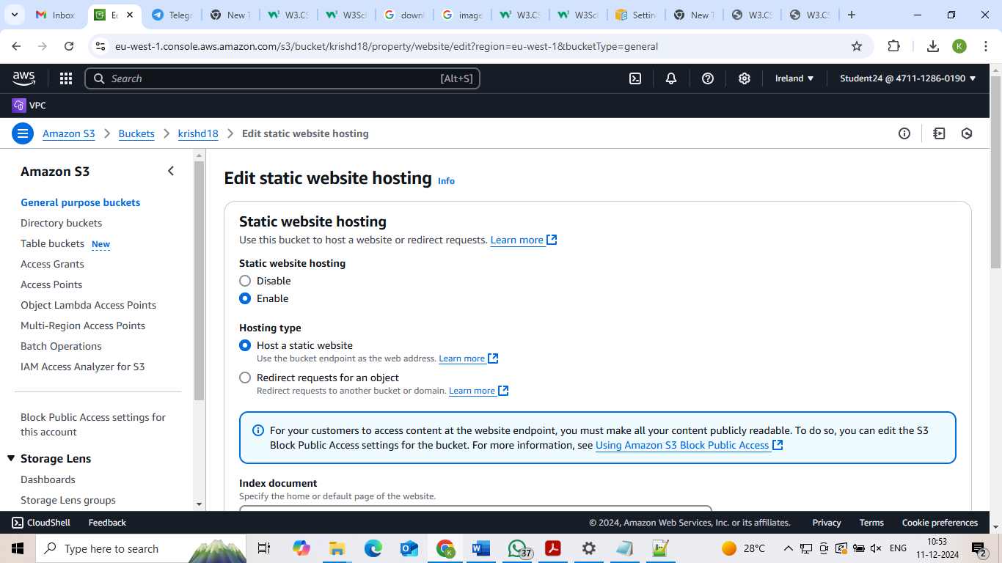

**Bucket setting:**

**Steps:**

1. **Go to permission, select block public access and click on edit.**
2. **Under block public access (bucket setting), uncheck the block all public access and click on save changes button.**

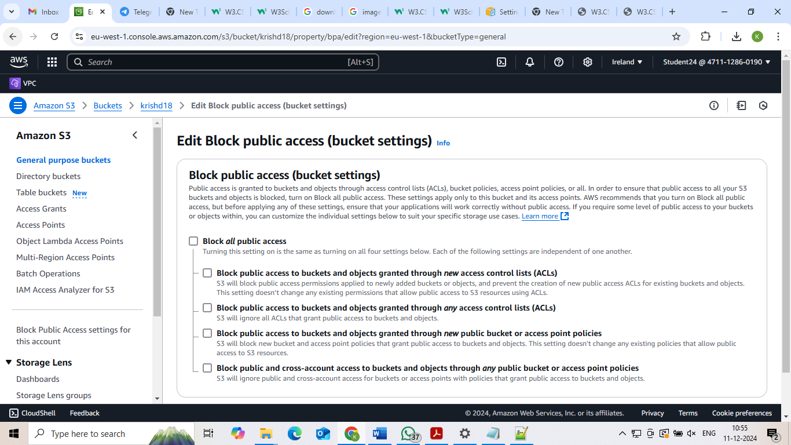

**Setting permission for website access and add bucket policy:**

**Steps:**

1. **Go to google browser and type bucket policy for static website.**
2. **You will get setting permission for website access and click on it.**
3. **You will get add a bucket policy and copy the code from the editor.**

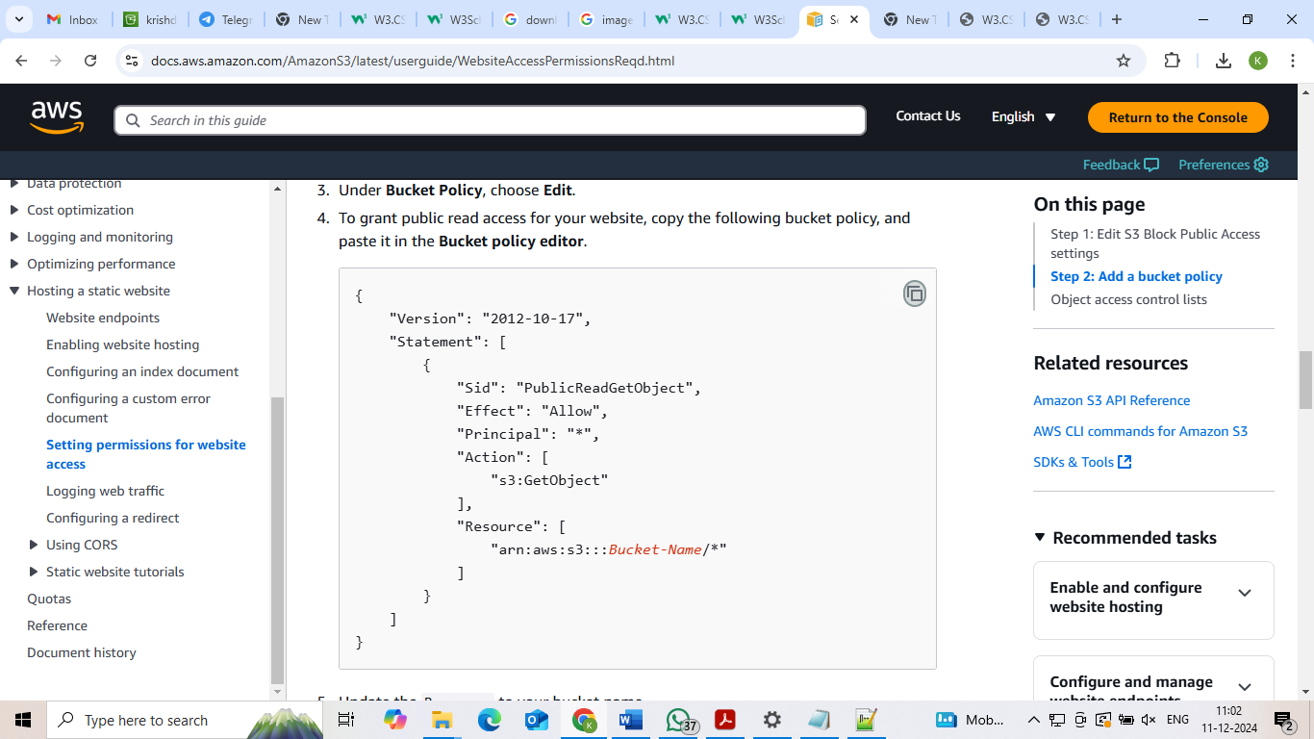

**Bucket policy:**

**Steps:**

1. **In permission, select bucket policy and click on edit.**
2. **Paste the code copied from the editor and change the ‘Bucket-Name’ as krishal18 (created bucket name).**

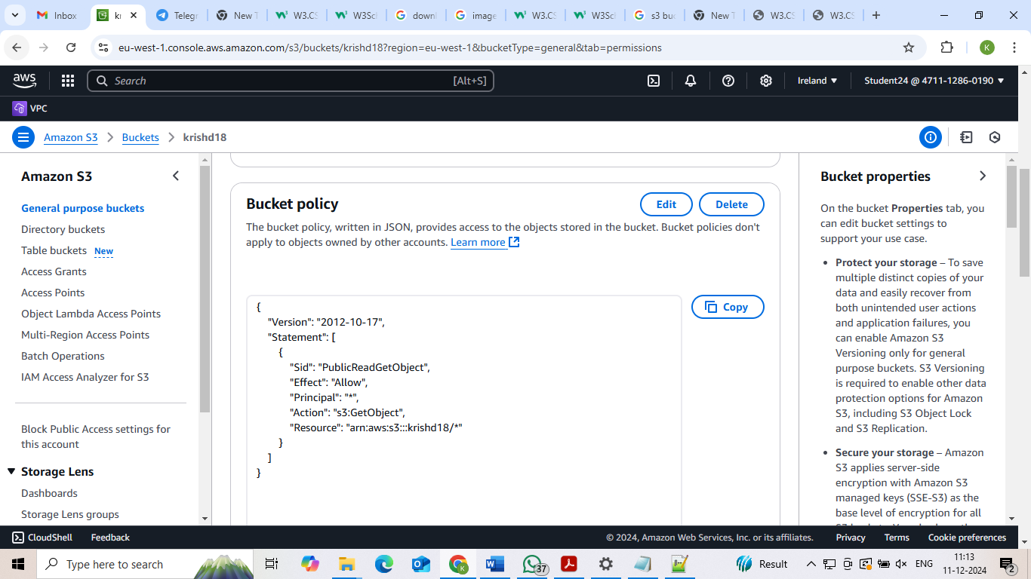

**Static website hosting url:**

**Steps:**

1. **In properties, under static website hosting, copy the bucket website endpoint url and paste it on google browser.**

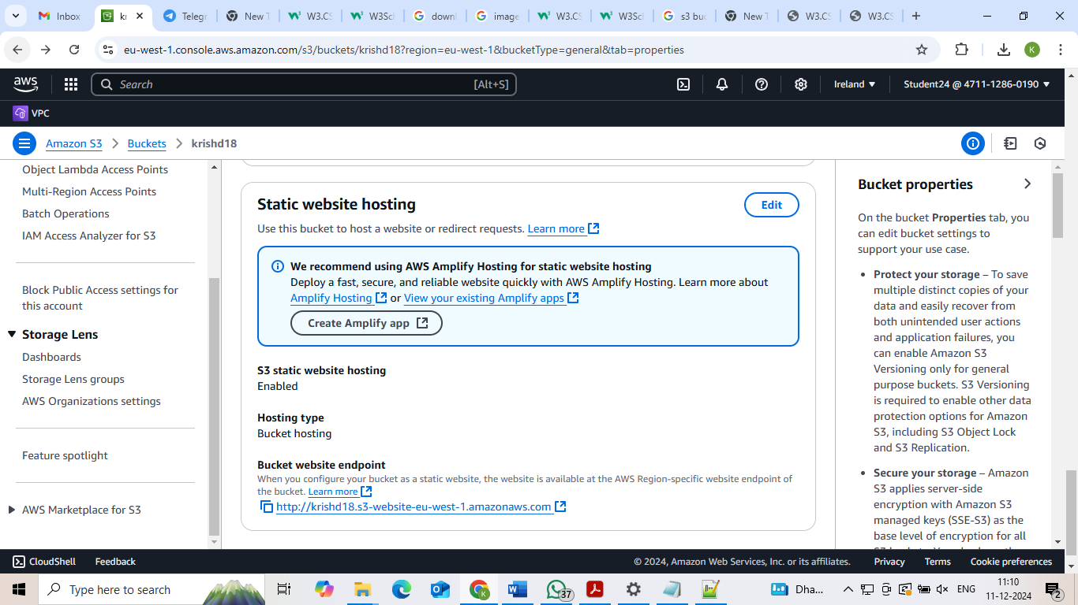

**Final Result**

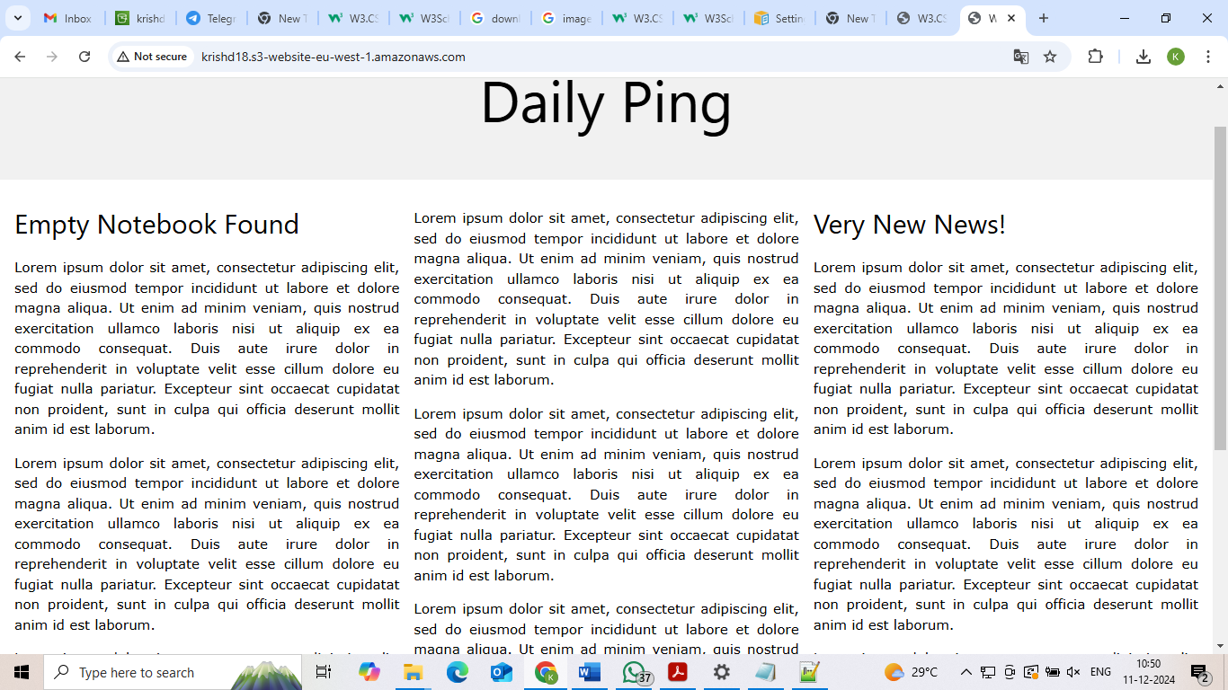

**Project 5:Launching the website using Load Balancer DNS Name**

**1. Virual Private Cloud**

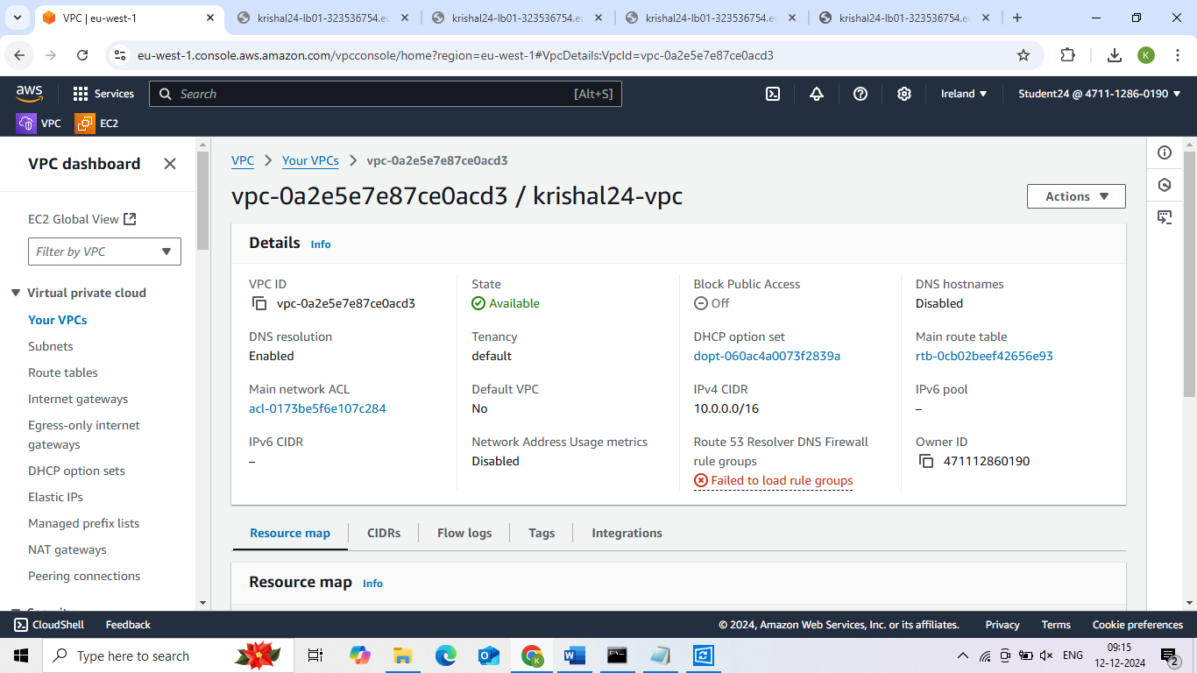

**2. Public Subnet1**

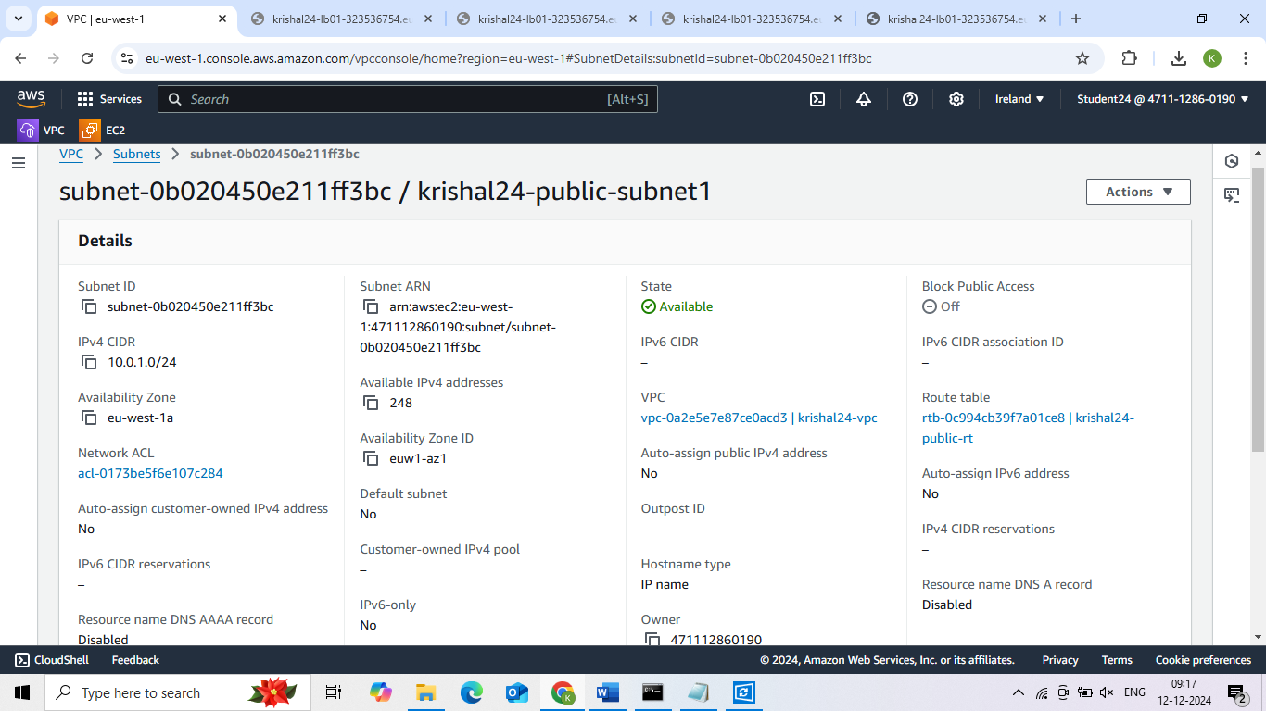

**Public Subnet2**

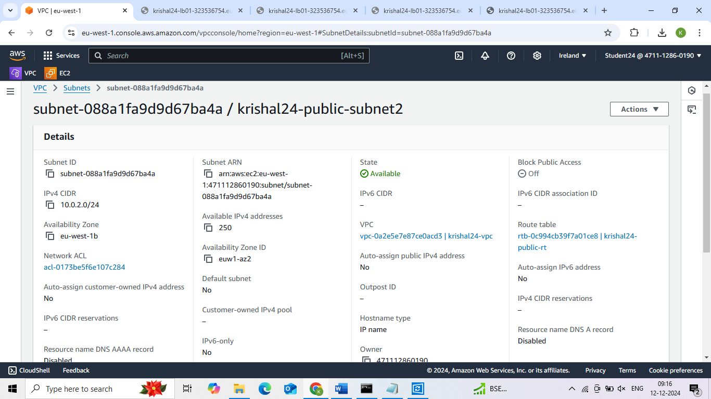

**3. Private Subnet1**

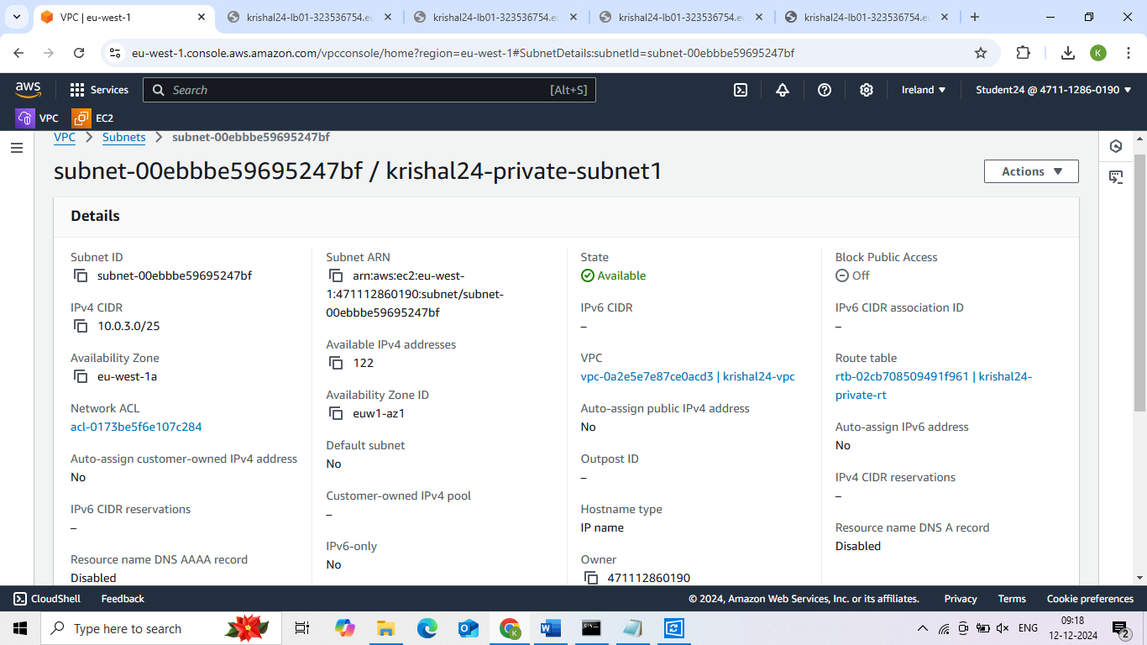

**Private Subnet2**

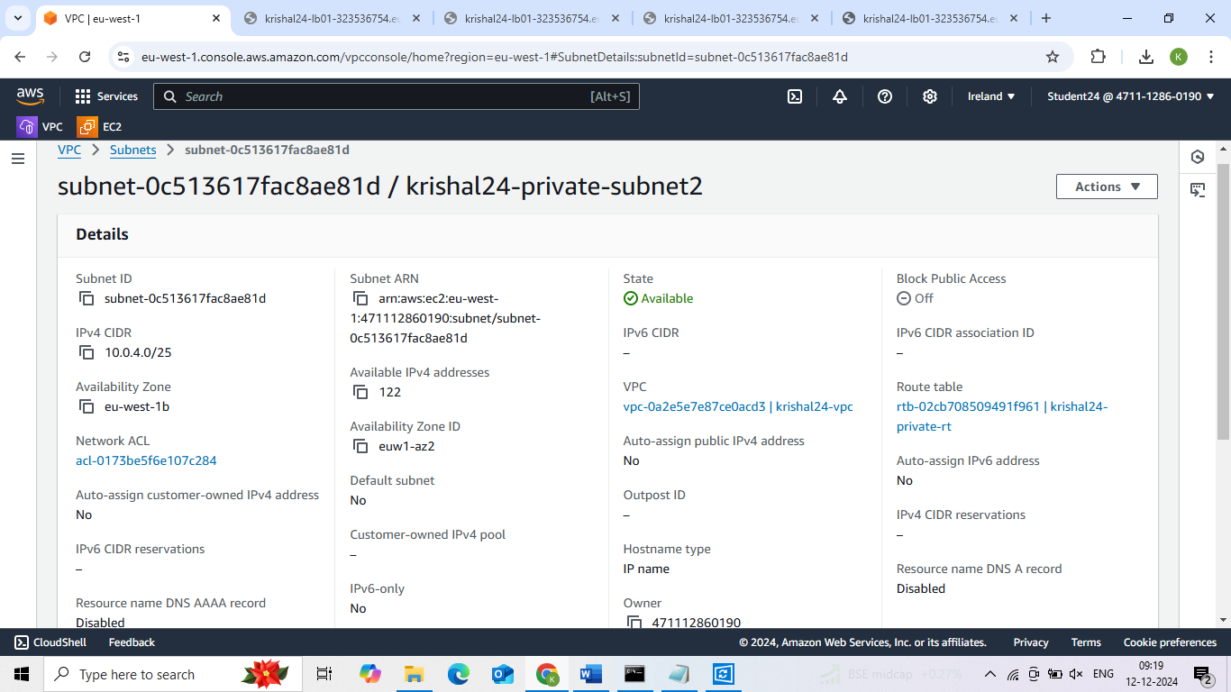

**4. Public Route**

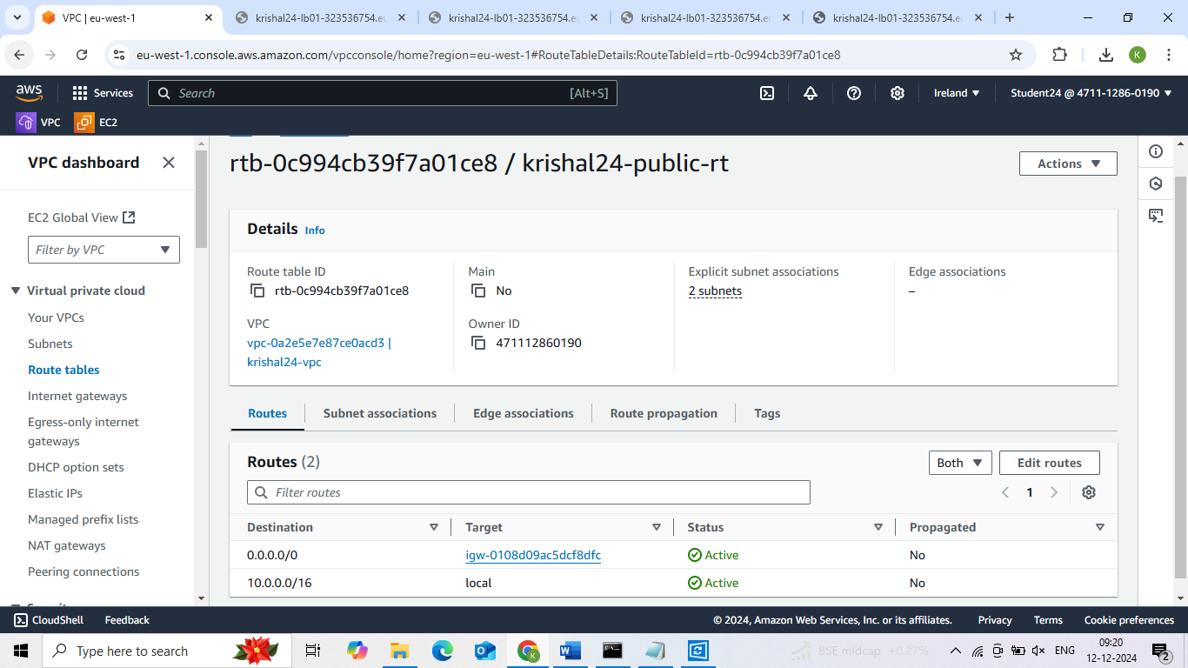

**5. Private Route**

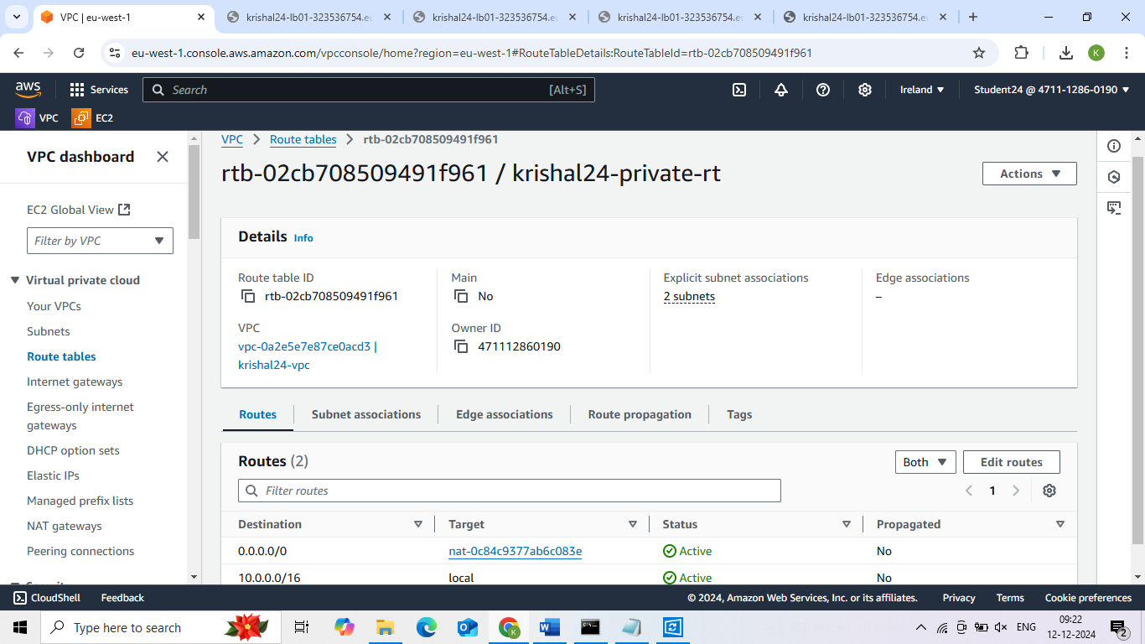

**6. Internet Gateway**

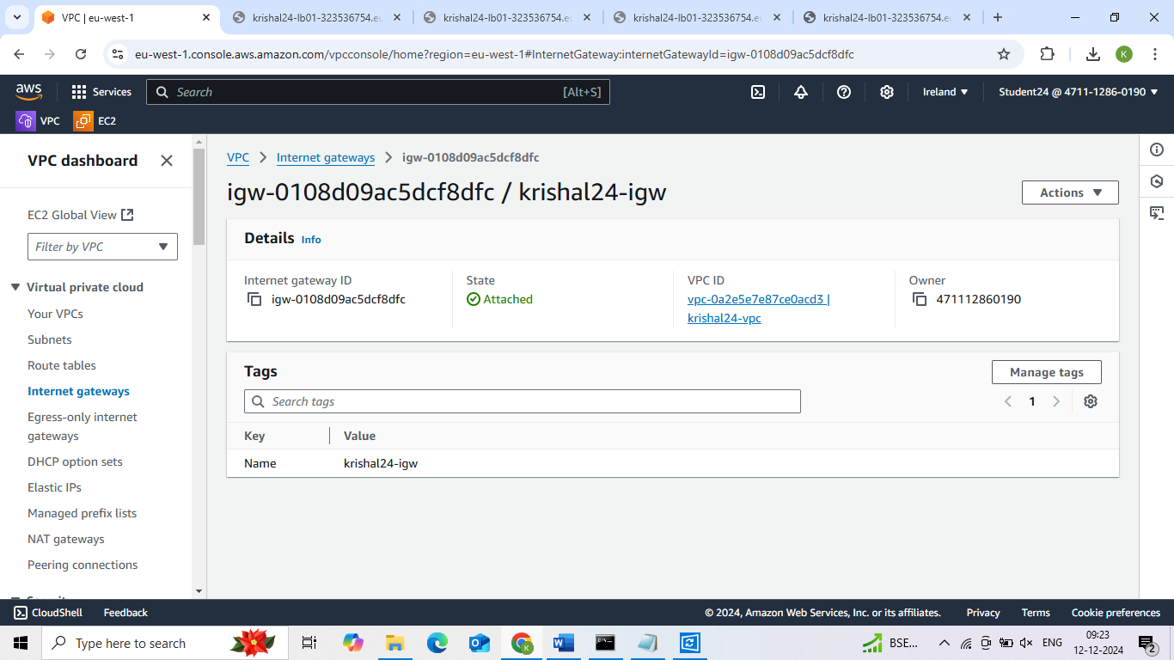

**7. NAT Gateway**

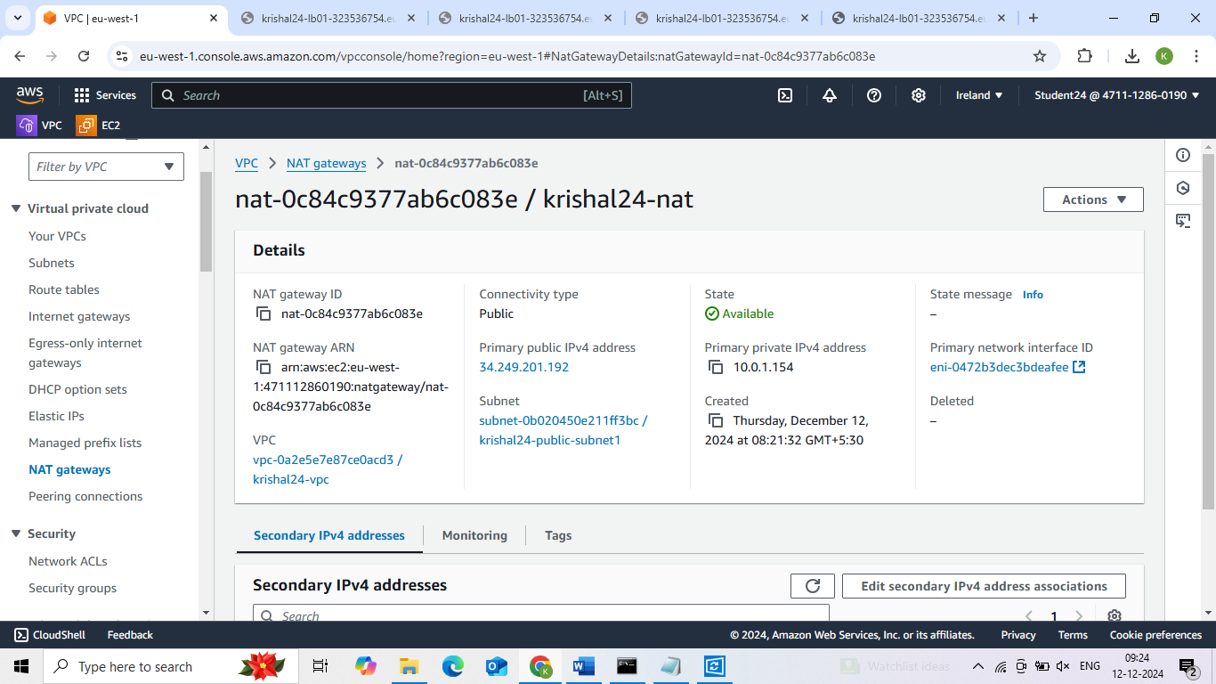

**8. Instance private server 1**

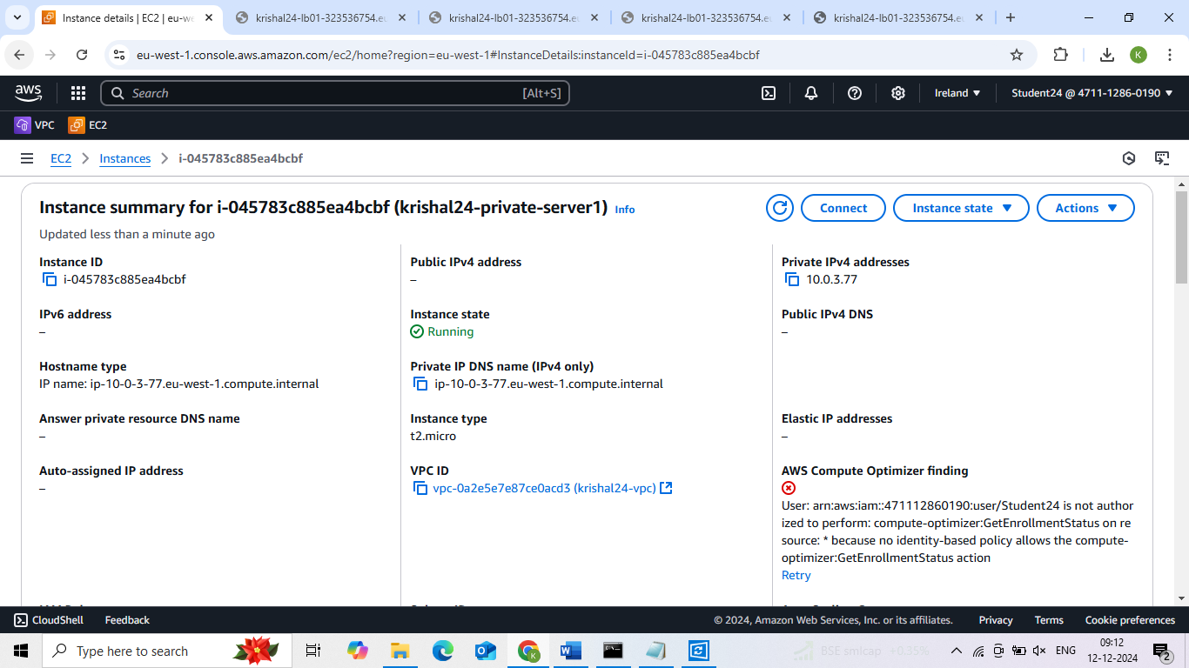

**Instance private server 2**

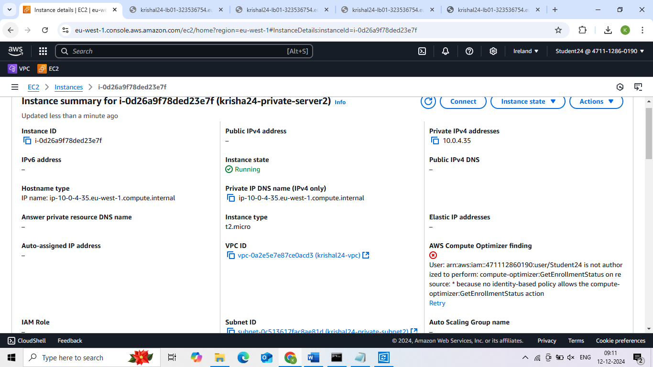

**Instance jump server**

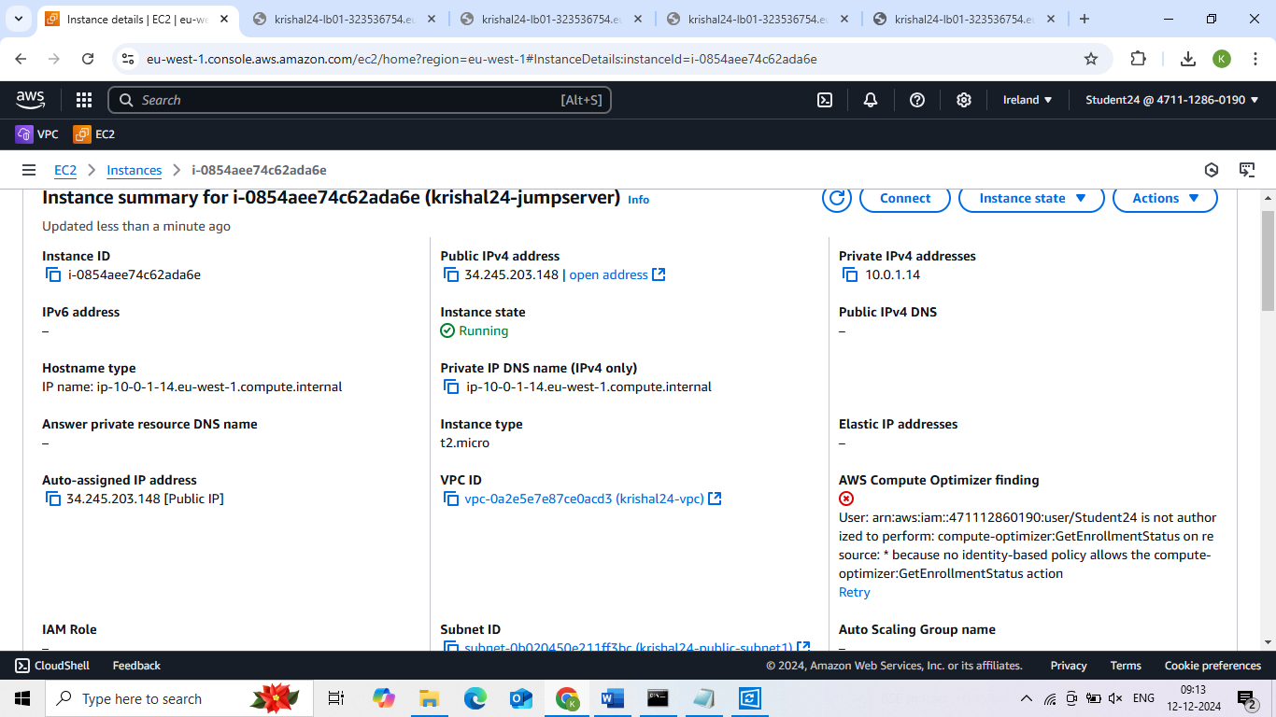

**9. Security Group**

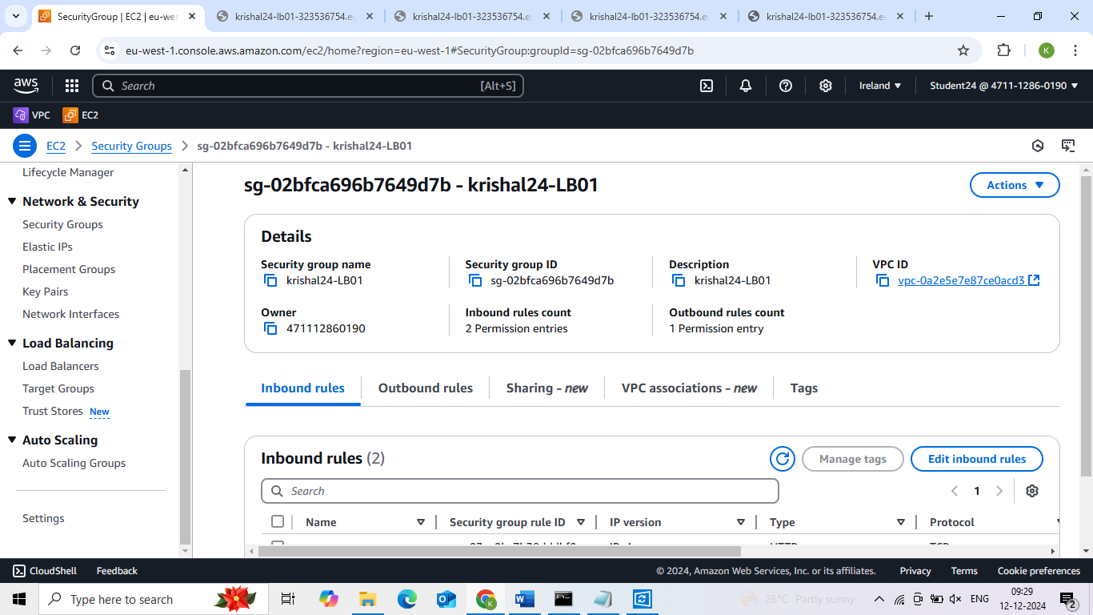

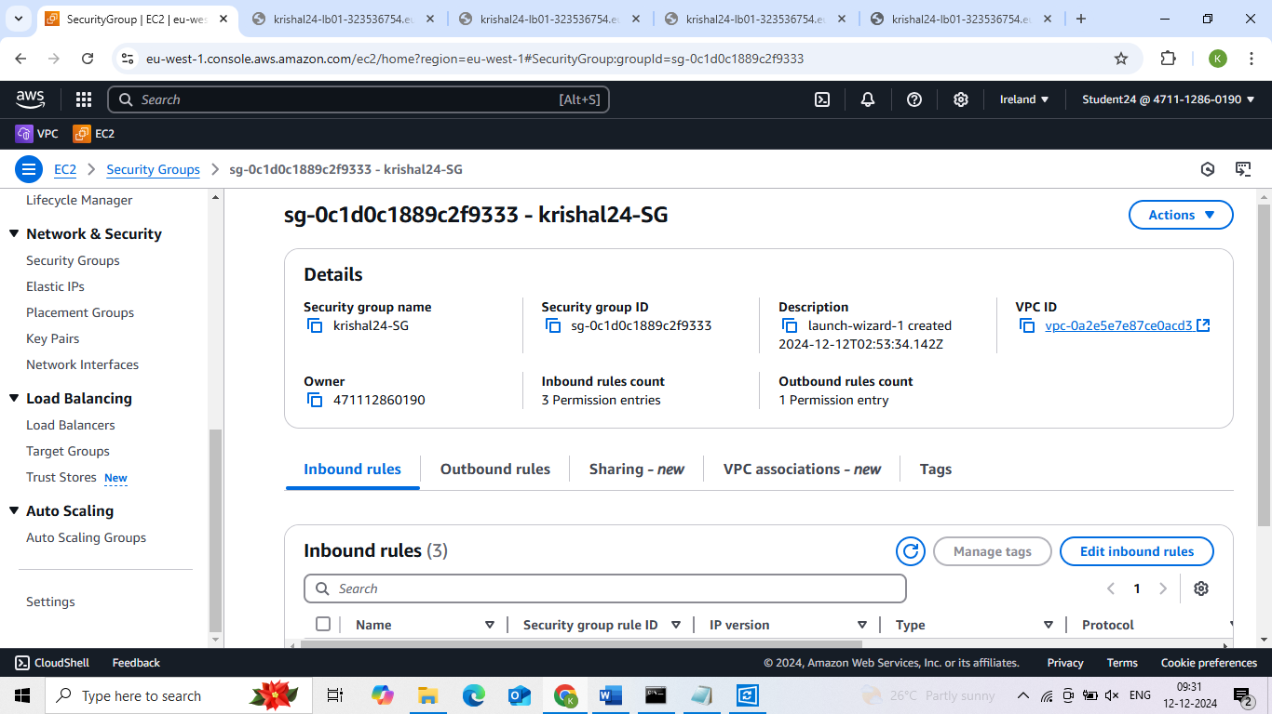

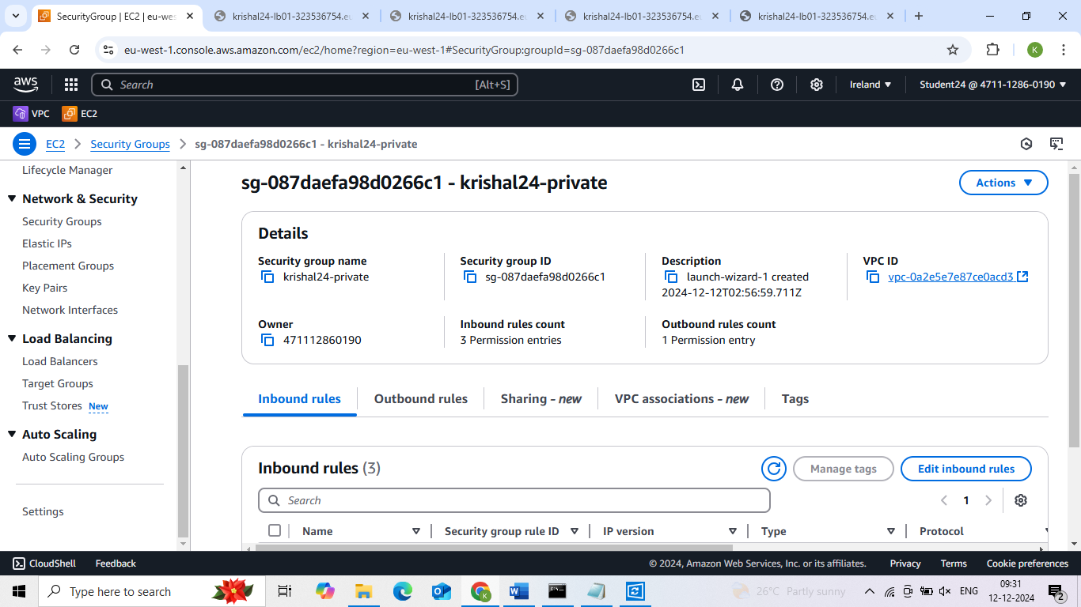

**10. Target Group**

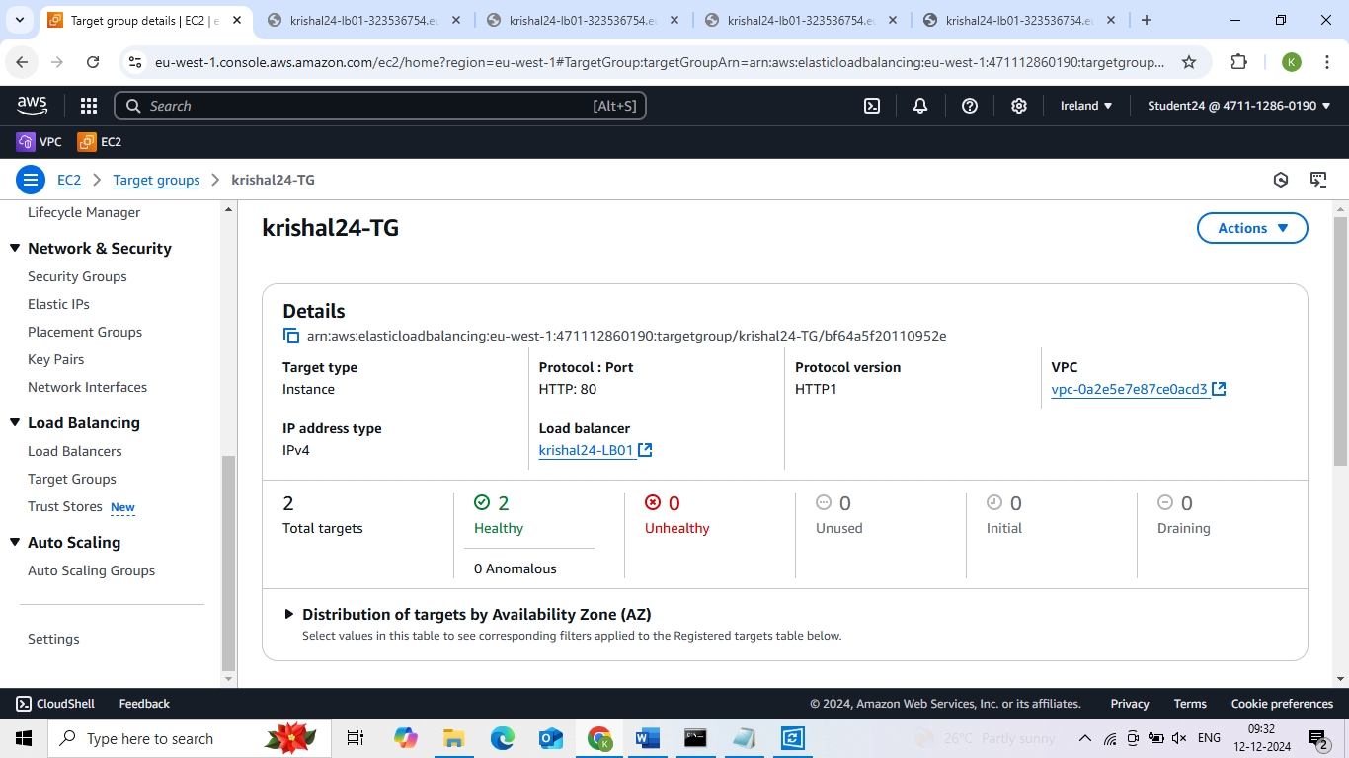

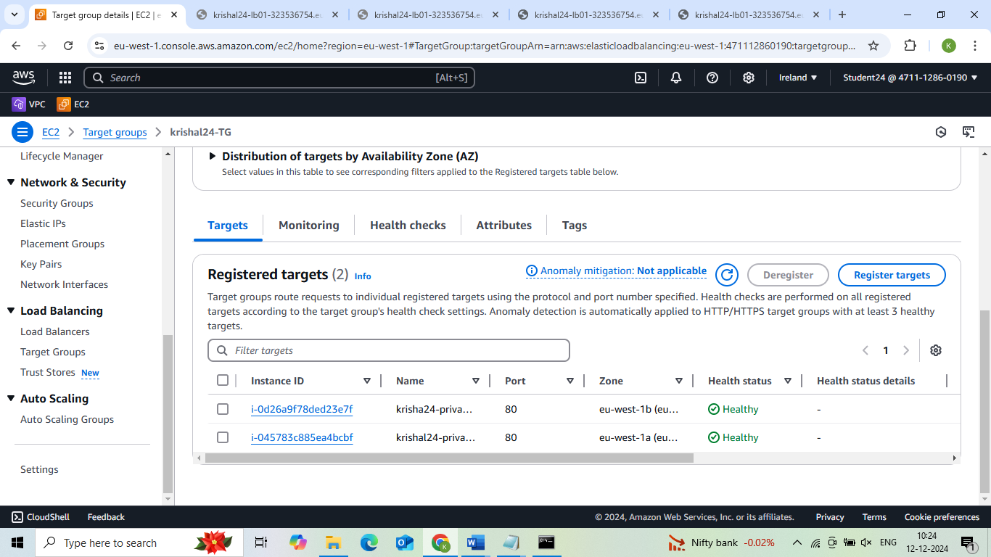

**11. Load balancer**

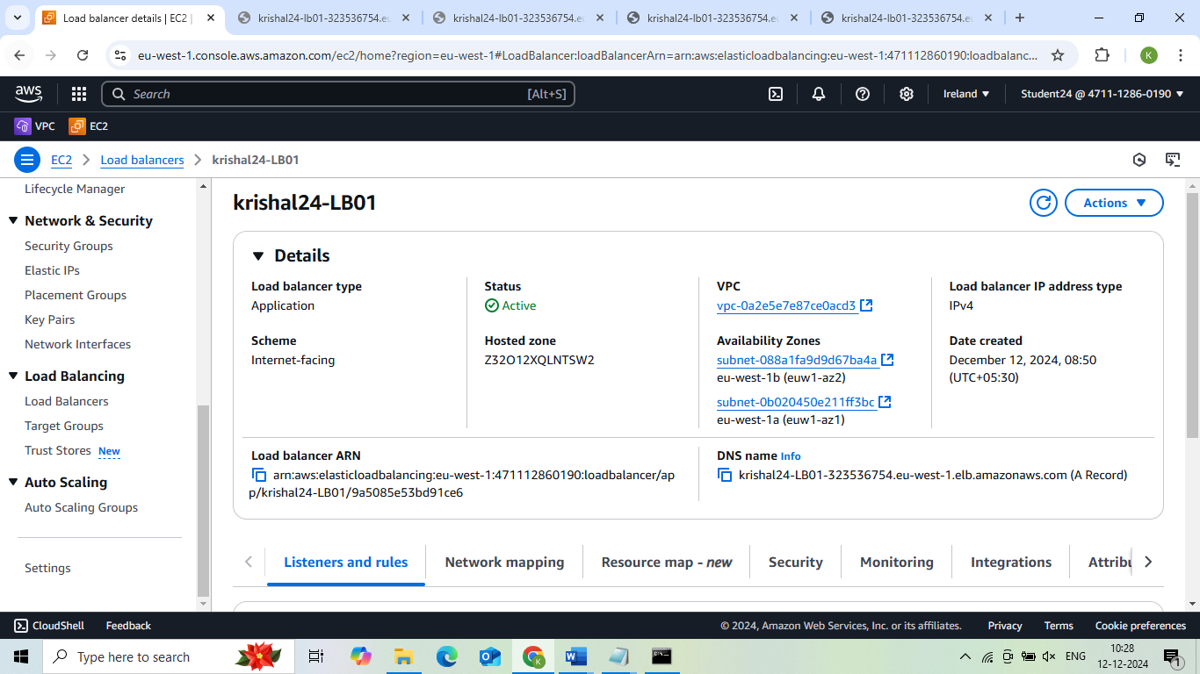

**12. Command prompt**

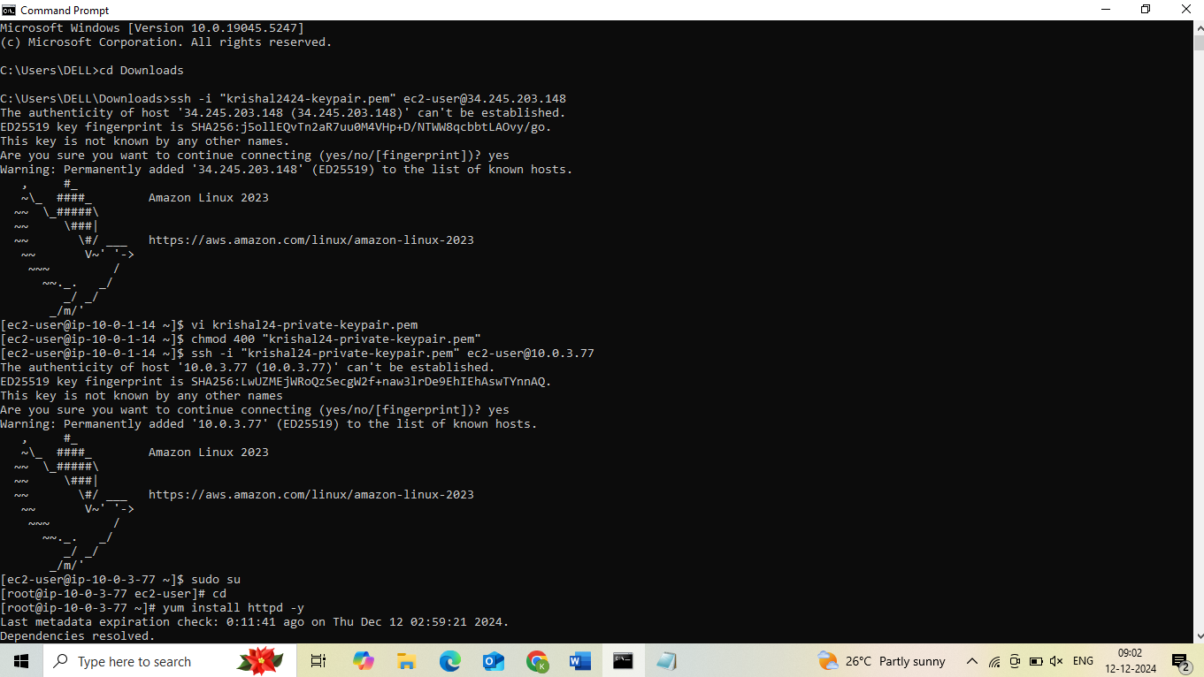

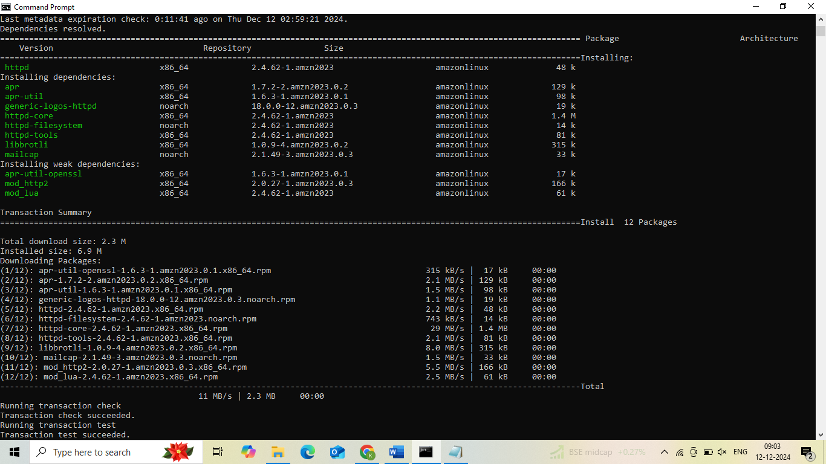

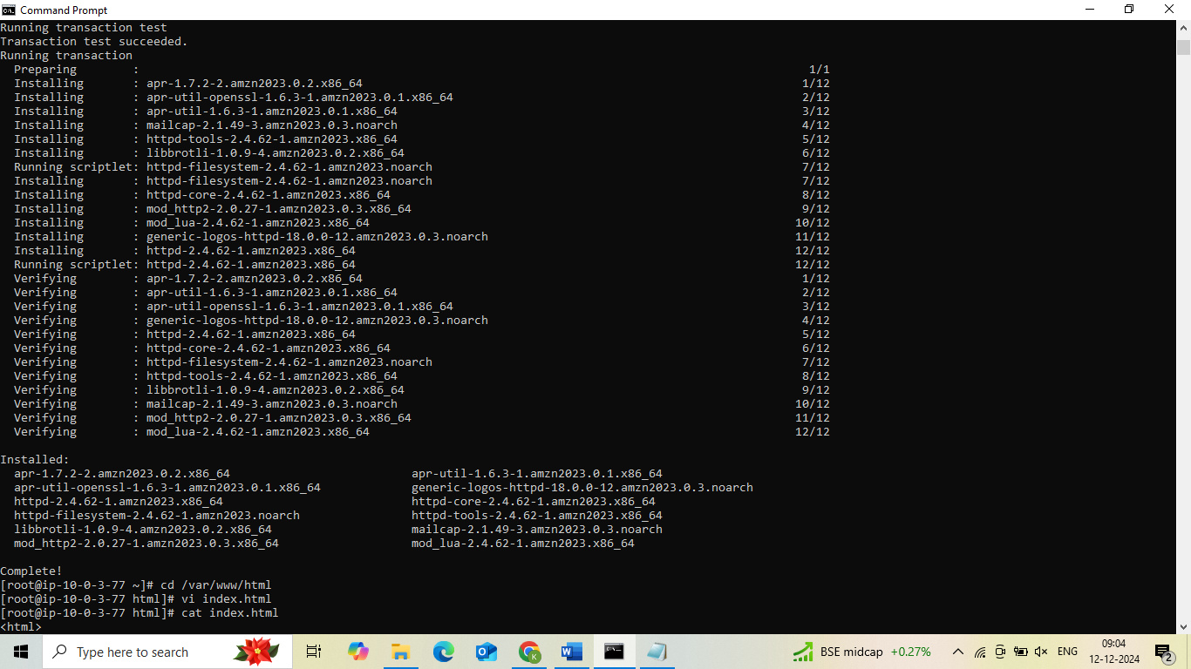

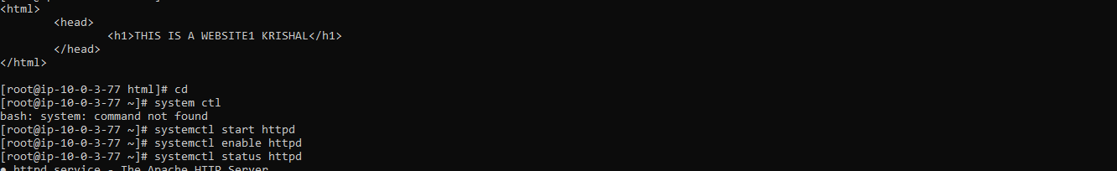

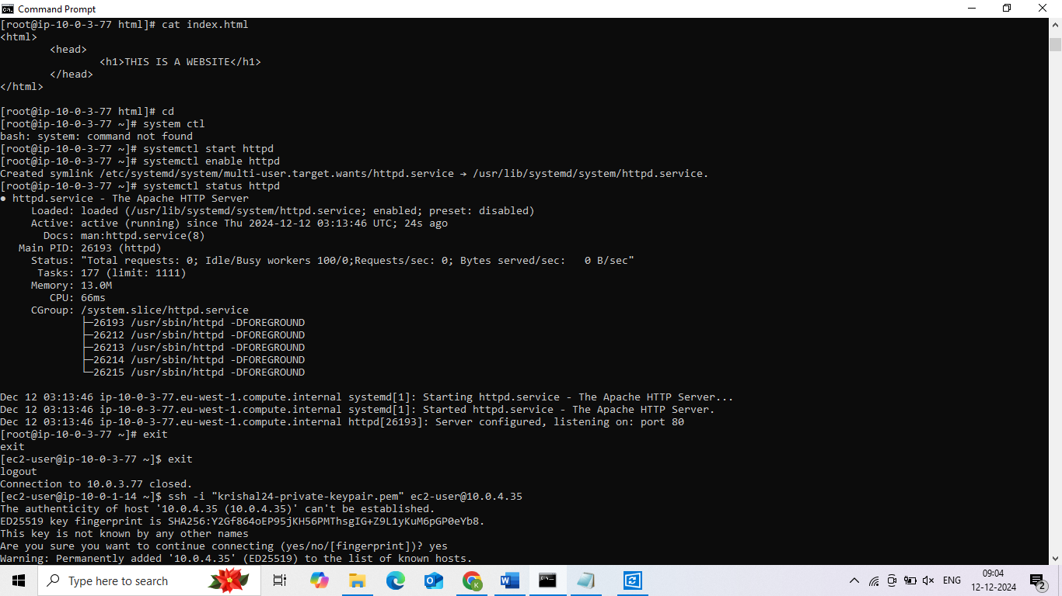

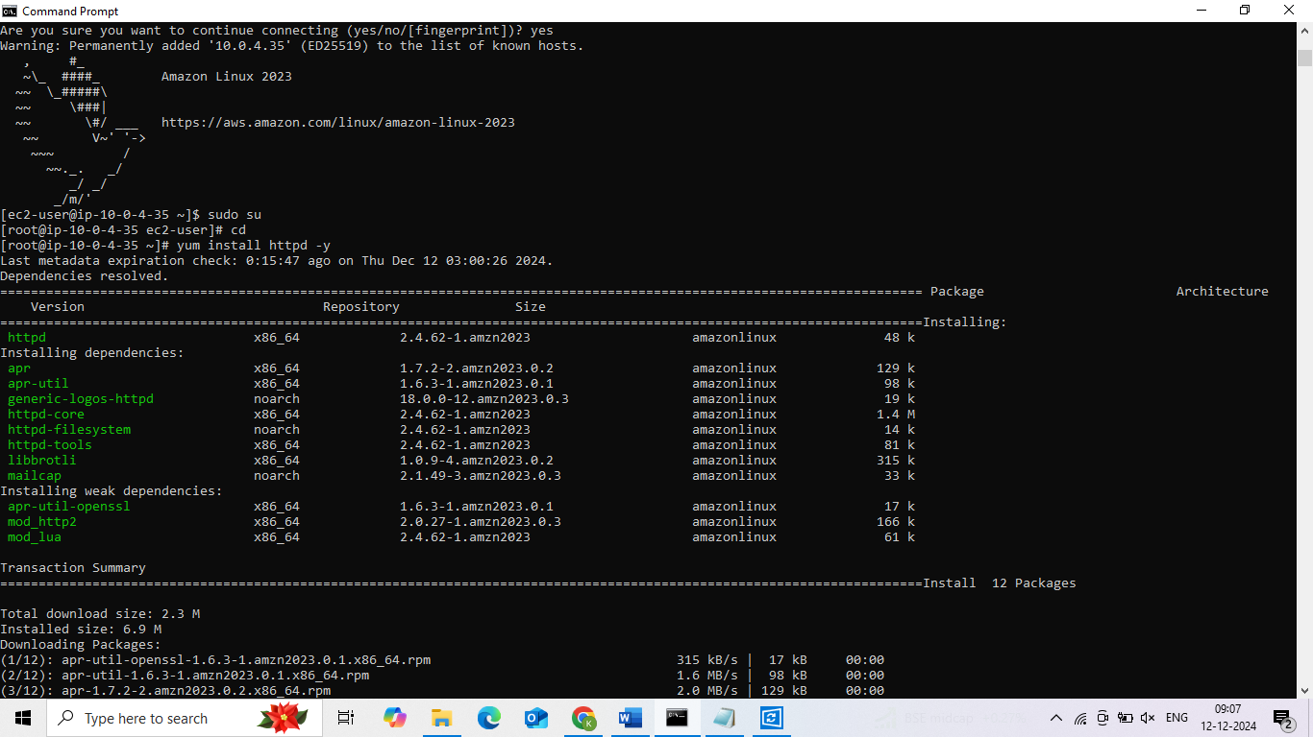

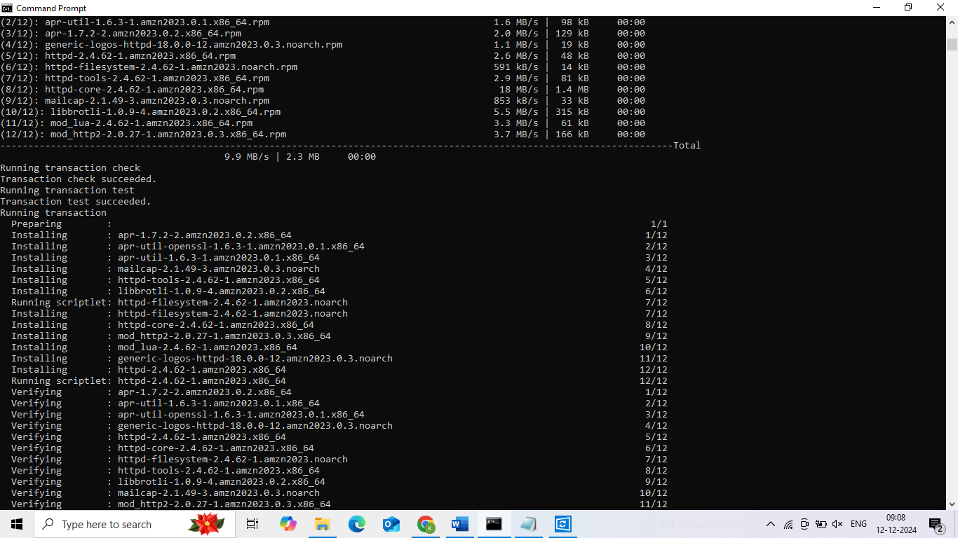



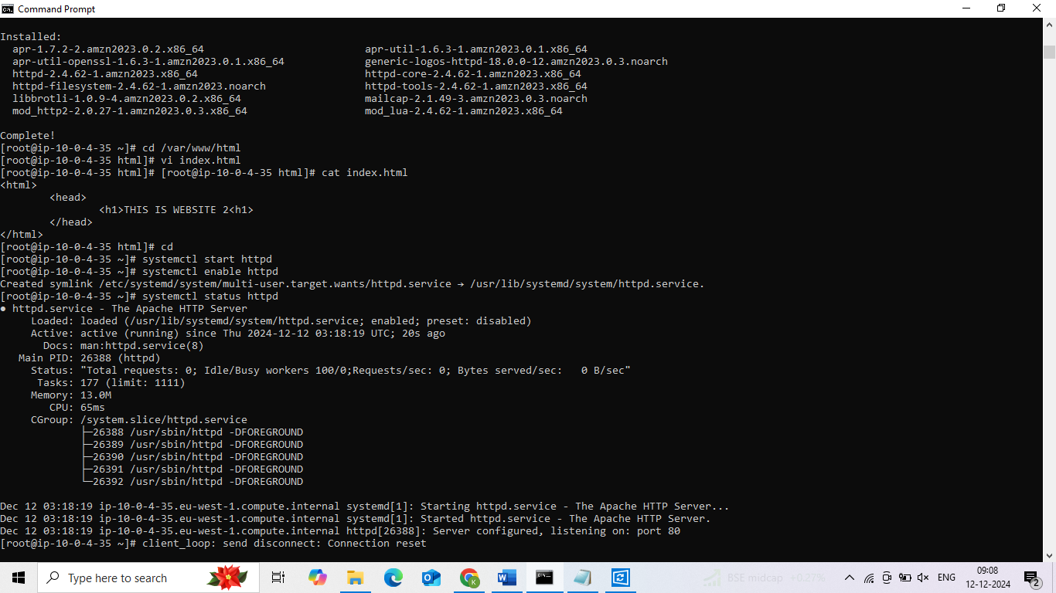

**13. Final Result**

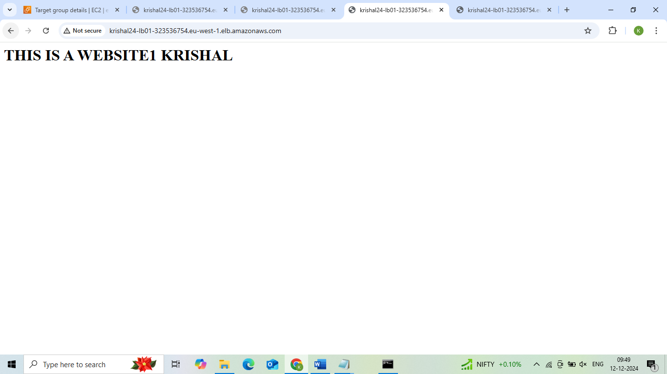

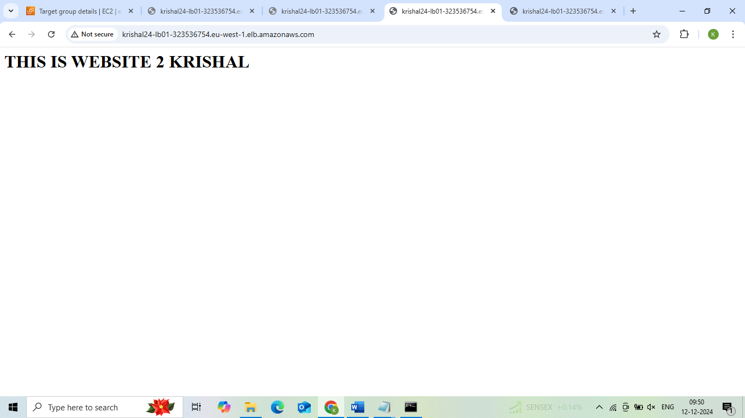

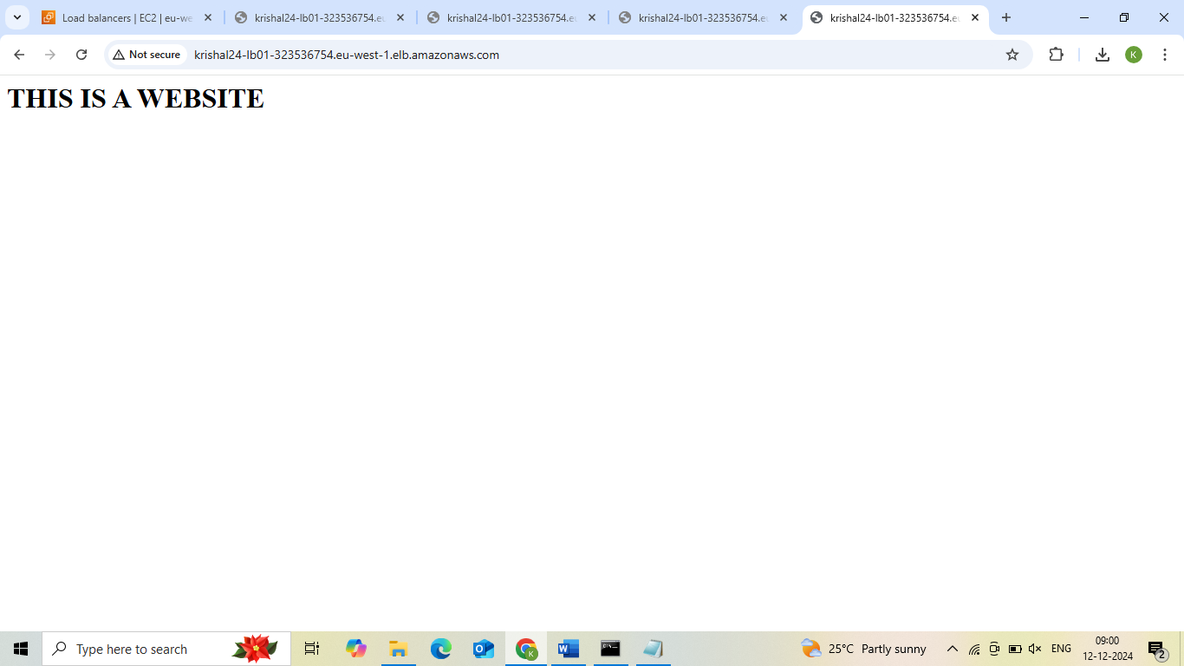

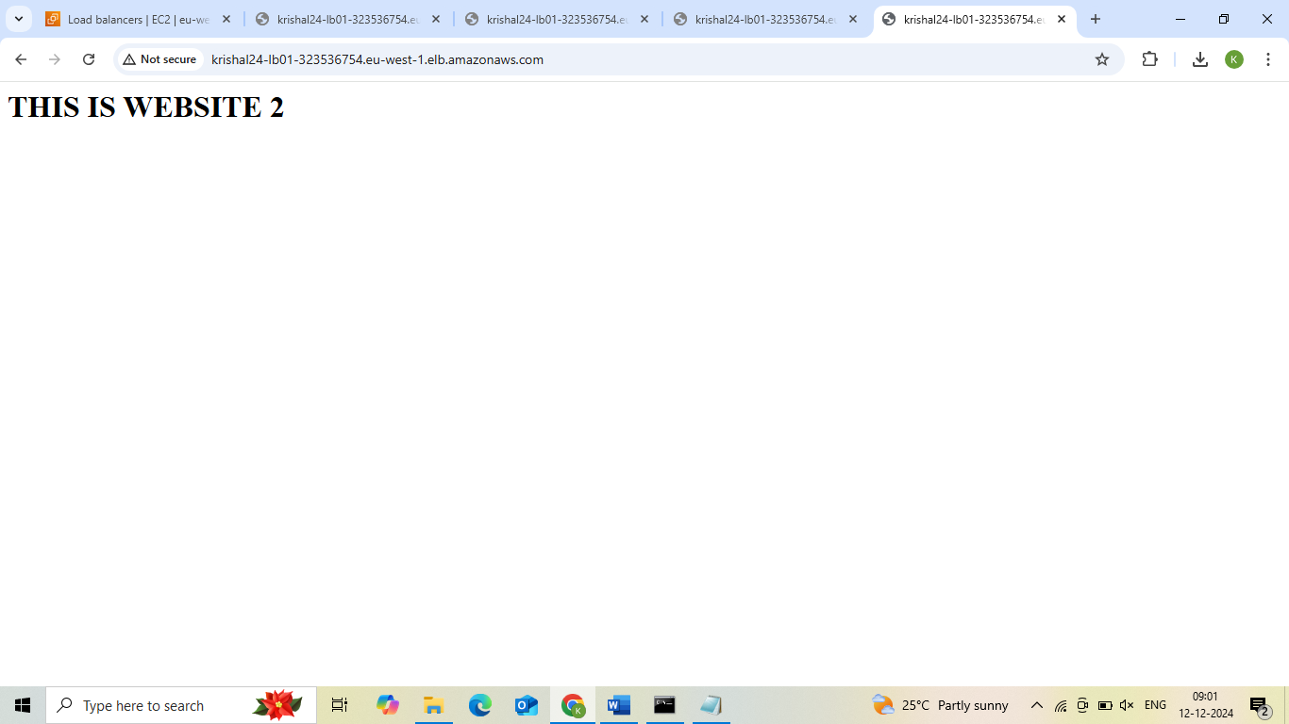

**Project 6:How to create a repository GitHub**

**1. Virtual Private Cloud**

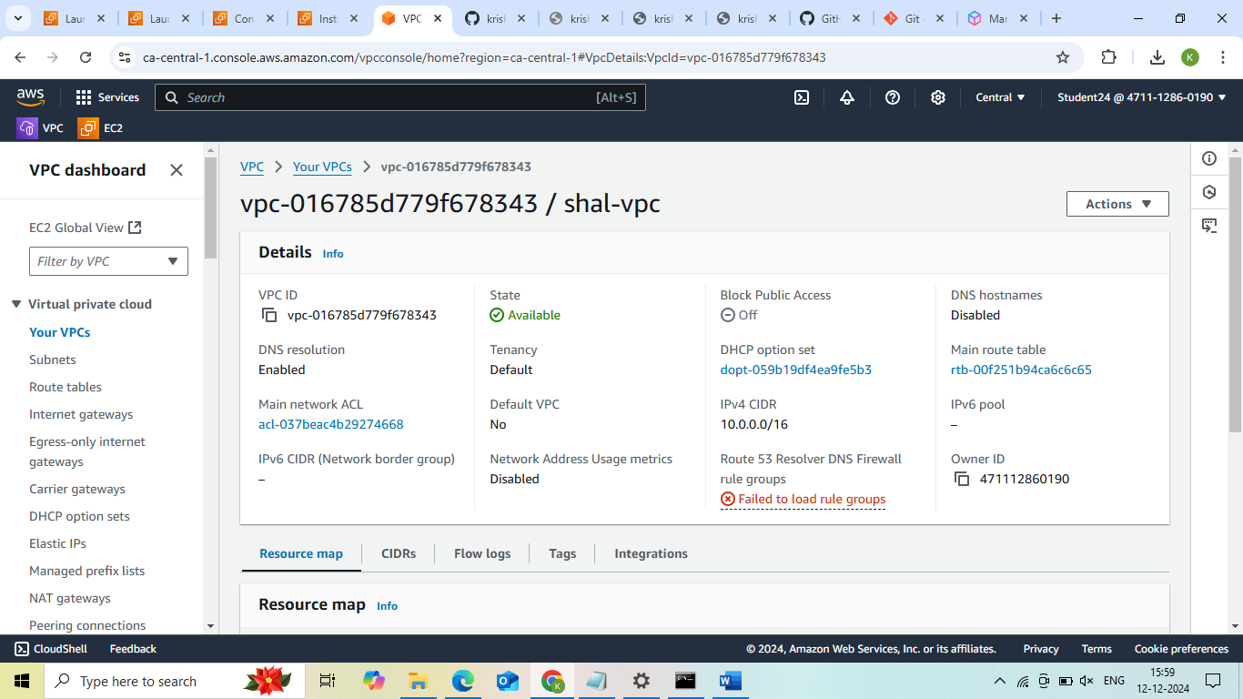

**2. Public subnet1**

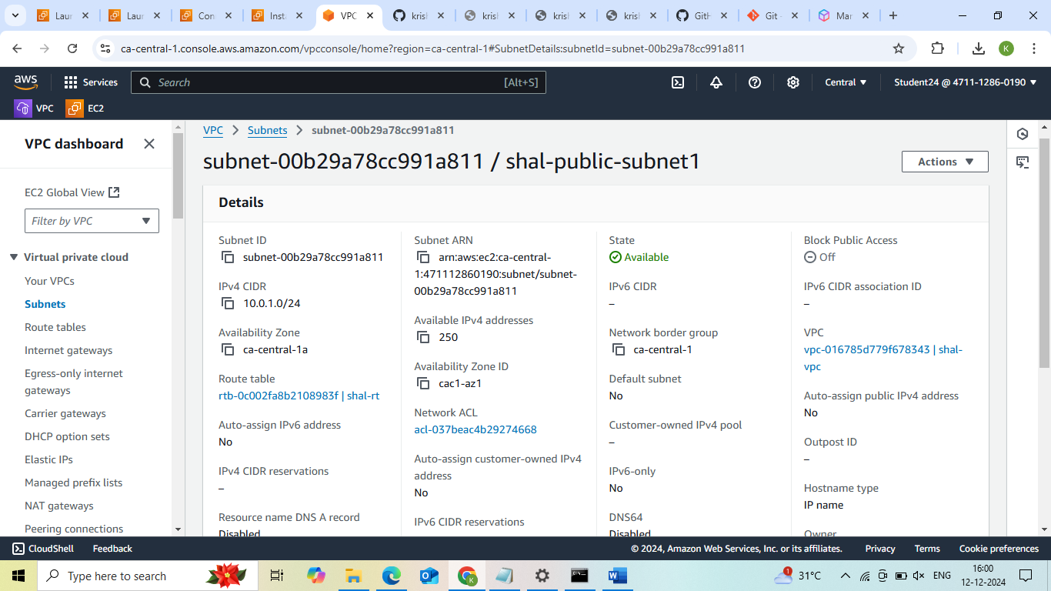

**3. Public subnet2**

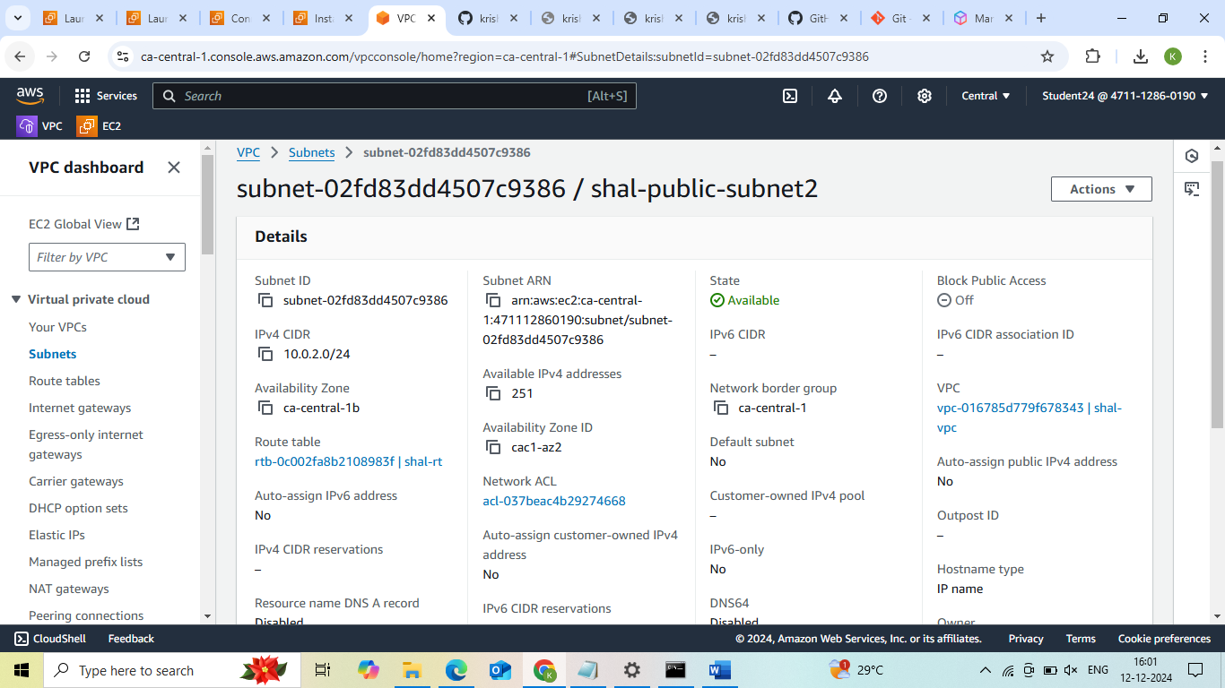

**4. Route Table**

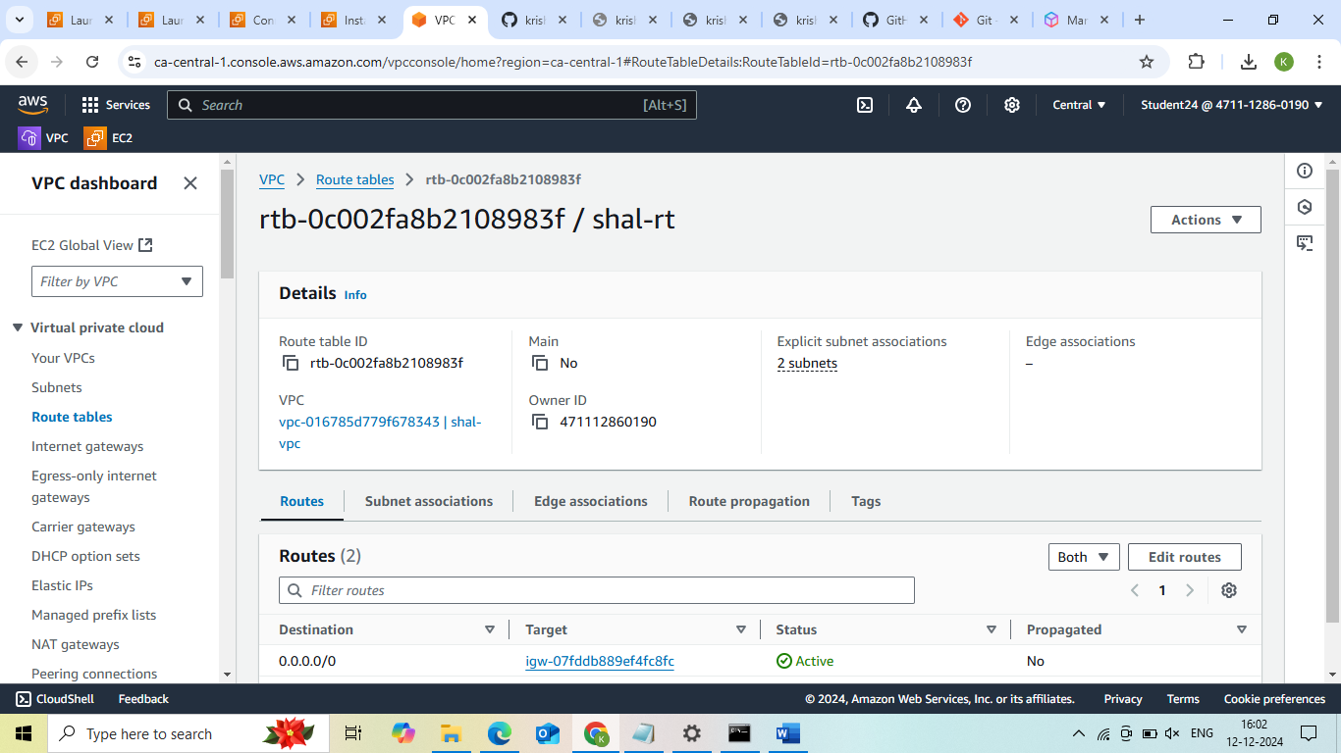

**5. Internet Gateway**

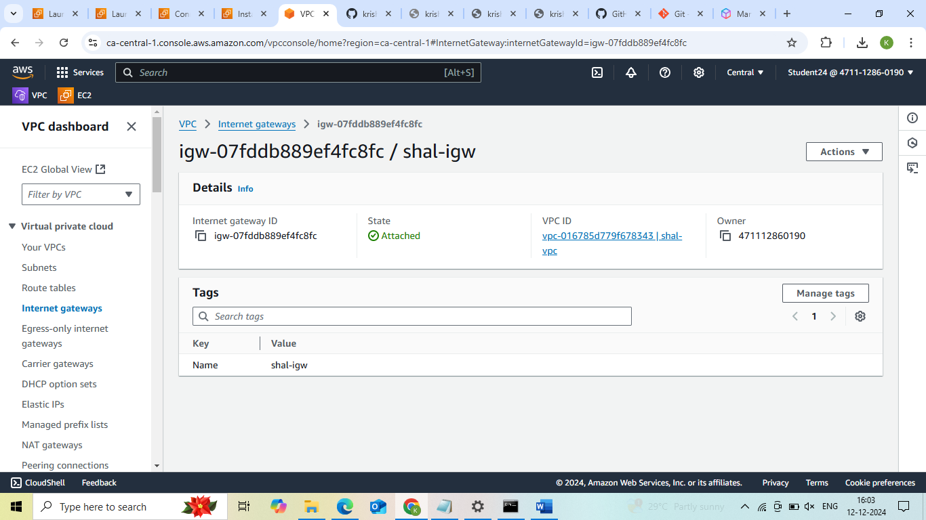

**6. Instance**

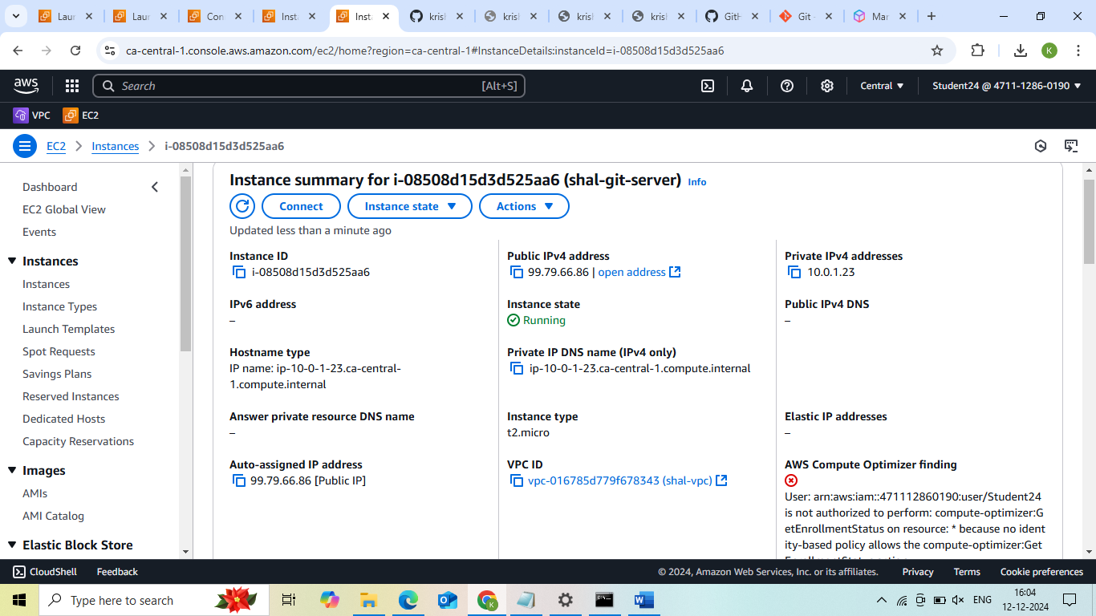

**7. Command Prompt**

**How to create repository git hub**

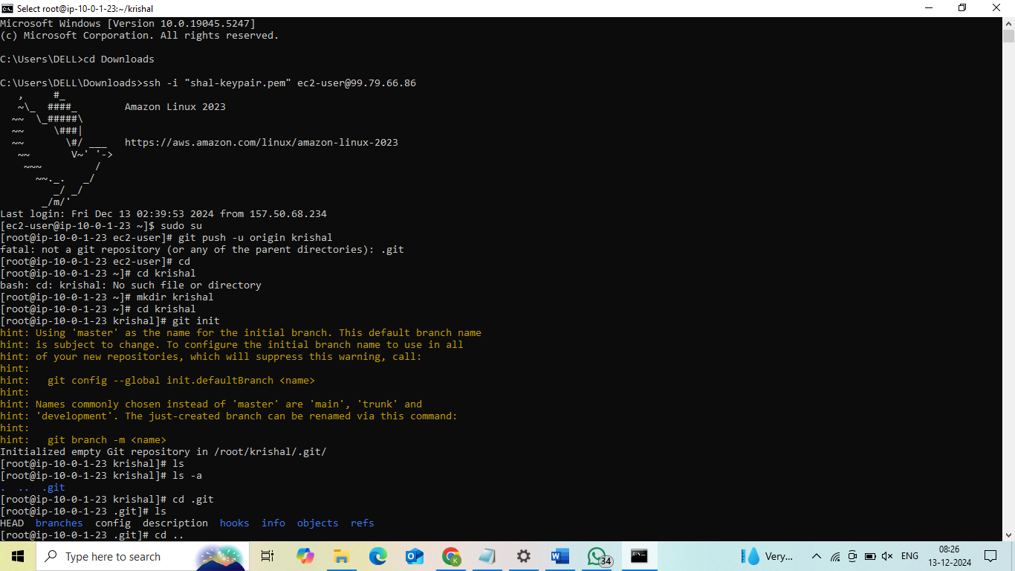

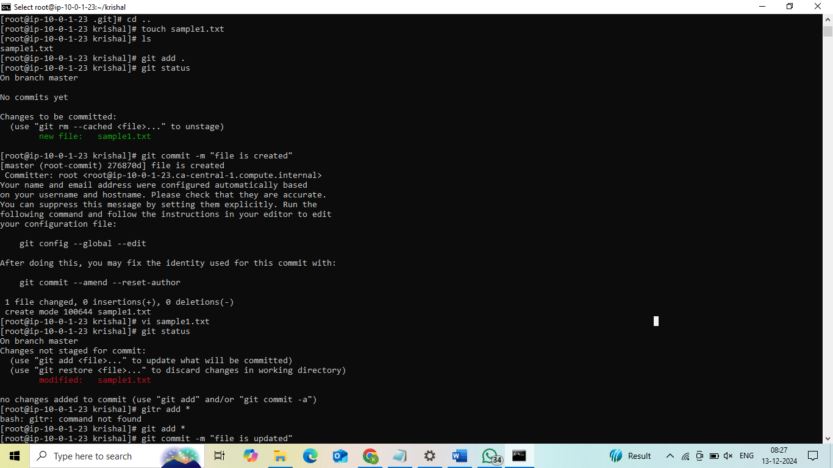

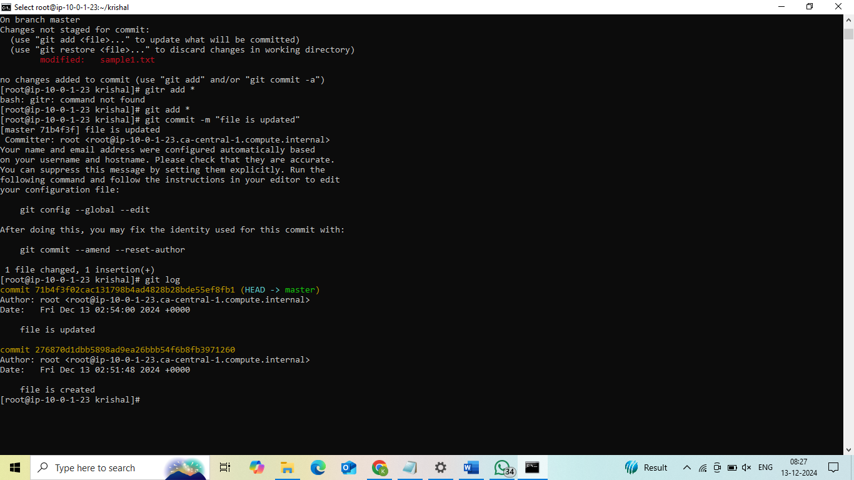

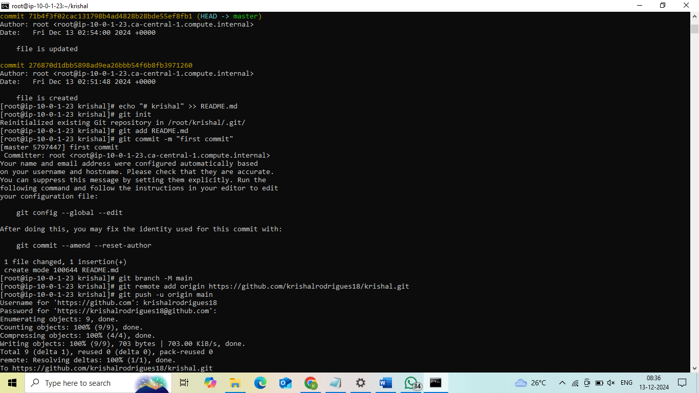

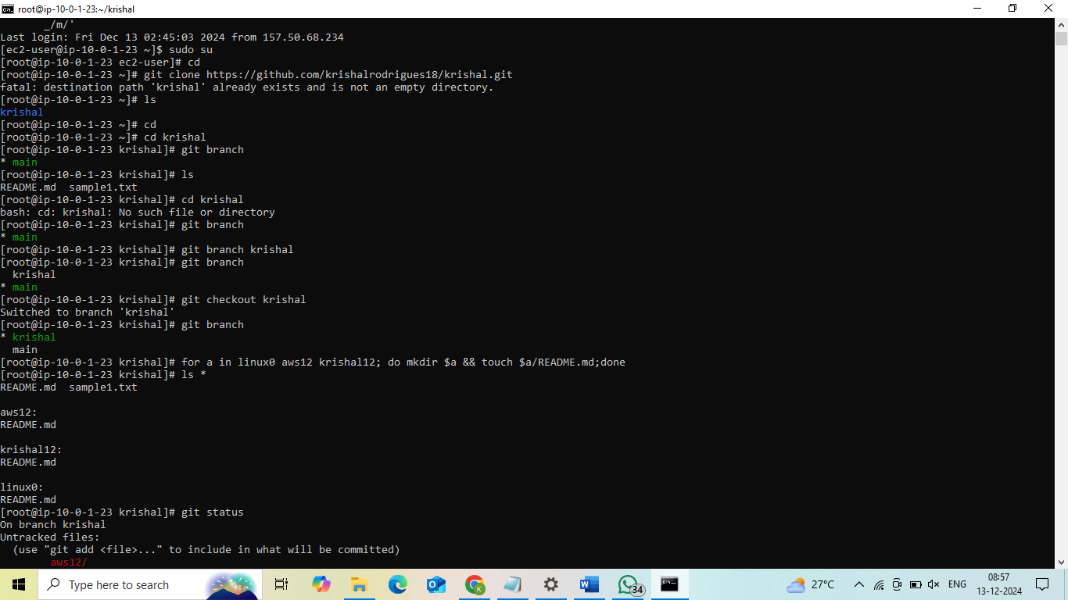

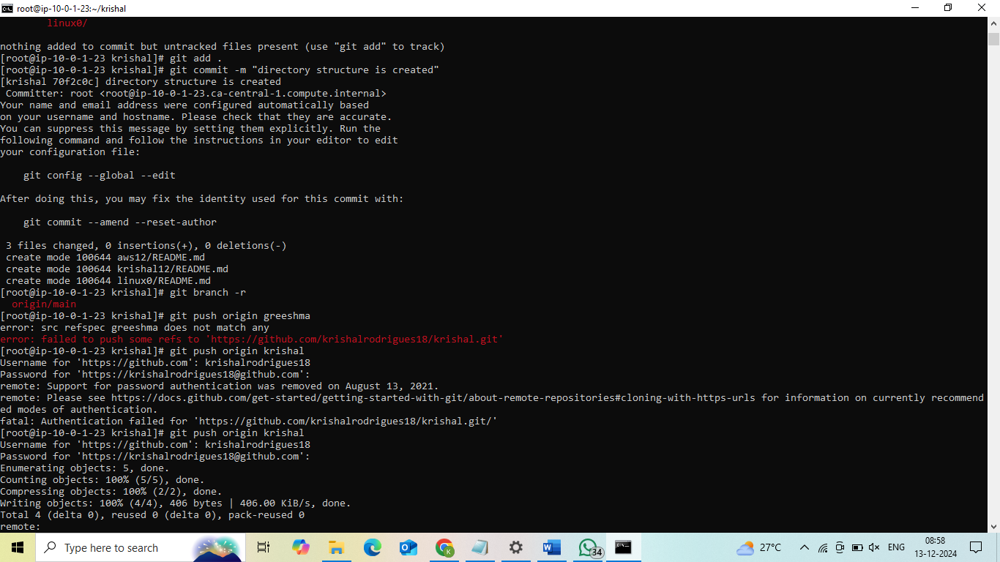

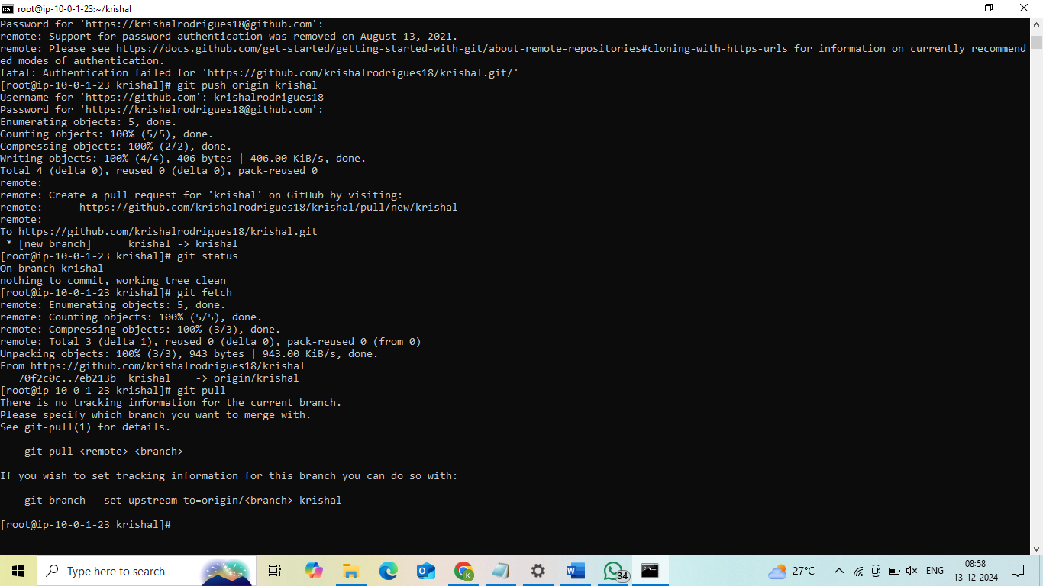

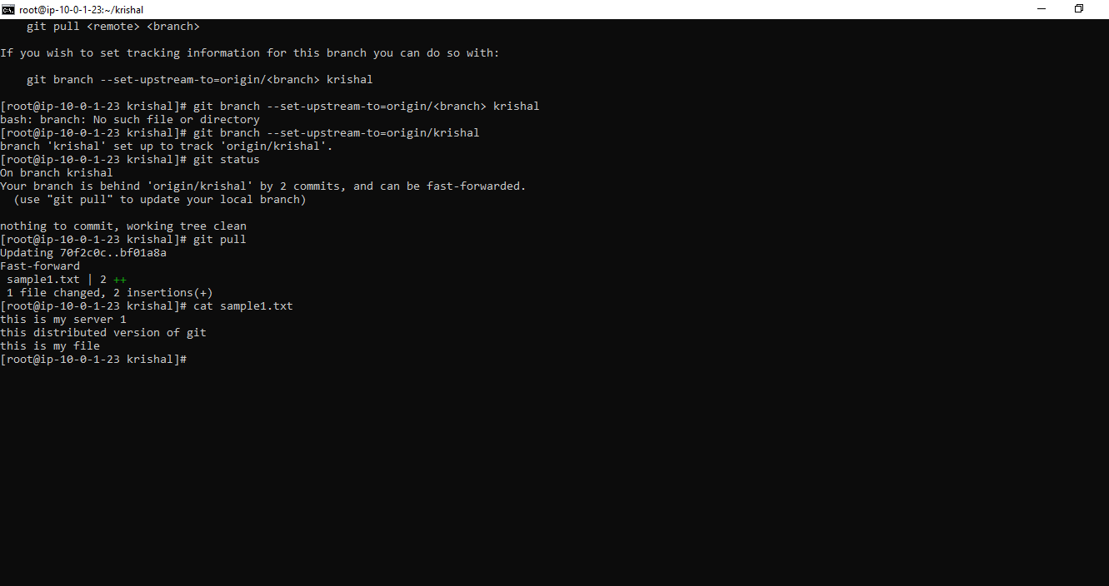

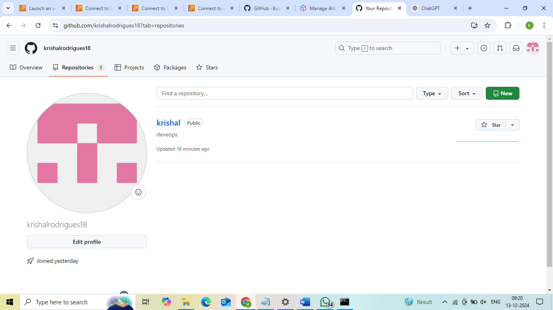

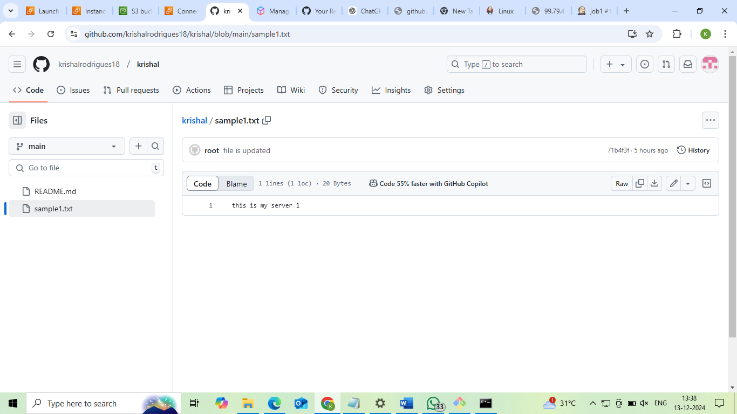

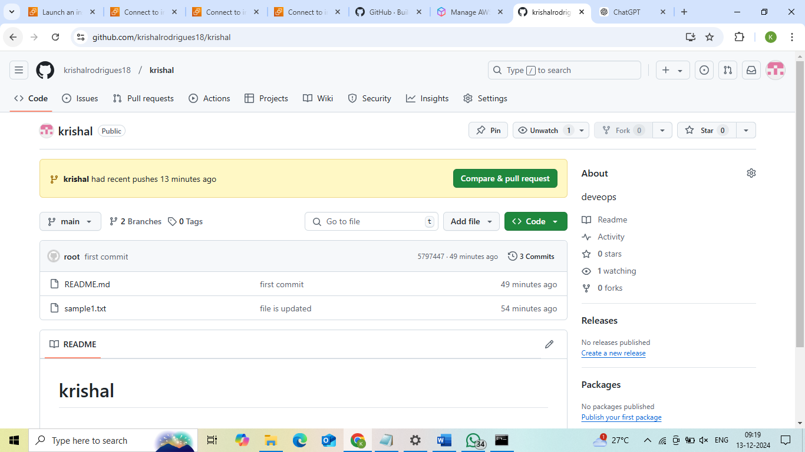

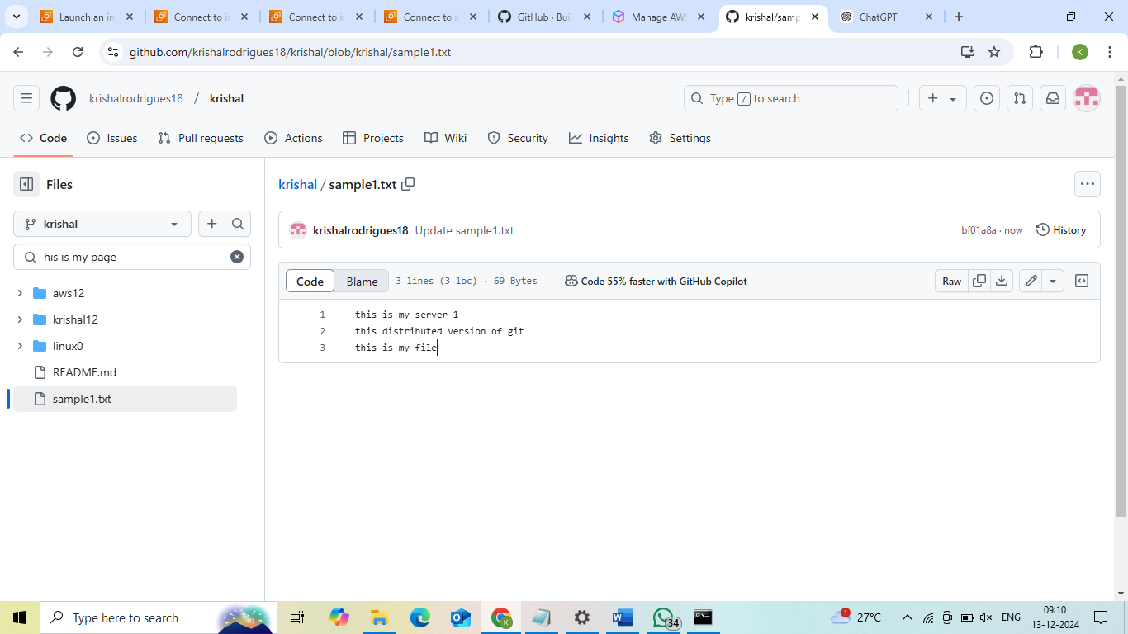

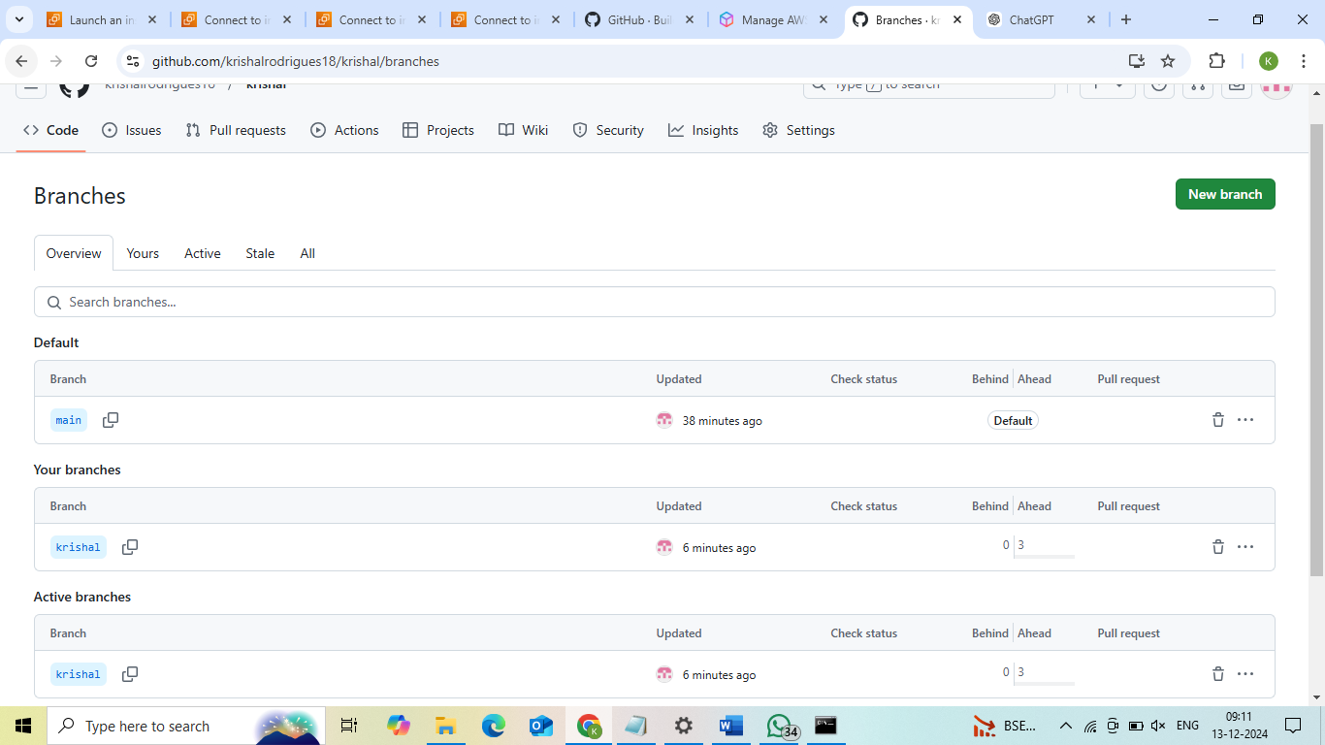

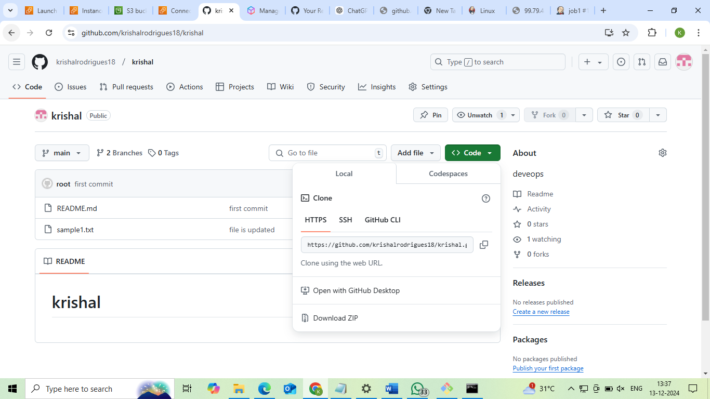

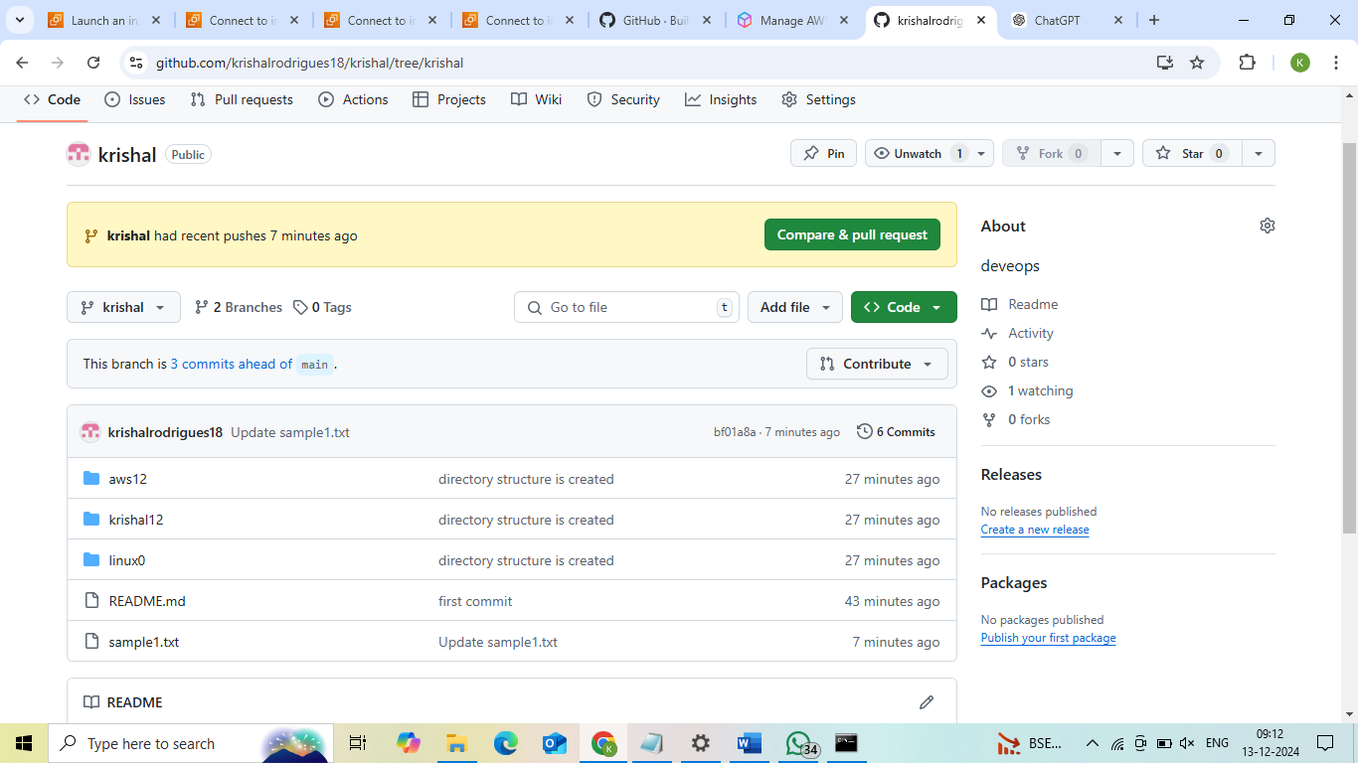

**Project 7:How to download and run project from GITHUB**

**Repositories:simple-reactjs-app**

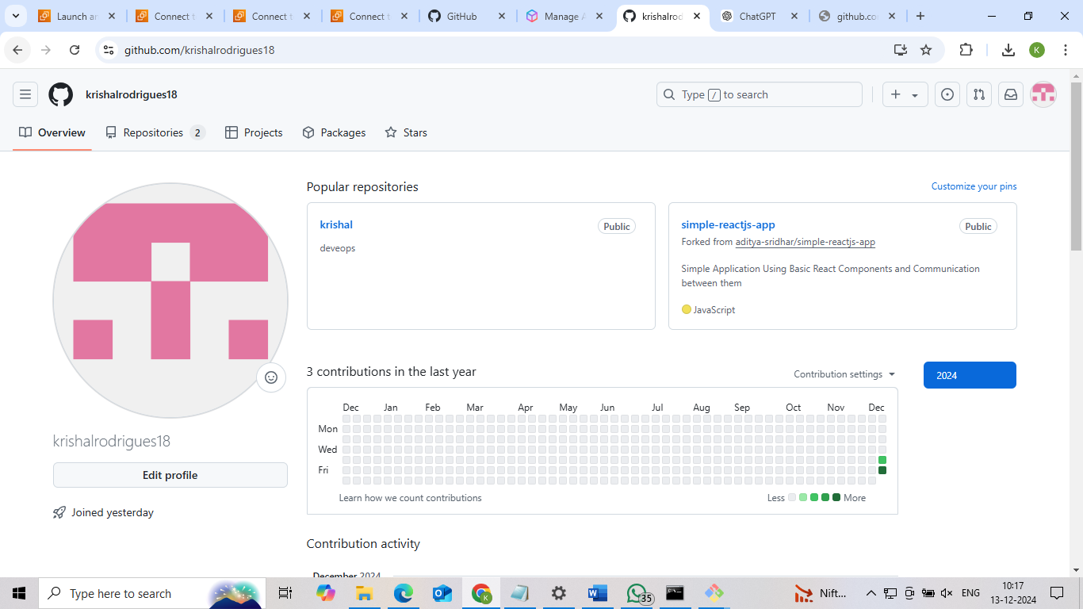

**Clone url**

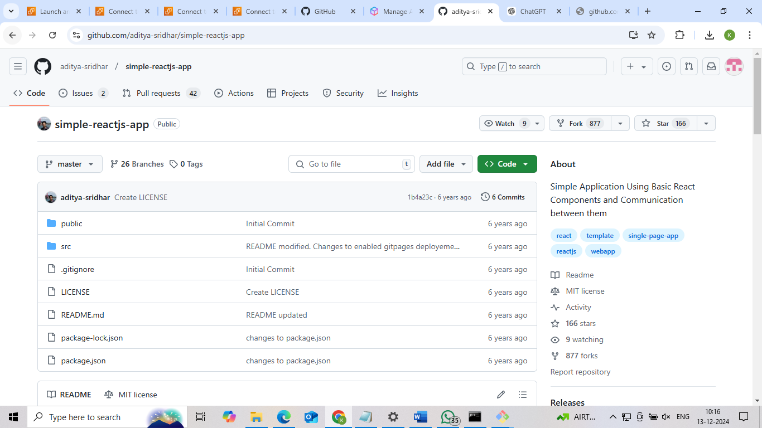

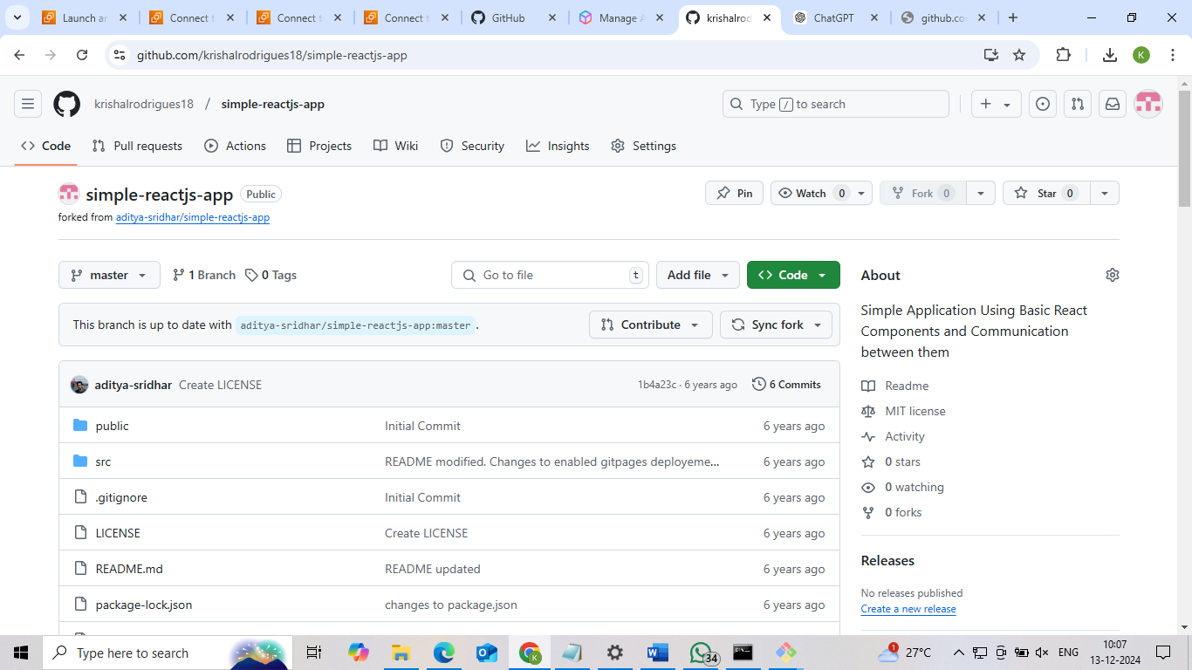

**Command Prompt**

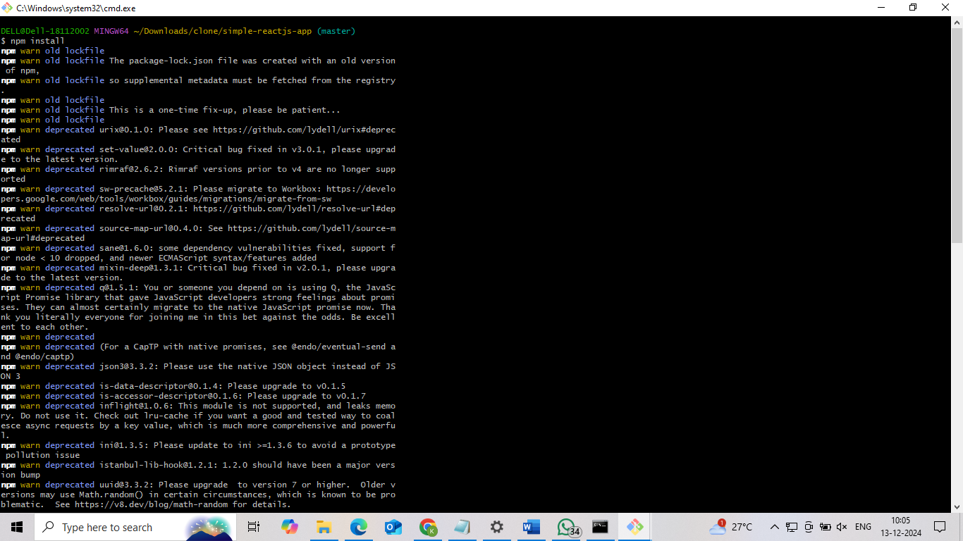

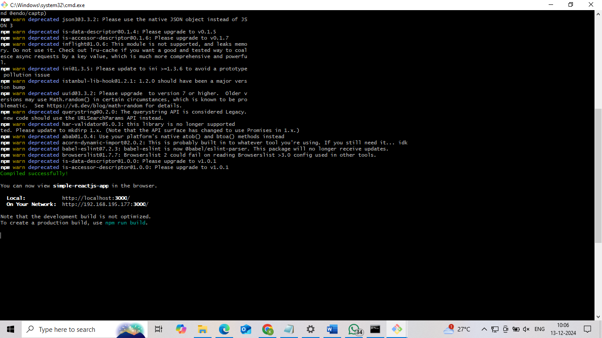

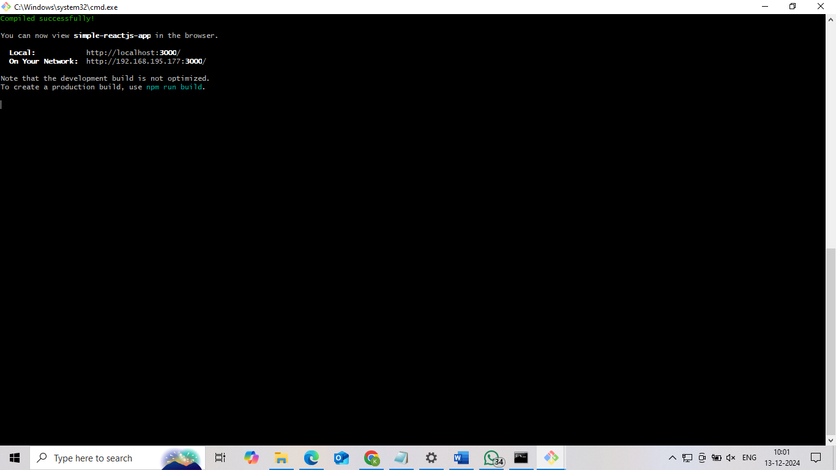

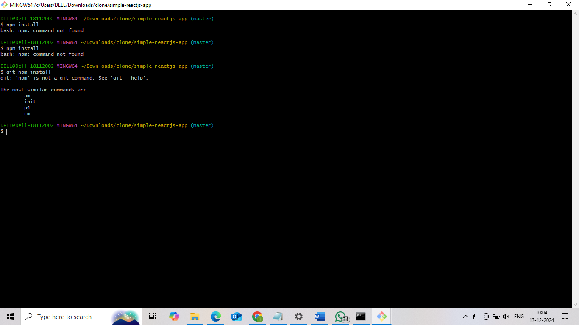

**Final Result**

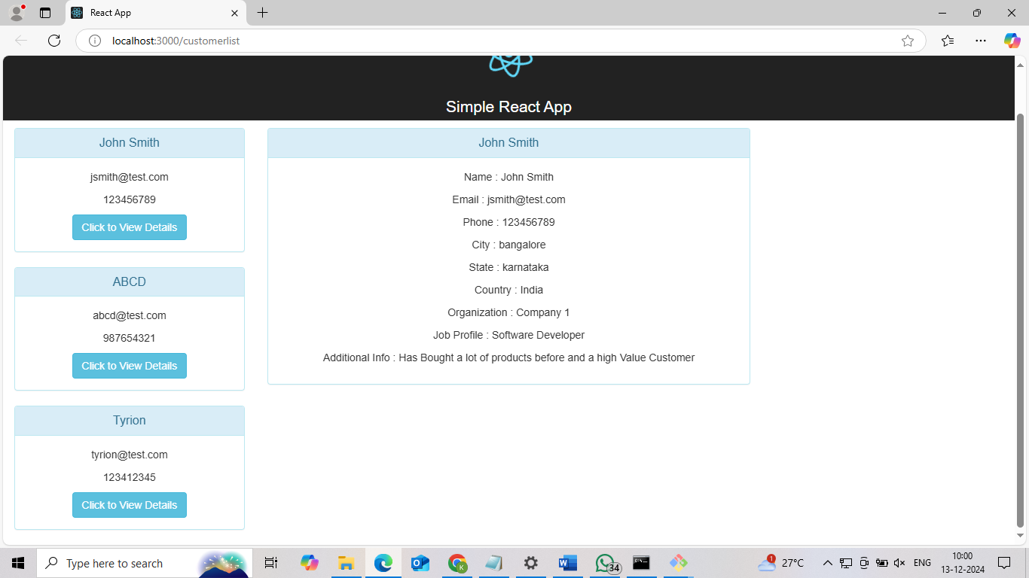

**Project 8:How to clone Github with Jenkins using Poll SCM Build Trigger**

**Creating the job-3-krishal**

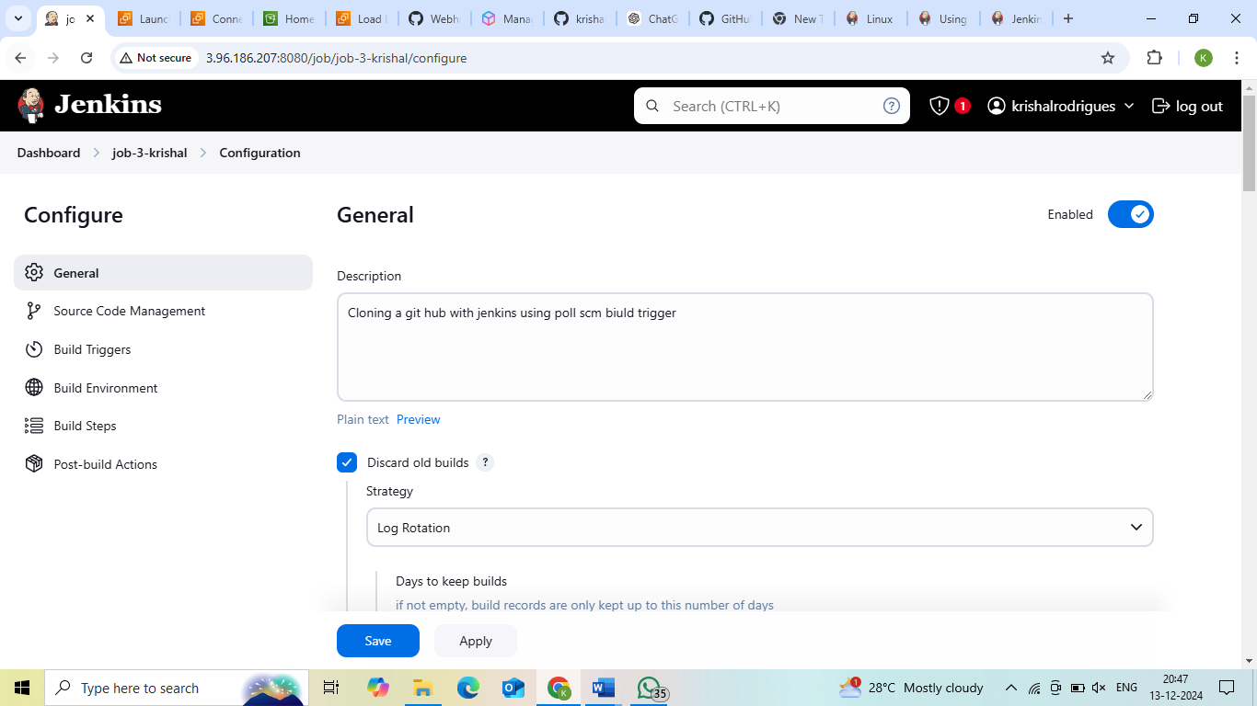

**Selecting the source code management**

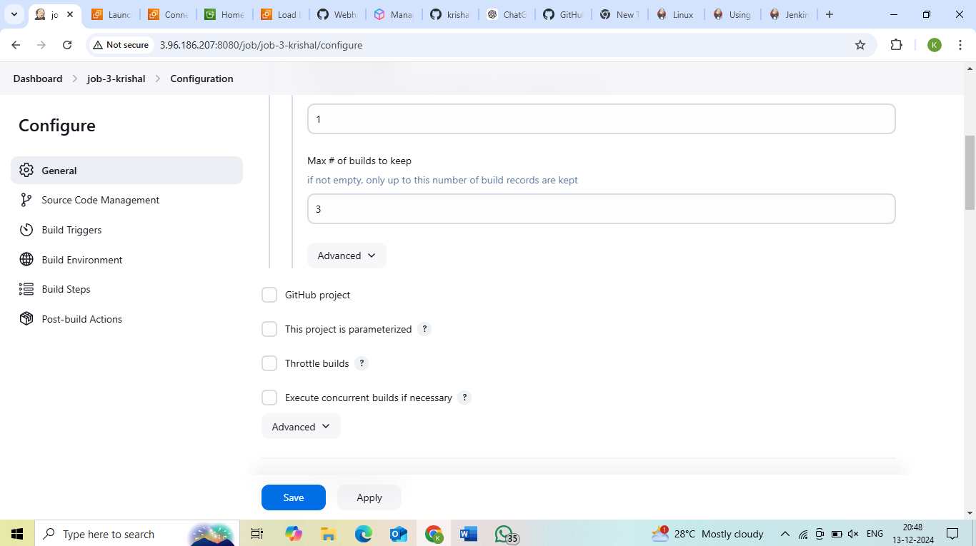

**Copying the repository url**

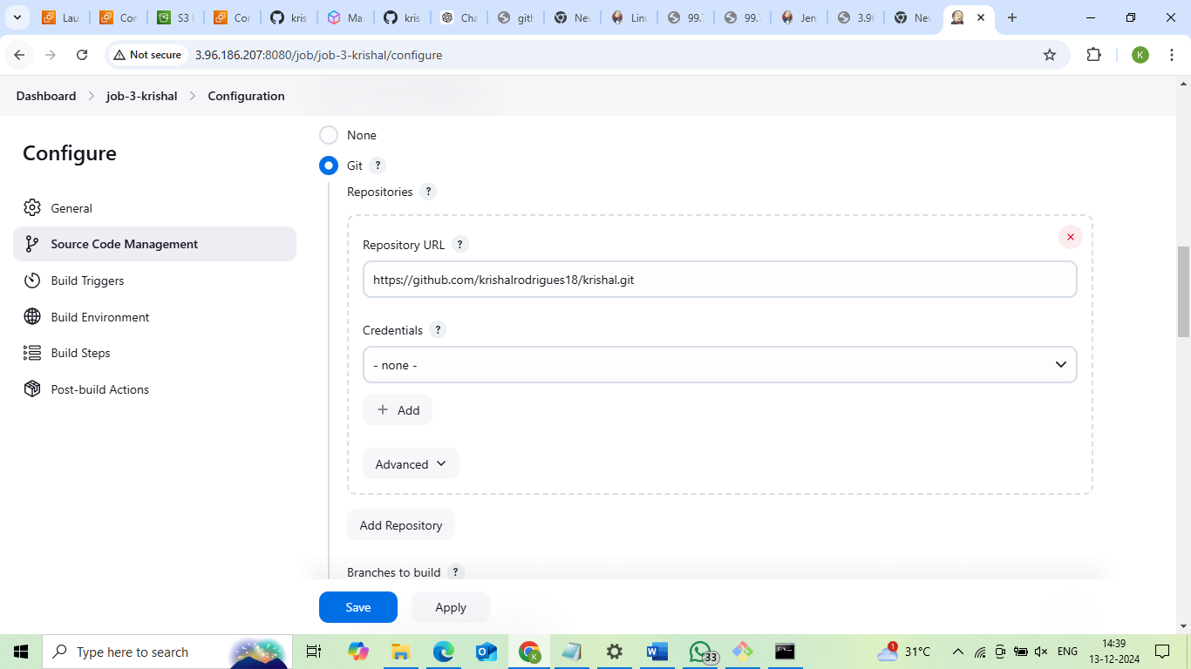

**Build Trigger**

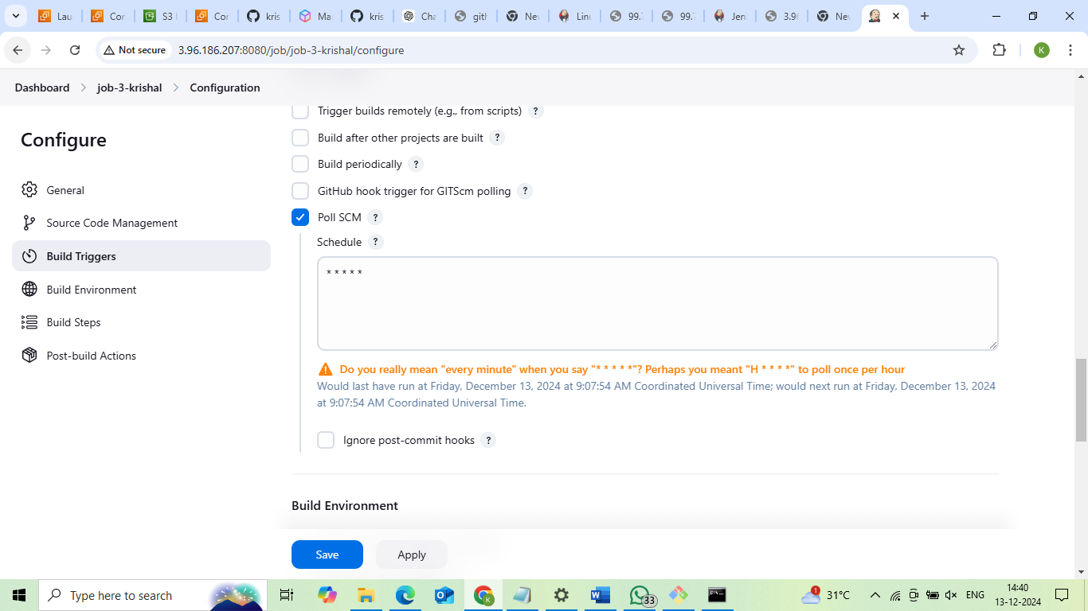

**Build steps**

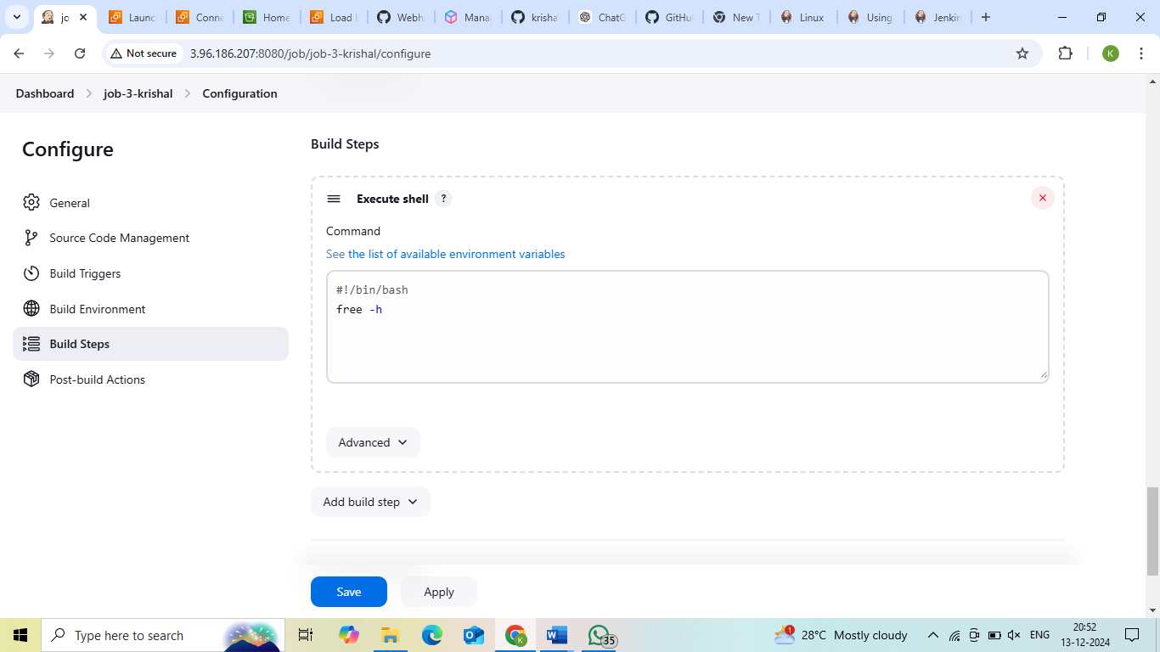

**status**

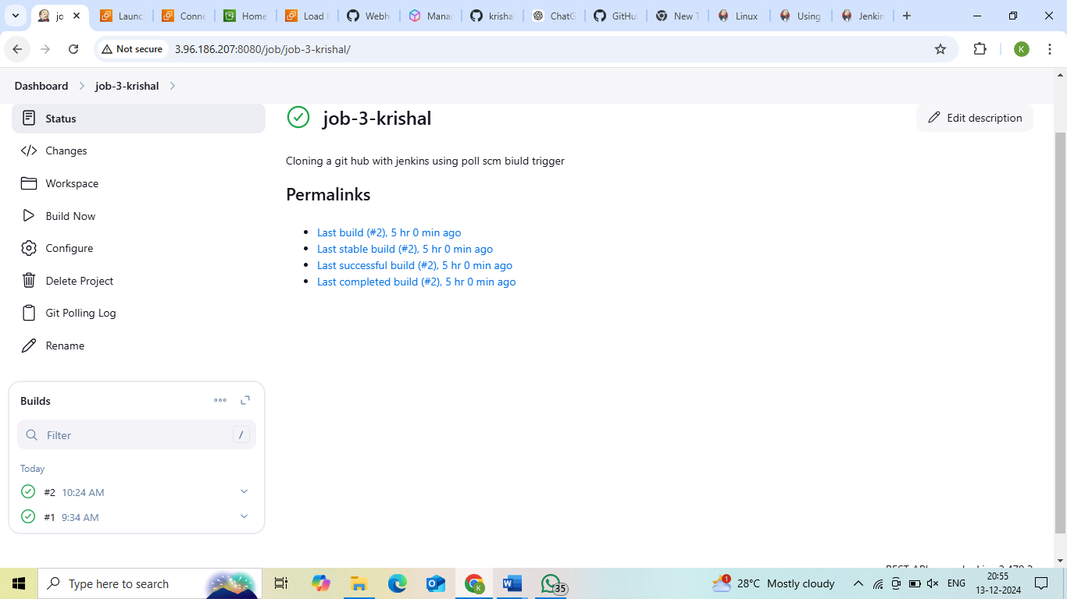

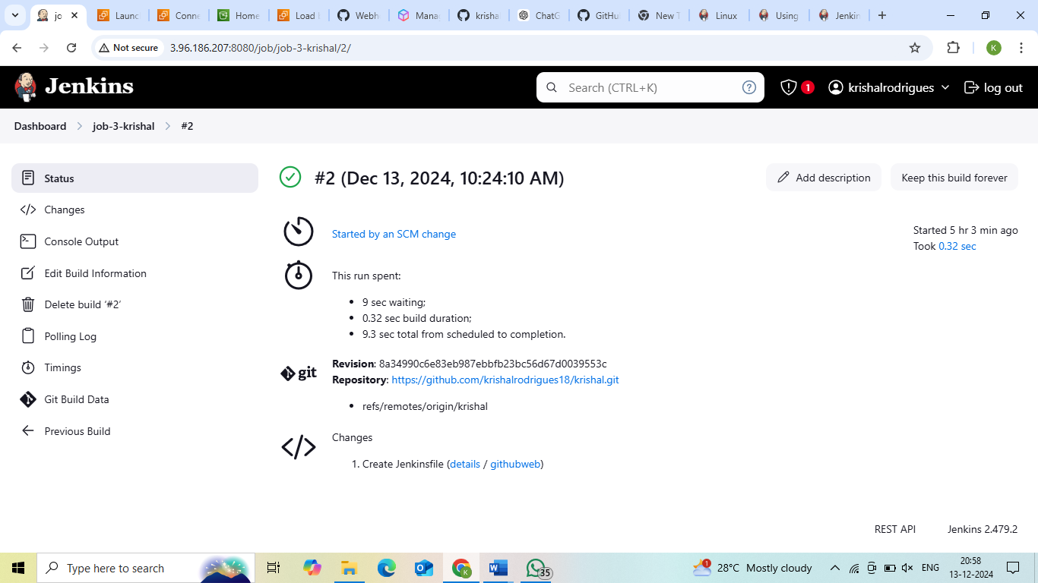

**Final Result**

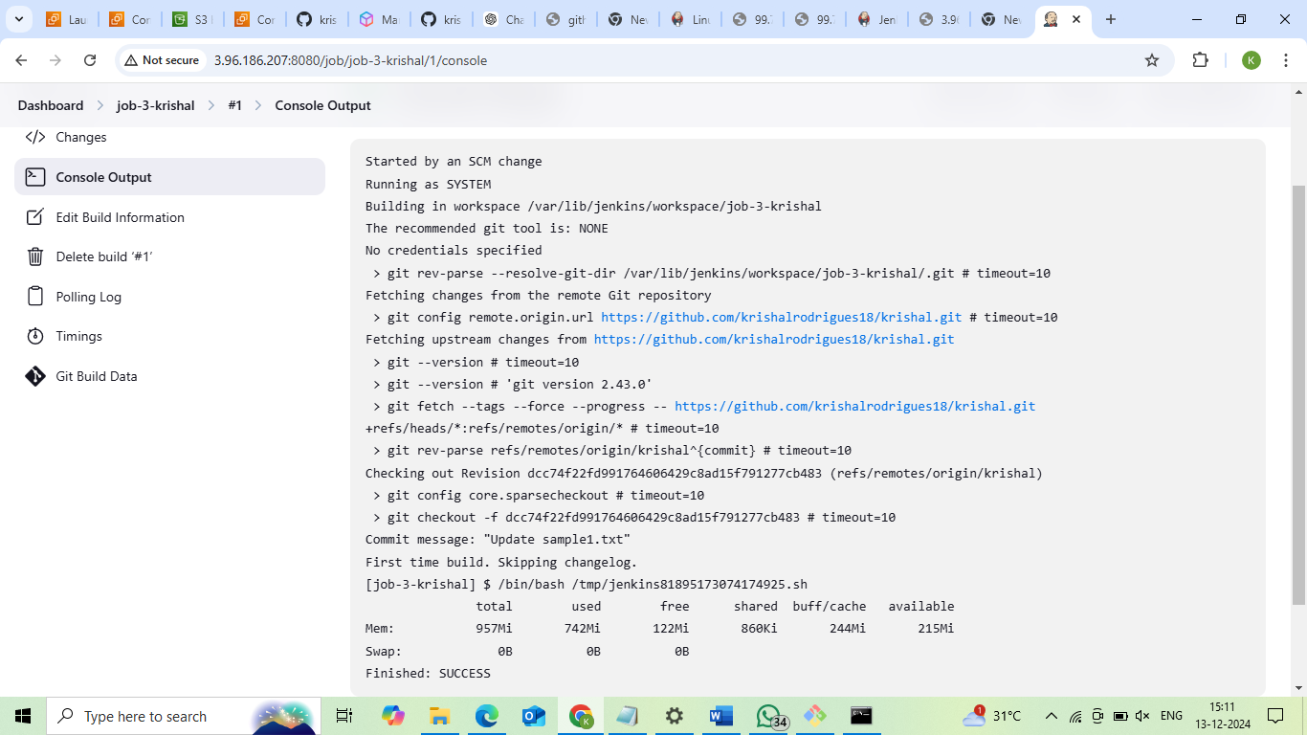

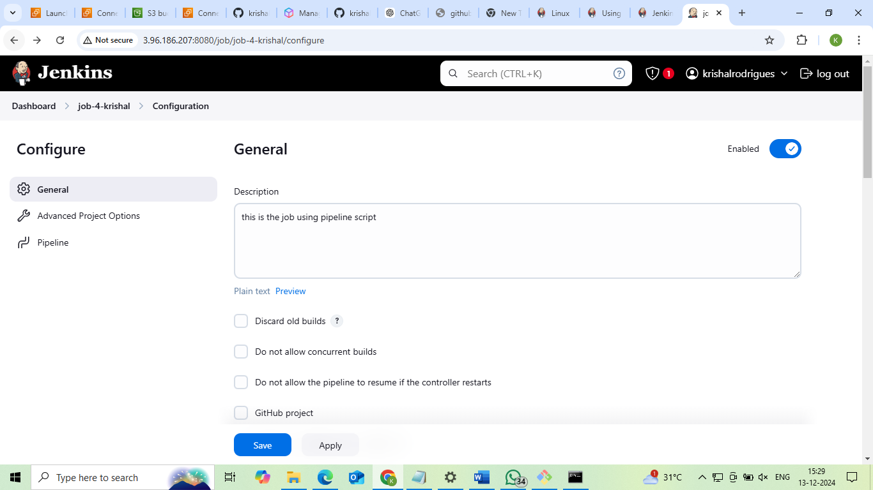

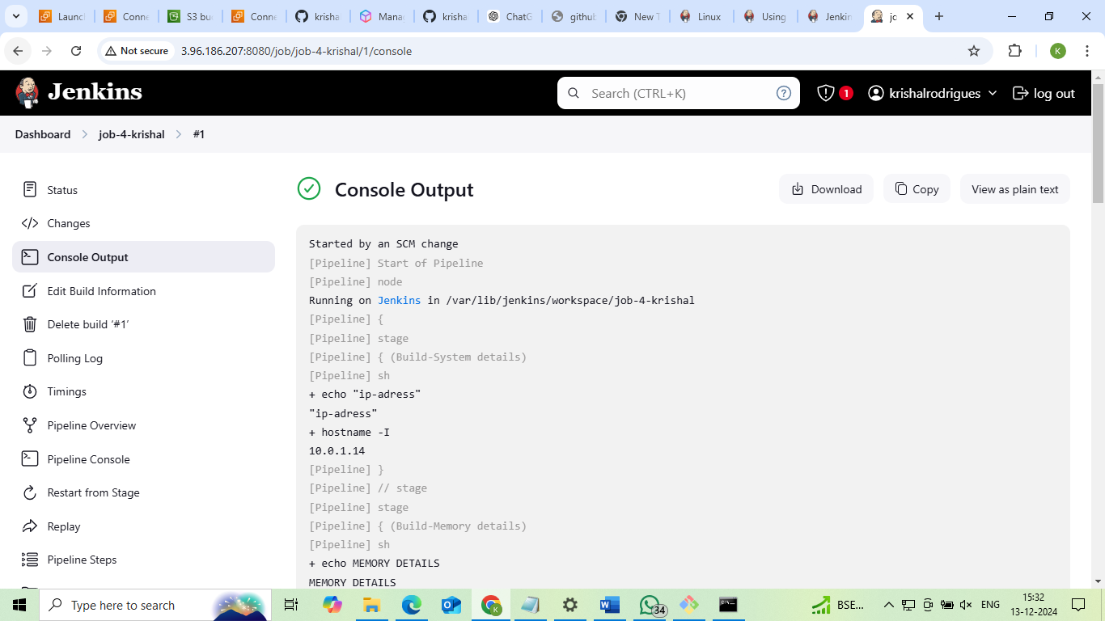

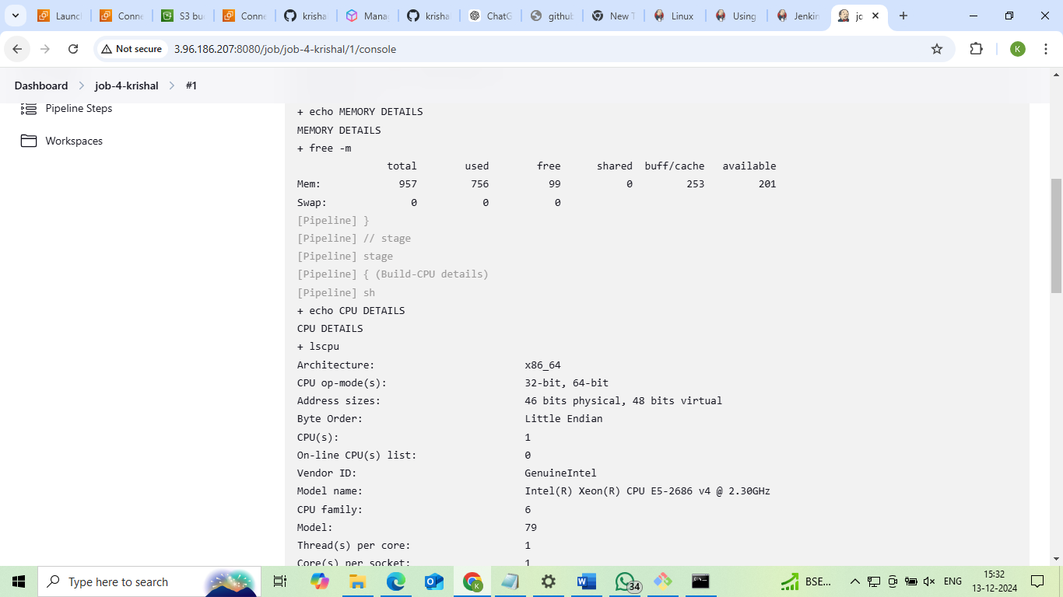

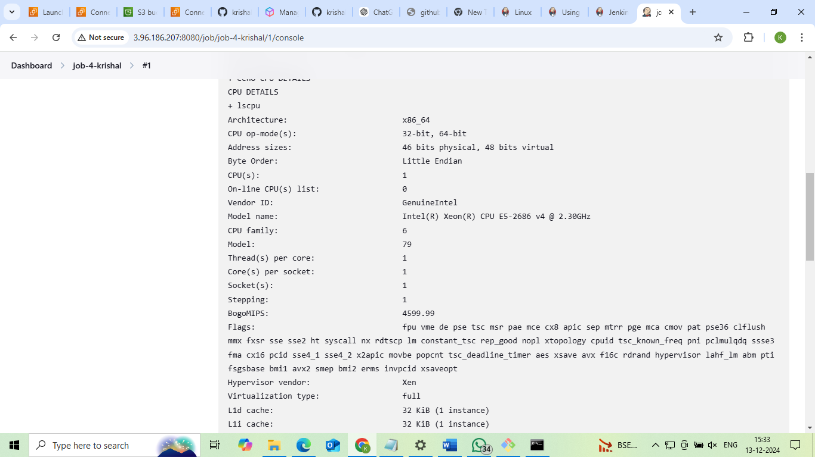

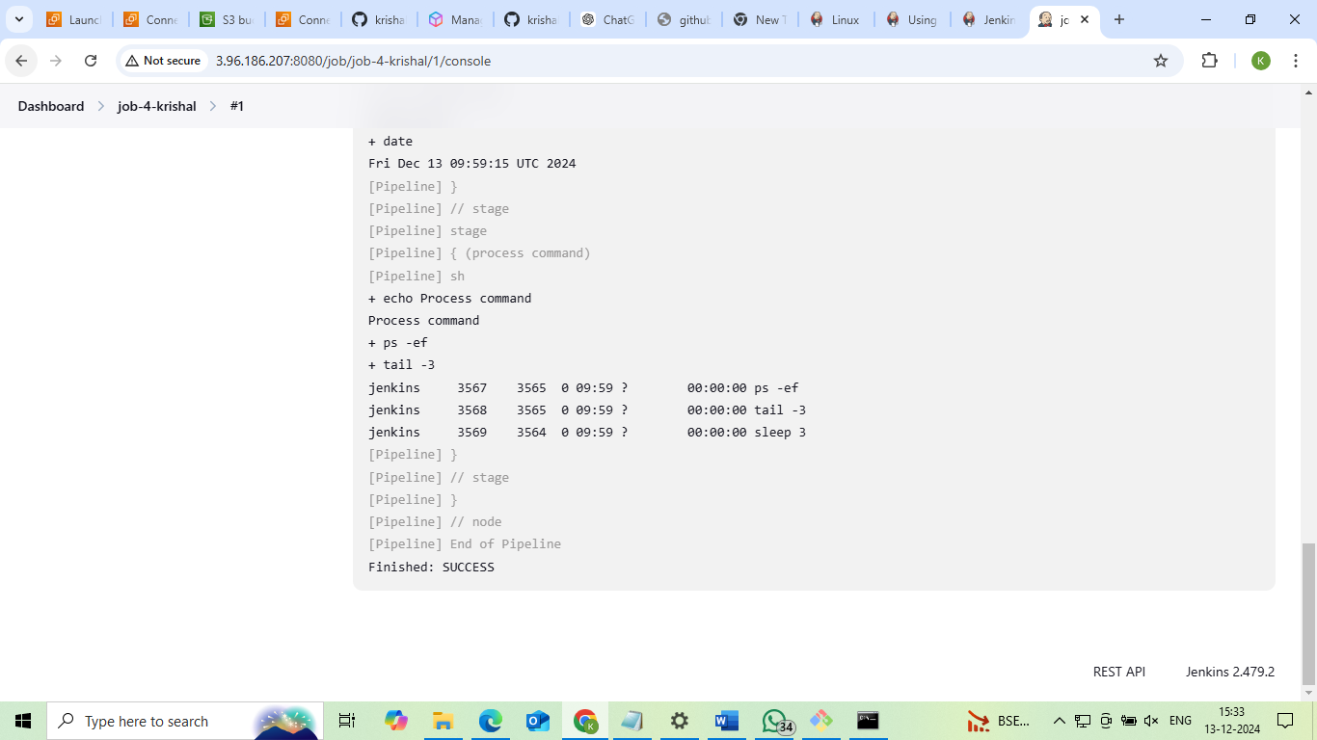

**Project 9:How to automatically trigger the job in Jenkins using pipelines integrating with GitHub**

**Dashboard**

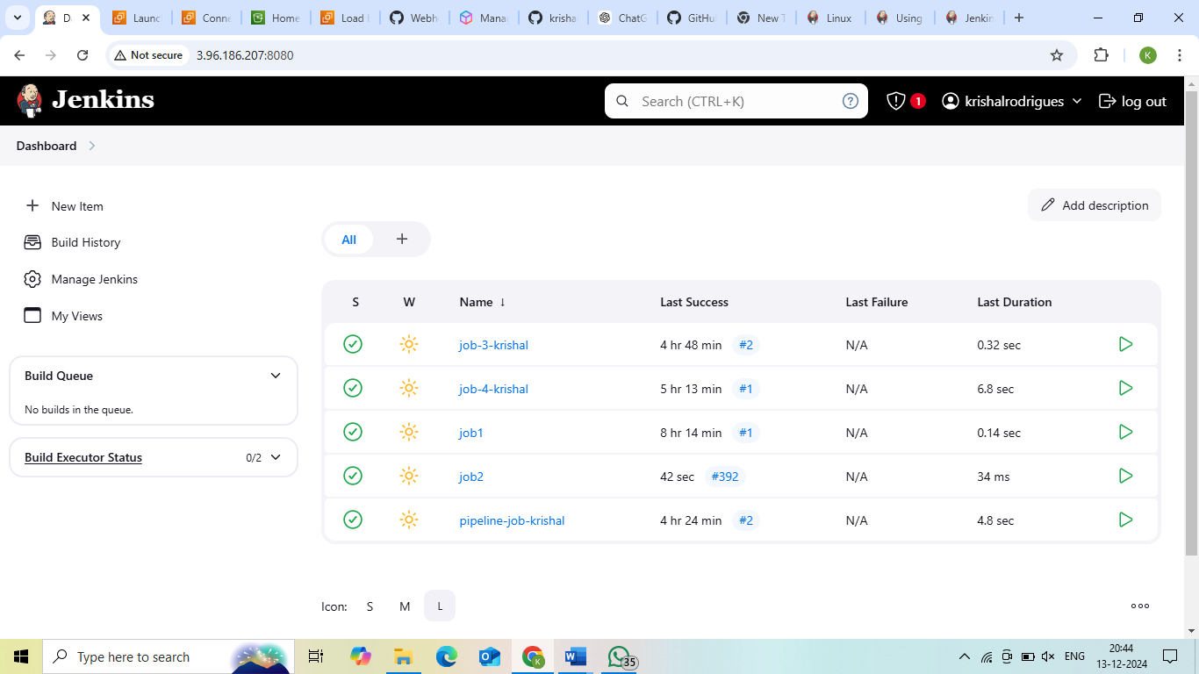

**Creating Webhook**

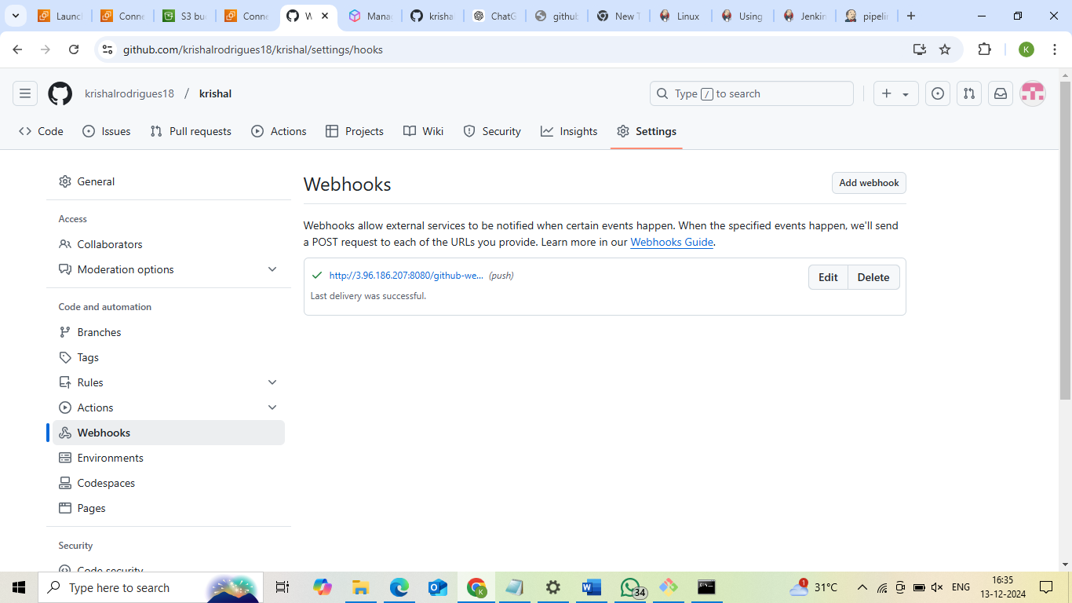

**Status**

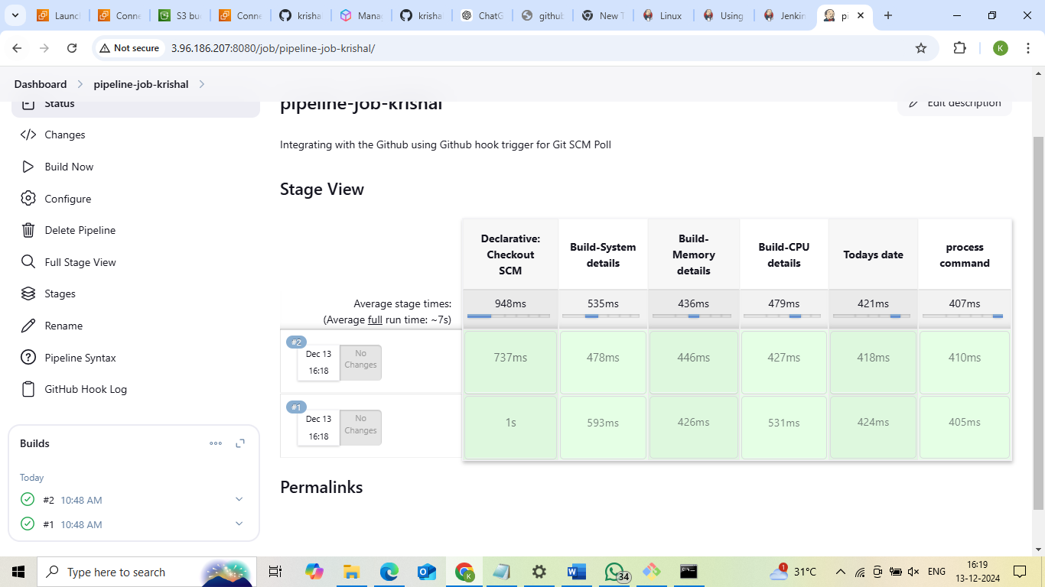

**Logs**

